Supplies for rising kindergarten and rising first graders and above
Pre-cut printout of Girl Scout daisy flower
Crayons or colored pencils
Extra paper to color on to protect the table surface
Cereal size bowl of water
Note: If a printer is not available you can draw a flower that has petals and a circle in the middle. Use about half of a standard 8.5 -inch X 11-inch paper and cut the flower out.

Girl Scout Daisy Flower
Before the virtual meeting, please cut out the flower as shown on the cutting line, so it is ready for the activity during the meeting. We suggest paper underneath the flower while coloring so the surface is protected.
If you do not have a printer available, simply trace or draw the flower on paper and write in the words. It does not need to be exact!
The flower can be colored with colored pencils or crayons. Fold each petal inward to touch the circle in the middle when directed.

See flowers below.

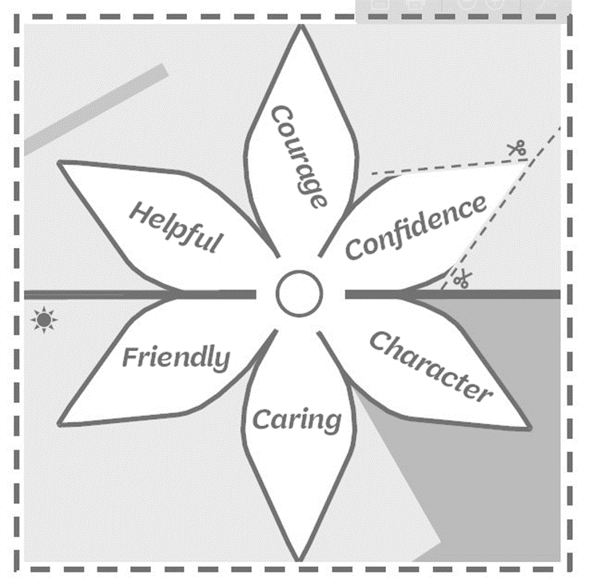

One more flower below.

