California Digital Learning Integration and Standards Guidance
Excerpt: Section B—Standards Guidance for Mathematics
(pages 101–212) and Appendix D—Mathematics Rubric Samples (pages 538–542)
Cover Page

Section B: Standards Guidance for Mathematics

Chapter 4: Digital Learning in Mathematics
Chapter 1 provided a wide range of general recommendations associated with effective teaching in a digital learning environment. This chapter includes additional strategies for a focused subset of topics most relevant to mathematics instruction and aligned to the ISTE Standards for Educators and National Standards for Quality Online Teaching (which were introduced in Chapter 1).
Additionally, the draft Mathematics Framework with an adoption target date of May 2022, devotes a chapter to the intersection of mathematics, technology, and distance learning. The Mathematics Framework emphasizes how technology “supports both the learning of meaningful mathematical content and the fostering of the productive habits of mind and habits of interaction embodied by the Standards for Mathematical Practice (SMPs).” The chapter expands upon three principles for incorporating technology in mathematics instruction, each of which are introduced and explained briefly below:
- Principle 1: Strategic Use of Technology in a Learning Environment Can Facilitate Powerful Learning of Mathematics: The first principle focuses on the intentionality behind the use of technology for mathematics to contribute to students’ “learn[ing], experienc[ing], communicat[ing], and do[ing] mathematics. It includes access (technology availability for students and educators), usage (technology’s use in the learning process), and skills (the students’ and educators’ ability to use the technology in meaningful ways).
- Principle 2: Support for Teachers of Mathematics Accompanies Use of Learning Technologies: The second principle concentrates on the need for robust and continual professional learning and support during a technology adoption process. Additionally, the school and/or district needs to provide time for teachers to learn how to use the technology, including ongoing and content-specific training, such as for mathematics.
- Principle 3: Learning Technologies Are Accessible for All Students: The third and final principle emphasizes the need for access and equity to learning technologies, including devices and digital tools specific for mathematics, for all students, including foster youth, youth experiencing homelessness, ELs, and students with IEPs and 504 plans. This access can include devices and the internet.
The topics included within each of these principles are covered briefly in this chapter within the context of mathematics and more generally in Chapter 1.
When implementing the strategies in this chapter, educators are further encouraged to create ongoing partnerships with family members and caregivers who help their students with their learning. This cultivates a robust support system for students as they work through assignments and problems that may be challenging. Educators might invite family and caregivers to online office hours and/or one-on-one meetings with students to identify interventions and resources and further strengthen the support system.

Preparing and Supporting Teachers for Digital Teaching

Professional Responsibilities
As referenced in Chapter 1, both the ISTE Standards for Educators and National Standards for Quality Online Teaching emphasize the vital importance of teachers collaborating with colleagues to support one another as they create authentic learning experiences that leverage technology. As is true for any subject area, this pedagogical training should also be content specific, as mentioned above, so that teachers can leverage those technologies to support their teaching of mathematics and their students’ learning (National Council of Teachers of Mathematics, 2015).
One way to encourage collaboration in mathematics might be to develop a supportive cadre/group of teachers, forming a formal professional learning community (PLC), at the regional, district, school, or grade level. By leveraging various digital tools, such as collaborative documents, social media, and video conferencing software, the PLC might be responsible for dividing content based on areas of expertise, creating activities, and sharing ideas for integrating technology.,

Teacher Presence
In Chapter 1, both the ISTE Standards for Educators and National Standards for Quality Online Teaching emphasize the use of digital tools to foster teacher-student relationships that build students’ sense of belonging to the school community. This focus on relationships is especially important in distance learning, where teacher presence is critical to helping students feel best supported for their success. This does not suggest that teachers have to be connecting to students synchronously all of the time. Instead, it can be achieved through a personalized note, quick feedback on an assignment, a private message of encouragement during group time, or email messages.
In the mathematics learning environment specifically, digital tools that allow teachers and peers to communicate feedback through video and/or audio help make the learning experience much more personable than purely text-based feedback. Additionally, videos allow students to stop and replay the content if they missed information the first time they heard it.

Digital Citizenship
Digital citizenship is one of the core components of both the ISTE Standards for Educators and National Standards for Quality Online Teaching, and it reminds teachers to model, guide, and encourage legal, ethical, and safe behavior related to students’ technology use. Chapter 1 presented the DigCitCommit competencies as a framework that allows teachers to consider strategies for teaching and reinforcing a comprehensive set of digital citizenship skills.
Addressing digital citizenship through the lens of mathematics specifically can provide students an opportunity to reinforce the “Inclusive” competency of the DigCitCommit framework (“I am open to hearing and respectfully recognizing multiple viewpoints, and I engage with others online with respect and empathy.”). For example, collaborative tasks related to mathematical ideas that necessitate investigation provide an opportunity for students to learn how to interact in respectful ways with each other and provide productive feedback to peers.
Furthermore, mathematics can be an ideal content area for practicing the “Engaged” competency of the DigCitCommit framework (“I use technology and digital channels for civic engagement, to solve problems, and be a force for good in both physical and virtual communities.”). For example, teachers can guide students in discussing and reflecting on how investigating mathematical ideas, asking questions, and making conjectures in mathematics may help in solving local and global issues around them. This activity may be further facilitated by using video conferencing tools to connect with experts in the field who are using mathematics to solve these local and global issues.
Teachers will find additional ideas for teaching digital citizenship through the lens of mathematics from resources like Tech InCtrl that provide lesson materials and ideas. Refer to Digital Citizenship in Chapter 1 to learn about more strategies.

Data-Informed Instruction
Both the ISTE Standards for Educators and National Standards for Quality Online Teaching emphasize the importance of teachers’ ongoing use of data to inform their instruction. In the context of mathematics, there are many ways digital tools can be used for formative assessment in online and blended learning environments to determine pedagogical effectiveness, understand support needs for students, inform and individualize instruction, and accelerate learning. Chapter 2 shares many of these approaches under Assessment for Learning, which explores frequent, formative assessments that may be used to inform instruction. Some examples for mathematics include, but are not limited to, the following:
- Students can meet in online work sessions where the teacher might give students just-in-time support, such as small lessons using Edpuzzle [a video-based lesson software], that provides data for the teacher as students collaboratively work through problems. As the students are working through problems, teachers can check in on students’ learning goals to identify students in need of additional support.
- Students might also meet with their teachers one-on-one to discuss their progress related to a specific concept, engage in a discussion-based assessment via video conferencing, and/or discuss their next steps.
- Students might write out their mathematical explanation as they solve selected problems in an online shared document. This enables teachers to closely monitor student progress and provide ongoing, supportive feedback and notes to bolster students' motivation as they continue their problem-solving process. It also provides a space for students to share if they are asked to present.
- Teachers can create a quick check-in survey using an online survey tool, such as Google Forms or Zoom polls, to ask students where they are with their understanding of concepts. Based on that assessment, the teacher can adjust their instructional approaches (e.g., pace of instruction).
Sample rubrics to assess and give feedback to students around their strengths and areas for growth in mathematics are included in Appendix D: Mathematics Rubric Examples. The rubrics connect the Drivers of Investigation to both the big ideas and the standards for mathematical practice (SMP).
Refer to Data-Informed Instruction in Chapter 1, as well as Chapter 2, to learn about more strategies.

Designing Meaningful Digital Learning Experiences

Aggregating Quality Synchronous vs. Asynchronous Instructional Time
Both the ISTE Standards for Educators and National Standards for Quality Online Teaching call on educators to design learning experiences that are best-suited for the specific learning environment. Teachers determine which information is better conveyed through real time, synchronous instruction with direct teacher-student interaction, and which information is appropriate for asynchronous instruction without direct teacher guidance or interaction.
As described in Chapter 1, when teaching synchronously, teachers are advised to present critical content information as concisely as possible after students engage actively in a task, reserving the remaining time for active learning activities that reinforce the content presented. In the context of mathematics, these might include the following:
- Students can practice solving an authentic problem independently during asynchronous time and then join a live Number Talk and discuss ways to solve the problem (synchronously), allowing them to share a variety of perspectives on approaches. To motivate and increase engagement, consider using breakout rooms in Zoom [video conferencing tool] for students to collaborate in small groups and then transition back to the whole class to share and compare strategies.
- Teachers can facilitate a live discussion with an expert, such as a mathematician who works at NASA, around a math topic to elicit curiosity and provide student-centered, mathematical experiences. Students can ask the expert questions and engage in a discussion about something tied to math that they are passionate about.
- Teachers can build math activities using digital tools, such as Desmos [a mathematics lesson building software], NearPod [interactive learning platform], and Pear Deck [formative assessment platform], in which students develop conceptual understandings and reflect with their peers on what they are learning together.
It is important to note that educators can be mindful of how groups are formed. Catalyzing Change in Early Childhood and Elementary Mathematics states, "Challenge ability grouping and ensure all children have access to mathematics learning environments where each child interacts with, learns from, and contributes to shared and deep mathematical understanding within a classroom community" (p. 125). While asynchronous learning activities can include tasks and exercises students review in order to prepare for synchronous time, it can also leverage active learning opportunities, including, but not limited to, the following:
- Students can record themselves using Screencast-O-Matic [screencasting tool] as they work with hands-on or virtual math manipulatives or simulation. While using the screencasting tool, they can speak about their understanding of what actions they are taking, what they are learning, and why it is important.
- Students can create a digital infographic based on data they have analyzed for a project. The process of creating the infographic can help students decipher what information is the most critical to share in a presentation they give to the class. Tools, such as Google Slides [online presentation tool], help students create infographics. Activities such as this provide students with an outlet to creatively visualize data and apply data literacy and data science skills.
- Students can create a graph using Google Sheets [online spreadsheet] to interpret and visualize data they have analyzed for a group project. Students can then share that sheet with peers who are working collaboratively on the project. Students can also write about what the visualization suggests within the context of the problem being solved.
- To assist teachers in monitoring student learning, students can take a daily self-assessment using Google Forms that will help the teacher know what concepts need to be covered for future learning activities.
- Students can use Geogebra [a modeling software for algebra and geometry] to visually model a problem to help provide an alternative representation of what they are learning.
- Teachers can use Desmos [a mathematics lesson building software] to provide interactive math activities for students. See sample activities focused on how to land a plane, where students can “plot the linear equation of a plane so that it lands on a runway” in Chapter 10 of the Mathematics Framework.

Universal Design for Learning
The ISTE Standards for Educators and National Standards for Quality Online Teaching emphasize that educators must design digital learning experiences that take individual learner differences into careful consideration. This includes leveraging the Universal Design for Learning (UDL) framework, introduced in Chapter 1, to help support all learners with accessible learning experience design.
LD OnLine, a national education service organization working in partnership with the National Joint Committee on Learning Disabilities (NJCLD), shares a number of key technology-empowered approaches grounded in the UDL framework that teachers can use. For instance, digital tools allow mathematics teachers to provide multiple means of representing concepts, which are especially helpful for students with difficulty processing language, navigating spatial concepts, or retaining mathematics-related facts. Such tools may include, but are not limited to, digital manipulatives, videos, pictures, simulations, and other graphic representations.
Other suggested strategies for integrating the UDL framework in mathematics contexts include:
- building computational fluency, such as counting with objects rather than using drill and skill approaches (e.g., using physical objects at home that students can then take video of as they count);
- converting symbols, notations, and text using text-to-speech software, which is typically built into platforms;
- building conceptual understanding by collaborating with others through video conferencing tools and digital whiteboards;
- making calculations and creating visual mathematical representations through graphing technologies; and
- using graphic organizers to help students depict and connect different mathematics concepts.

Infusing Opportunities for Creativity
The ISTE Standards for Educators call on educators to nurture creativity and creative expression to communicate ideas, knowledge, or connections. The Mathematics Framework encourages teachers to help students “view mathematics as a vibrant, inter-connected, beautiful, relevant, and creative set of ideas” (Chapter 2). An authentic activity or problem elicits students to wonder, ask questions, investigate, and be creative. Strategies for infusing mathematics instruction with imaginative and creative activities may include, but are not limited to, the following:
- Focus on investigations around the big ideas of mathematics. Have students apply the Drivers of Investigations and explore patterns to solve authentic problems that include an open-ended, complex issue with multiple solutions. With video conferencing tools, students can work together to engage in discussions around creative ways to solve problems, play various leadership roles, ask reflective questions, consider multiple perspectives, and arrive collaboratively at possible solutions. Students can then use apps, such as Notability [application for documenting data and sharing learning with others], to take notes on what they have found in their deliberations.
- Invite mathematicians and other professionals in the field to talk about the importance of mathematics in various career pathways and connections to real-world problems. Invite professionals who reflect the ethnic and gender diversity of the school community. Such opportunities to connect with experts can allow students to see direct connections between concepts and possibilities for what they may encounter in future career opportunities. To foster further engagement, invite students to collaboratively compose a set of questions relevant to their curiosities and interests for the guest speaker. To support these efforts via digital tools, many organizations, such as National Geographic, NASA, and local zoos, have created content to support educational programming, which includes interviews and presentations by professionals. Other examples of guest speakers might include pilots, who can share with students the connection of aerospace dynamics and applied mathematics with physics, or a construction worker or manufacturing engineer, who can talk about how fractions are part of their day-to-day work.
- Invite students to create informative and explanatory tutorials focused on teaching a math concept to other students. One of the best ways to learn something is to teach someone else (Koh, Lee, & Lim, 2018). To promote motivation and engagement, consider offering students a choice in how to develop their tutorial. Options may include video, oral presentation, digital brochure, or poster. Teachers can curate a collection of student-produced tutorials (with permission from students and parents), cultivating an ever-expanding library of tools that other students can use into the future. This activity also provides students a chance to boost their confidence and take control of and have an empowered voice in their learning.
- Ask students to generate their own problems or tasks for the class to solve that require their peers to recall previous concepts learned. Student-generated problems can help students “connect math concepts to their background knowledge and lived experiences...promot[ing] creative reflection, sense-making, and application of students’ procedural and conceptual knowledge.”
- Use inquiry-based learning to provide students opportunities to devise their own questions to launch an investigation around a given topic and share them with their peers in a collaborative online space, such as a discussion forum. This allows students to have control and choice, as well as get ideas and questions from peers to expand their learning. When students are younger, there might be a need for more teacher guidance in this process, and the collaborative activity might be better done in a synchronous session in small groups with peers who are working on similar inquiries.
- Using virtual gallery walks with tools, such as Google Slides or VoiceThread, students can visit stations illustrating a variety of representations of manipulatives (hands-on and virtual) focused on a particular math concept. As a follow-up, students can use spatial skills to externally visualize a concept to process how they think about it (e.g., graphs, simulations, coding, infographics). Students can video conference in breakout rooms while they are working on their visualizations to share ideas to deepen their understanding.
- For younger students, it is essential to create daily themes to further engage students and provide them a variety of ways to represent their learning (Hege, n.d.). Mathematics learning can include items from their personal lives so that students can make a direct connection. Students can use digital choice boards to decide, based on the theme, how they are going to represent what they have learned.
Refer to Infusing Opportunities for Creativity in Chapter 1 to learn about more strategies.

Encouraging Authentic Collaboration
The ISTE Standards for Educators call on educators to collaborate and co-learn with students to discover, use, and create new digital resources. This type of collaboration in online learning environments is critical to establishing meaningful relationships, cultivating a supportive community, deepening student learning, providing a foundation to grow students’ sense of belonging, and giving every student a chance to develop their own mathematical understandings. Teaching mathematics in a relevant and coherent way can be supported by multiple instructional approaches, including inquiry-based learning, problem-based learning, and project-based learning. Investigations, open-ended tasks, and meaningful problems in mathematics can provide a variety of opportunities for authentic collaboration among students.
Key considerations when building project-based learning opportunities into virtual mathematics instruction may include the following:
- When possible, allow students to choose the topic of their project so that they have more control and buy-in for what they are working on. Invite students to identify an interdisciplinary issue in their community and think through how mathematics can be part of the solution to the problem.
- Invite students to create digital portfolios in Seesaw [portfolio-based learning application] to empower them to share their thought processes when approaching the problem, which can also help students see the relevance of mathematics for everyday life. Encouraging students to share their thought processes also provides peers with varying perspectives on how to approach the problem and solution.
- Invite students to create a response to a mathematics problem using a variety of technologies of their choice. For instance, students can create tools, such as infographics (with Canva [a graphic design tool]), digital comic strips (with Google Slides), games (with Scratch [an online programming tool]) and videos (with Flipgrid [a video-based discussion software]). This provides an opportunity for students to choose how to best express themselves and represent their learning. It also provides a unique opportunity for students to understand how their peers work through complex problems based on varying cultural and contextual perspectives and experiences.
- Allow students to connect with and share their project with a mathematics professional and/or mathematics-focused organization so that they can expand their connections and receive feedback from a global network of experts (Drexler, 2018). Allowing students to network can provide greater balance between teacher control and student autonomy.
Additional examples of strategies to encourage authentic collaboration in mathematics learning in online and blended settings include the following:
- After providing students with protocols and guidance related to productive and positive online communication, such as those shared in Chapter 1, invite them to engage in peer editing each other’s mathematics project work. This can be done using collaborative tools, such as Google Workspace [suite of online, shared tools]. This also provides students with feedback and evaluation experiences to further reinforce digital collaboration skills.
- Use and reference visuals that allow students to make direct links to materials and spaces students have immediate access to. For instance, students could find varying angles using the walls in their homes or learning spaces or use different objects that create angles.
- Invite students to relate their mathematics concepts to their home environments or their communities. For example, educators can ask students to identify a problem that directly relates to concepts learned. Students can document the problem as well as show how they may solve that problem. A variety of digital tools can help with this documenting process, including shared documents and digital spreadsheets to record data and develop visualizations. Students can use cameras, cell phones, as well as tablets to additionally document the process visually.
- Structure a virtual Number Talk, which are explained in Chapter 5, through a video conferencing tool or breakout groups. Give students a problem to mentally solve and ask students to defend their answers using mathematical reasoning. Through discussion, students have the opportunity to explore, compare, and develop strategies. Number Talks provide students an opportunity to have their voice heard as well as to build new understandings as they talk through their process.
Refer to Encouraging Authentic Collaboration in Chapter 1 to learn about more strategies.

Chapter 5: Introduction to Standards Guidance to Teaching Mathematics through Big Ideas and Connections
Chapter 4 provided information about digital learning in mathematics. The purpose of Chapters 5-9 is to present standards and instructional guidance to support the continuum of learning from TK/K through grade 10. These chapters prioritize critical areas of instructional focus by grade levels. Attention to these critical areas will ensure that students transition to the next grade level well prepared to learn new skills and concepts. This guidance serves as a companion resource to the California Common Core State Standards: Mathematics and the Mathematics Framework. The organization of the content and practice standards as “big ideas” raises the individual standards to a higher level of “big ideas” and highlights the importance of the content and the ways it is connected to other content and practices. The standards guidance is intended to support teachers as they implement math instruction in online, blended, or in-person learning environments.
California’s goal for all students is that they learn mathematics as a meaningful subject of connected ideas. Teaching with meaning and connections requires a different organization of content and practice standards. The Mathematics Framework advocates for teaching to “big ideas” rather than organizing teaching around the small descriptions of mathematics set out in the standards. Mathematics professor Randy Charles defines a big idea as a “statement of an idea that is central to the learning of mathematics, one that links numerous mathematical understandings into a coherent whole” (Charles & Carmel, 2005, p.10). A “big idea” approach has been shown by research to engage students and increase achievement (Boaler et al., 2021; Cabana et al., 2014, Makar, 2018). The approach raises the individual standards to a higher level of “big ideas” that show teachers and students the importance of the content and the ways it is connected to other content and practices. As teachers orient their approach to big ideas and connections, they will find that there seems to be less content to teach and more time for students to explore ideas and learn deeply. The same content is actually taught and learned, but the organization of connections and big ideas allows for a more coherent approach in which students learn different, connected ideas together. The Mathematics Framework has organized Content Connections (CCs) of “Communicating stories with data,” “Exploring changing quantities,” “Taking wholes apart and putting parts together,” and “Discovering shape and space,” and this document organizes the big ideas under these broad content headings, which are explained in more detail below. Each grade band section (TK-2, 3-5, 6-8, 9-10) shows the progression of big ideas across the grades.
The Mathematics Framework includes a principle that mathematics learning in classrooms should always have a purpose and that rather than students working through questions without mathematical direction, they should work on an approach of “investigating and connecting.” To do this, the Framework recommends “crosscutting drivers of investigation” that can guide investigations. The drivers are:
- Making sense of the world (understand and explain),
- Predicting what could happen (predict), and
- Impacting the future (affect).
Figure 5.1 shows these drivers and the ways they can be applied to any combination of content and mathematical practices.
Figure 5.1. The Drivers of Investigation, Content Connections, & Mathematical Practices from the Mathematics Framework.
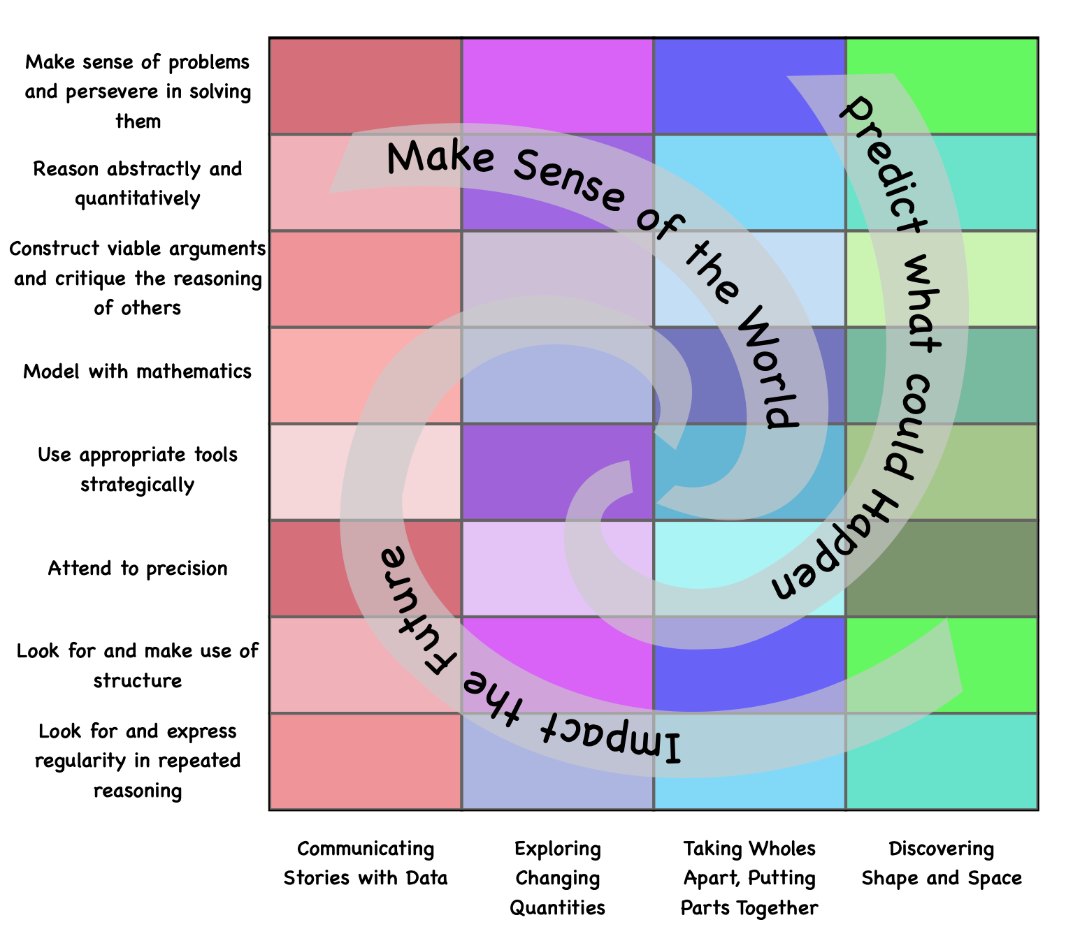
Long description: Three Drivers of Investigation (DIs) provide the “why” of learning mathematics: Making Sense of the World (Understand and Explain); Predicting What Could Happen (Predict); Impacting the Future (Affect). The DIs overlay and pair with four categories of Content Connections (CCs), which provide the “how and what” mathematics (CA-CCSSM) is to be learned in an activity: Communicating stories with data; Exploring changing quantities; Taking wholes apart, putting parts together; Discovering shape and space. The DIs work with the Standards for Mathematical Practice to propel the learning of the ideas and actions framed in the CCs in ways that are coherent, focused, and rigorous. The Standards for Mathematical Practice are: Make sense of problems and persevere in solving them; Reason abstractly and quantitatively; Construct viable arguments and critique the reasoning of others; Model with mathematics; Use appropriate tools strategically; Attend to precision; Look for and make use of structure; Look for and express regularity in repeated reasoning.

Big Ideas and Network Maps
The California Common Core State Standards: Mathematics offer domains, cluster headings, and standards – with most textbook publishers translating the detailed standards into short, procedural questions. A problem with working through standards and associated questions is that teachers do not have time to go in depth on any of the standards, or even to teach them all. A different approach is to consider the big ideas, as set out in the introduction to this section, that bring in many different standards, that often go across the clusters and domains. As students work on rich tasks, they will encounter many of the standards but in a more connected and meaningful way. This document sets out this “big idea” approach to mathematics, with the goal of helping teachers and their students, both during a period of decreased learning time and moving forward.
To highlight mathematical connections, each grade has a network map which shows the big ideas as nodes. These represent important and foundational content, and an ideal approach to teaching mathematics, in person or online, starts with choosing rich tasks that focus on the big ideas. As students explore and investigate with the big ideas, they will likely encounter many of the different content standards and see the connections between them.
The size of the node relates to the number of connections it has with other big ideas. The connections between big ideas are made when the two connected big ideas contain one or more of the same standards. The big idea colors in the nodes correspond to the table where the big ideas are correlated with full descriptions. The descriptions of each big idea are not taken from the standards or the clusters or domains; rather, they are new descriptions, as many of the ideas go across clusters and domains. For example, in grade 3 the big idea: Fractions of Shape & Time, brings together standards from the domains of Measurement and Data, Number and Operations in Base Ten, Fractions and Geometry. The new descriptions integrate well with the mathematical practices, as they describe mathematics as a subject of reasoning and communicating. The approach is illustrated through three vignettes, at grades 4, 8, and Integrated 2.
Grade Four Vignette: Teaching to Big Ideas
Perplexing Measures (Boaler, Munson, & Williams, 2017)
In this lesson, students encounter the big idea of “Measuring and Plotting,” which includes standards from the domains of Number and Operations - Fractions and Measurement and Data. The activity supports learning inside the Standards of Mathematical Practices; 1. Make sense of problems and persevere in solving them, 2. Reason abstractly and quantitatively, 3. Construct viable arguments and critique the reasoning of others, 4. Model with mathematics, 5. Use appropriate tools strategically, and 6. Attend to precision.
Ms. Kamala wanted her fourth grade students to experience measurement in a creative way and understand the idea of measuring with different units. She chose to use an activity called Perplexing Measures from Mindset Mathematics, Grade four. Ms. Kamala began the lesson by asking students to make and name their own unit of measure. Each group was given a different length of adding machine tape and told that it had a length of 2 whole units. Students learning in a virtual setting can find or piece together a long piece of paper that is around 3 inches wide and greater than two feet long. Students estimate the length and width instead of measuring exactly with a ruler or yardstick. The students in Ms. Kamala’s class folded their strip of paper tape into 16 equal increments by halving after each fold. After they completed folding, they stretched out their measure strip and labeled the increments, counting by eighths. They continued counting by different unit measures, whole numbers, quarters, and halves so the different representations of equivalent fractions were shown on their strip.
Figure 5.2. Adding Machine Tape Folded in Half 8 Times to Produce 16 Equal Units
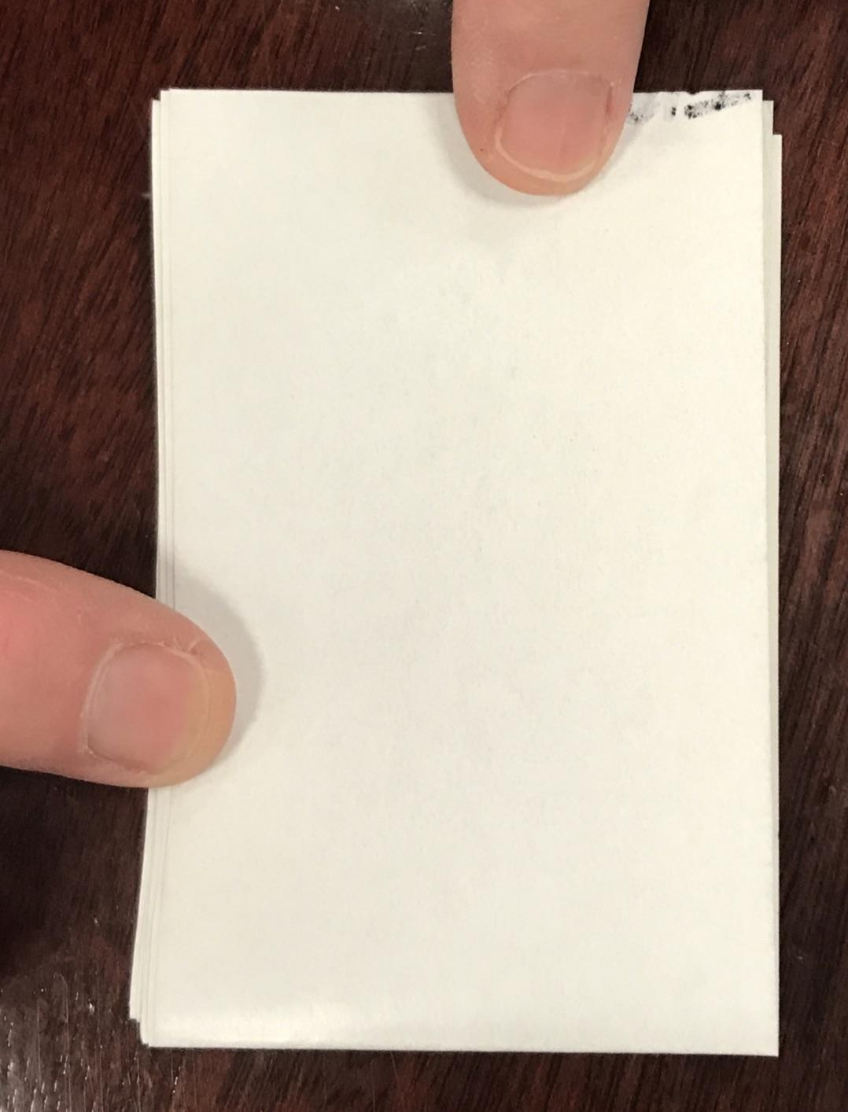
In one of the groups the students labeled their measuring strip a “Zoomboogle.”
Figure 5.3. Measure of One Zoomboogle Is Approximately 71 Centimeters Long
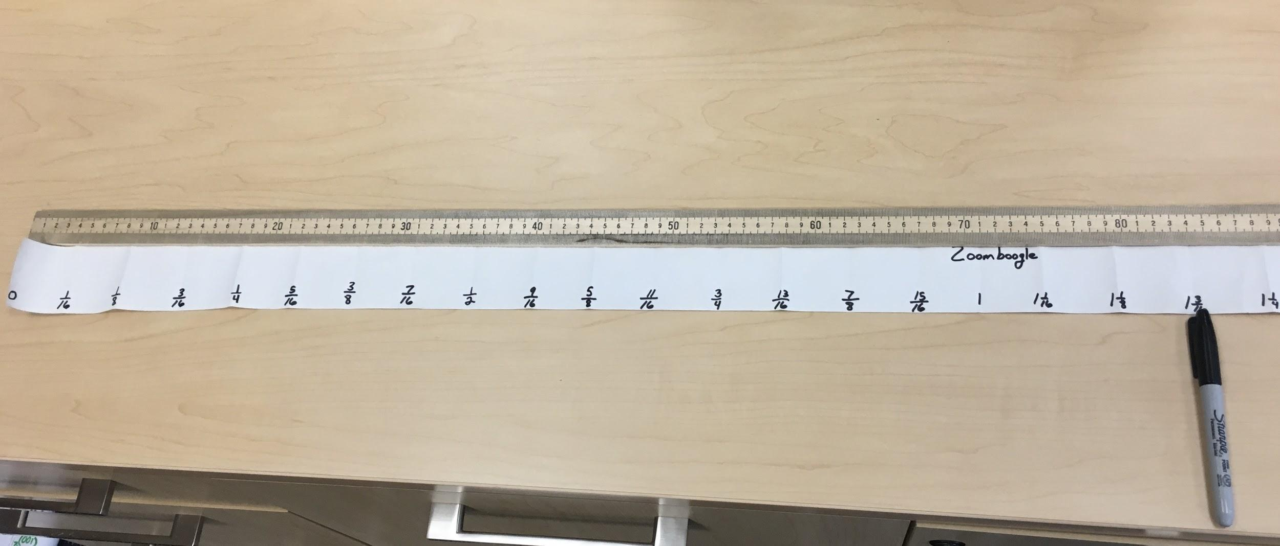
Students were asked to measure different items and record the measure to the nearest eighth of a unit.
Figure 5.4. Student Measure of a Tangram Structure and a Stuffed Black Cab Toy
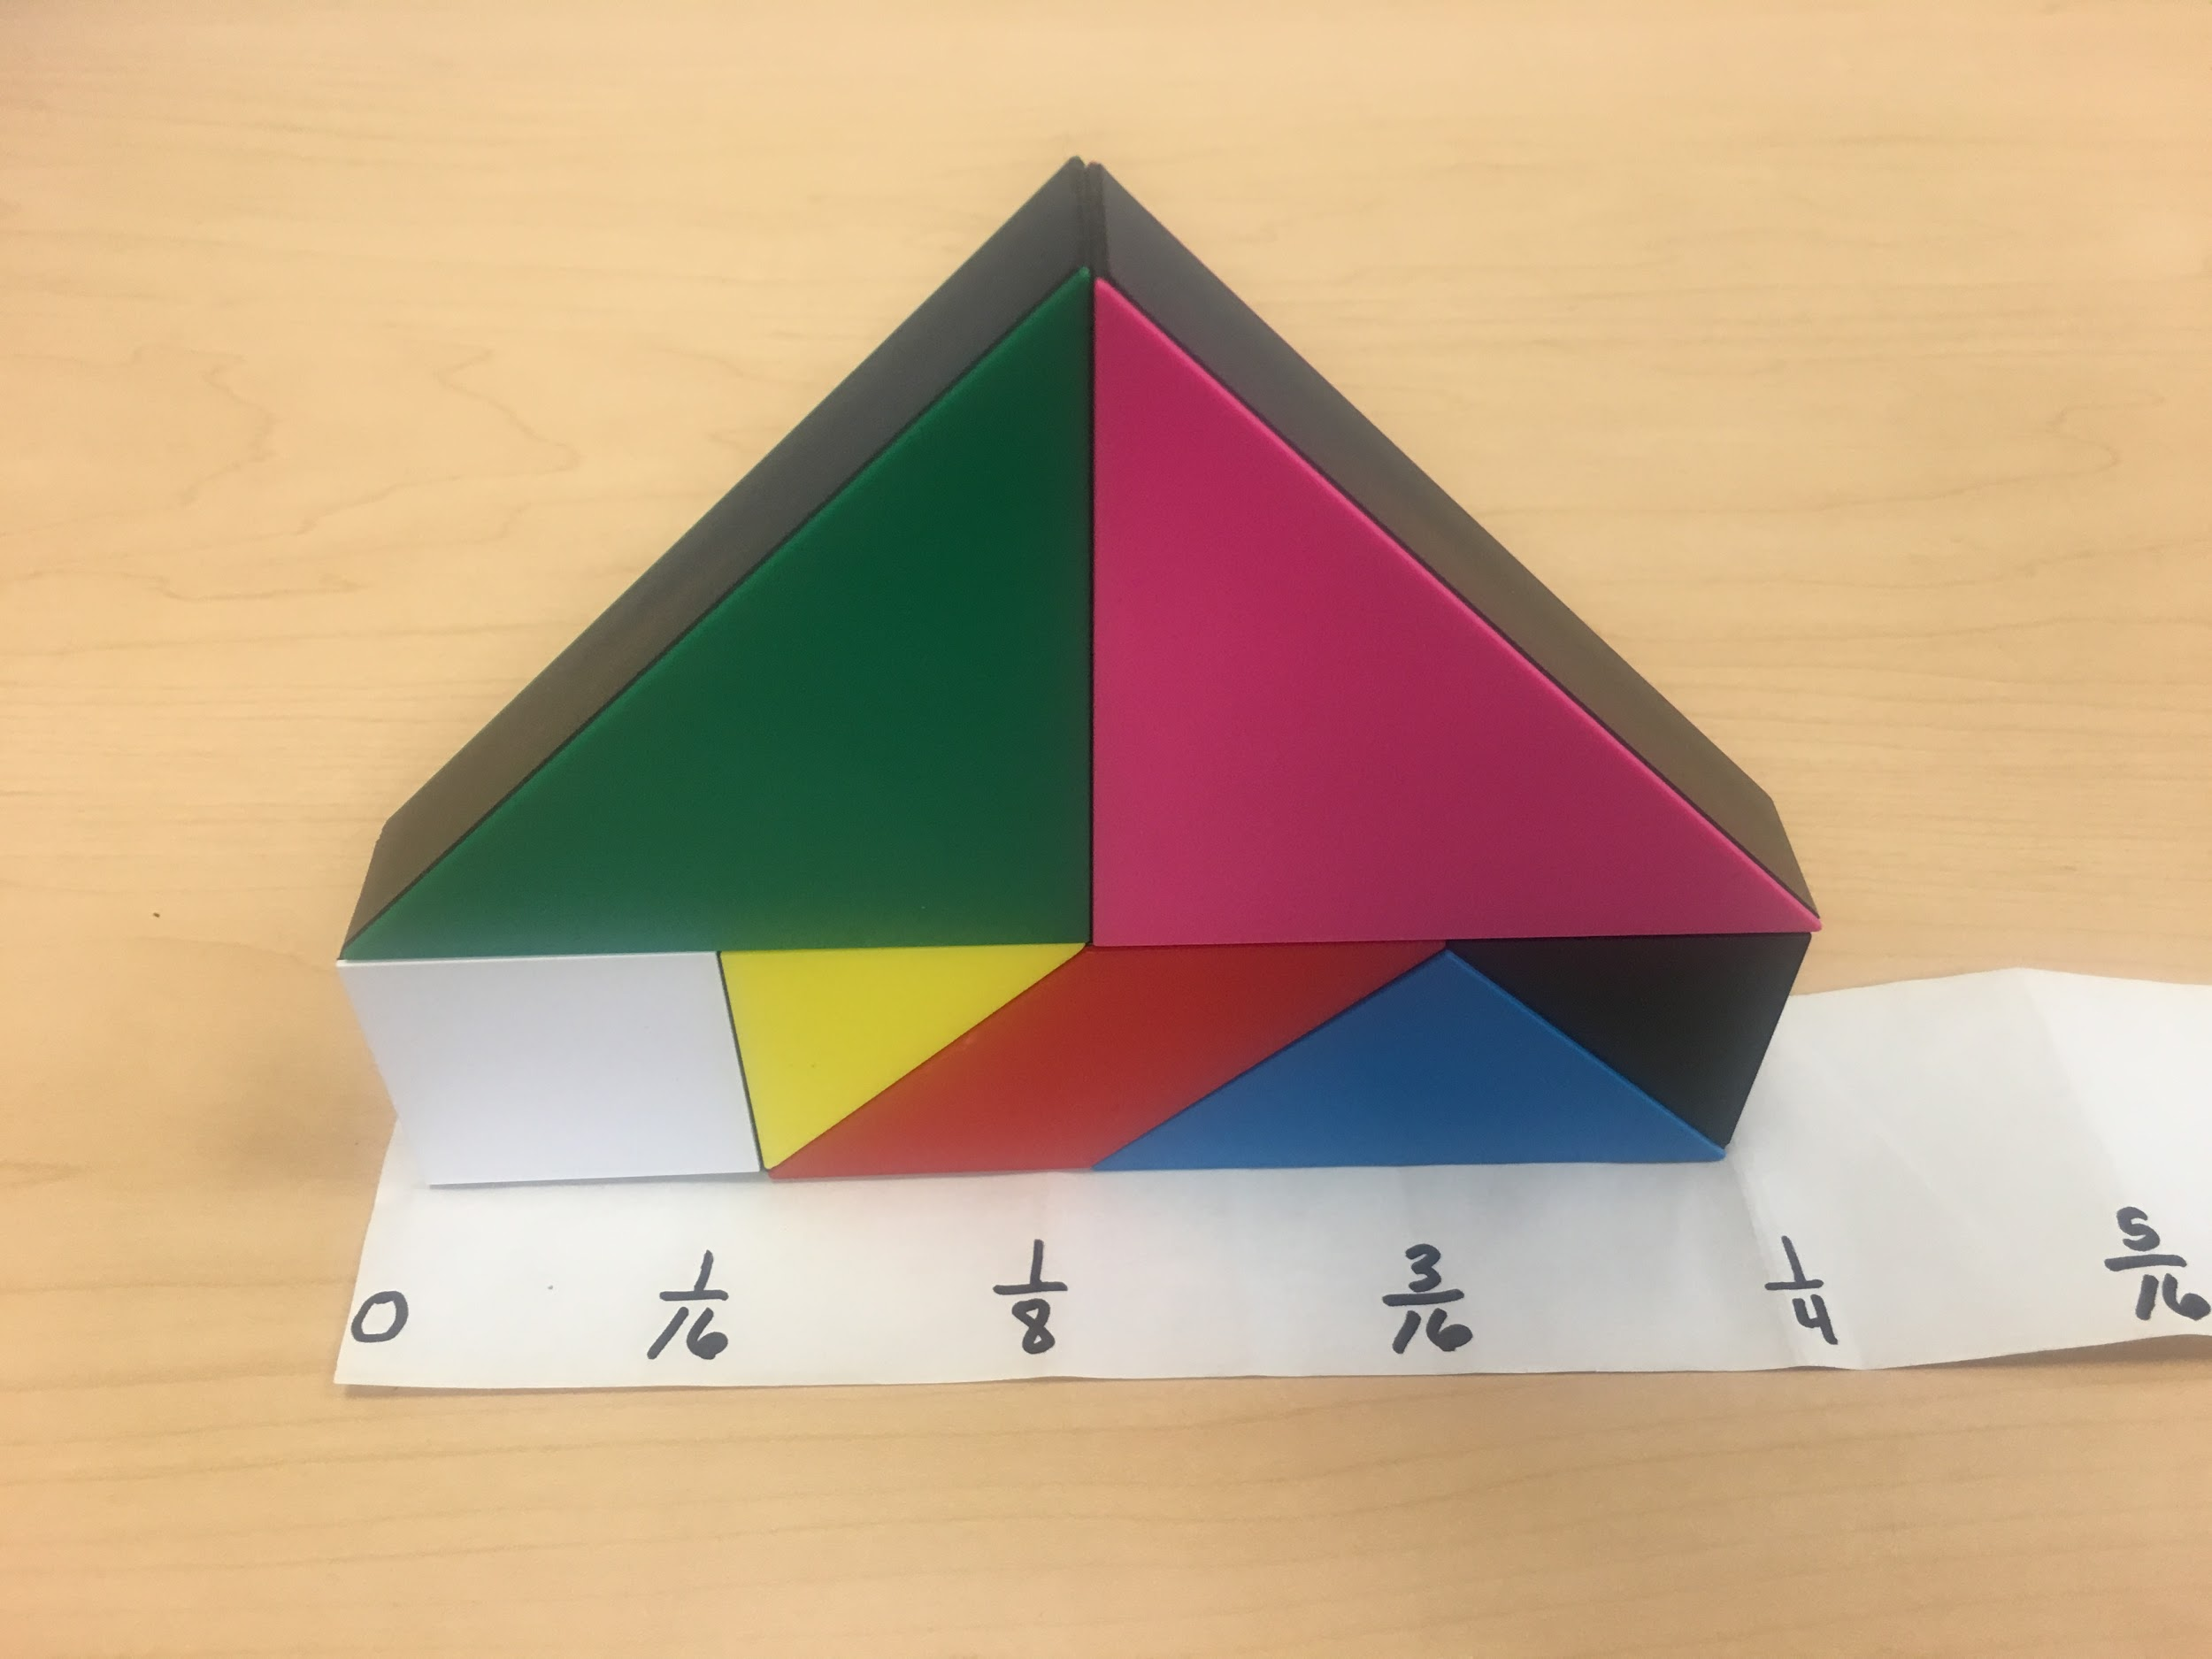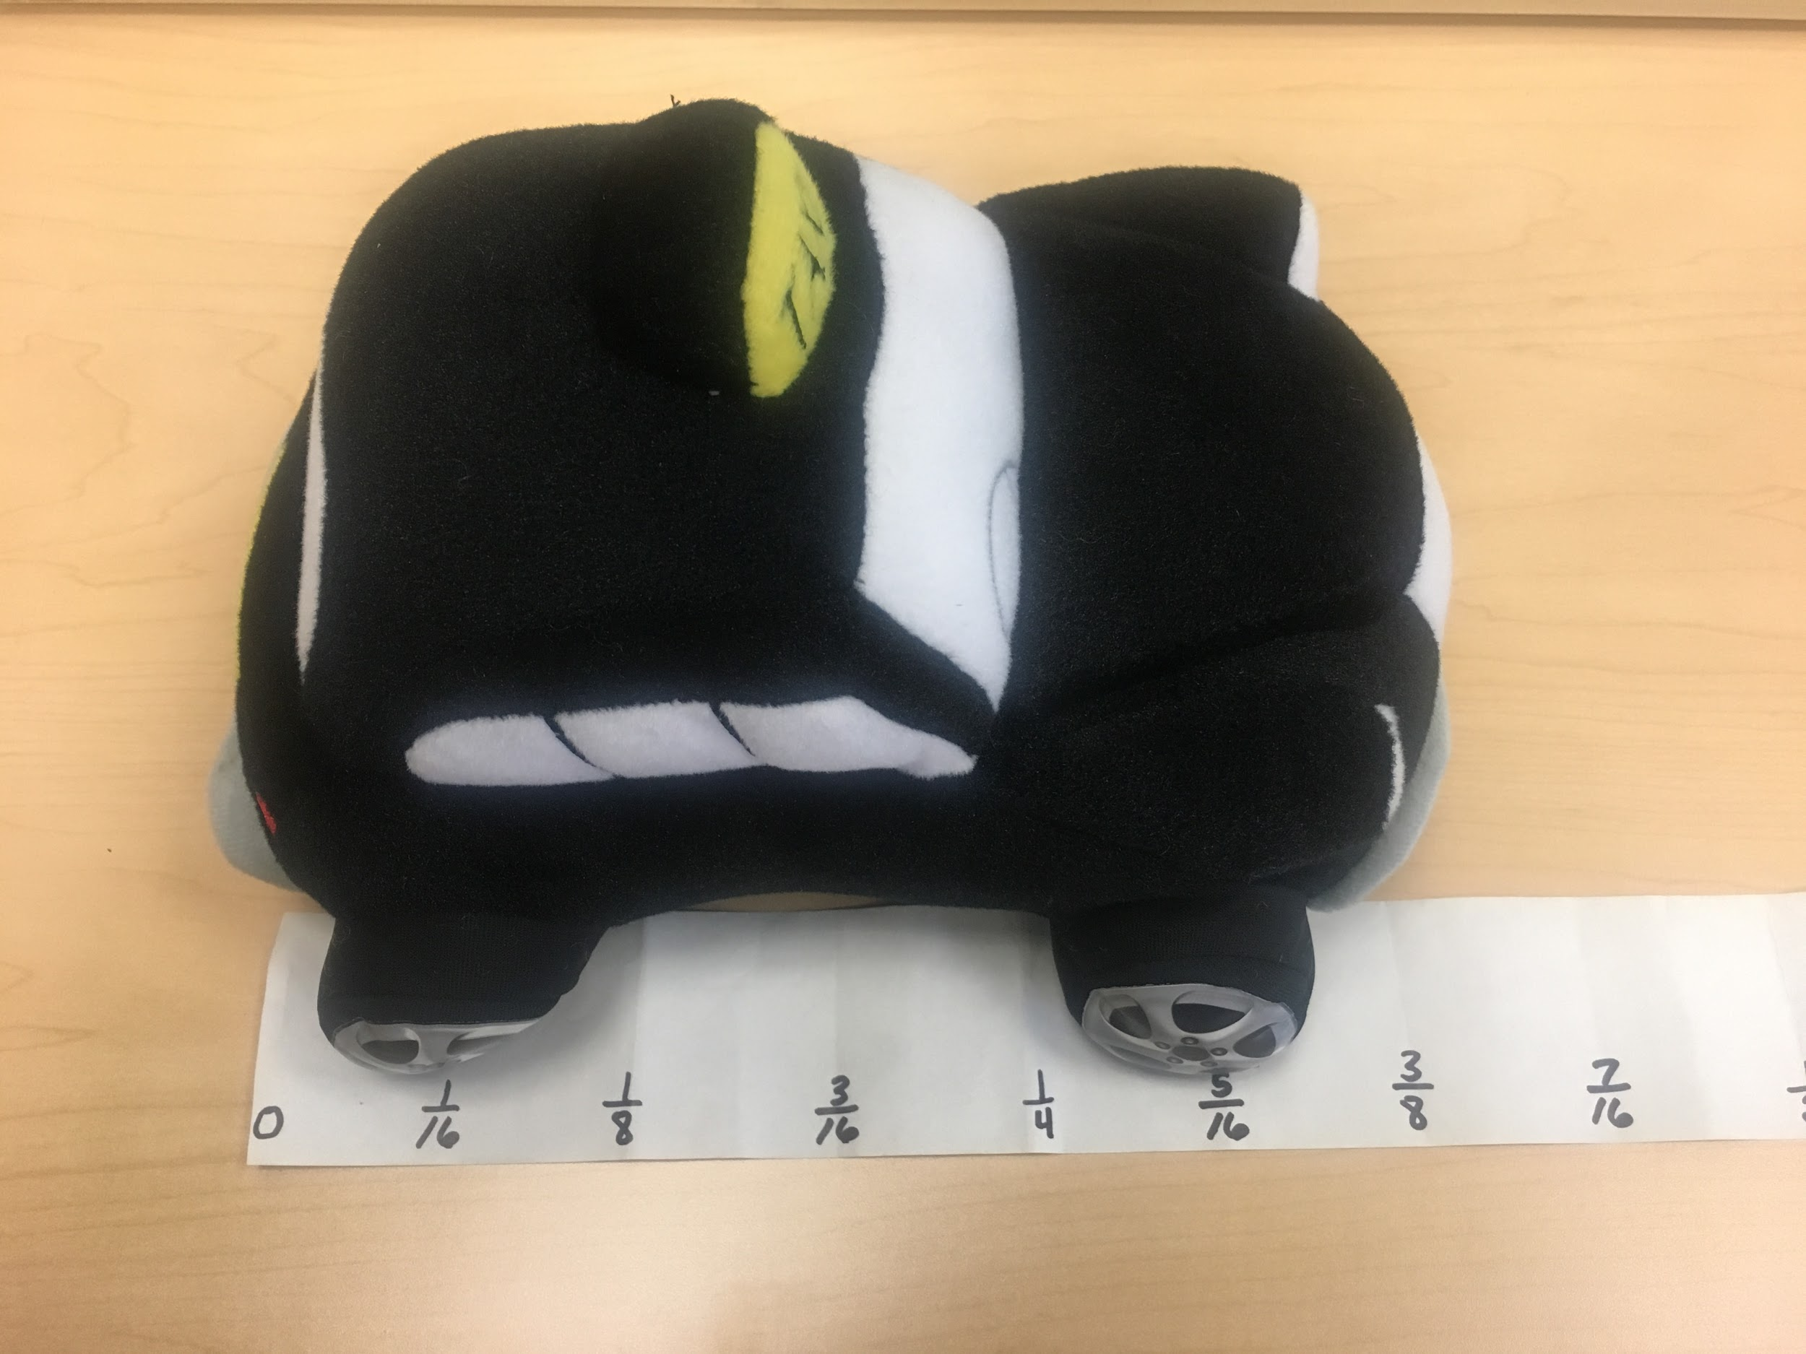
The tangram structure measures close to one quarter of a Zoomboogle, and the black cab measures about three-eighths of a Zoomboogle. Students measured and recorded different objects approximating their measures to the nearest eighth.
After students completed measuring and recording lengths of objects, Ms. Kamala asked them to make a measurement display of the objects they measured with a table showing the objects and the measured length. Students in a virtual setting could collaborate inside of a Google Sheet where they enter each item measured in one column and in another column enter the measure they determined using their personal measuring tape. Another option for students in a virtual setting would be to add images of what they are measuring in Google Slides presentation that can be shared with the class. In Ms. Kamala’s class, groups of students moved around the room to the different displays and verified the measures of the objects using the measuring strip the group had created. Students left notes with questions and feedback for the other groups. Many students commented on the creative names the students used for their measuring strip, while others questioned the estimated value of the measure that was recorded. Still others asked why an object was measured by the dimension that was chosen: “Why did you measure the height of the desk and not the length or width?” After groups had a chance to review the comments and questions left for them, Ms. Kamala began a class discussion by asking, “What challenged you in this activity? How did you respond to that challenge?” She pays particular attention to students who are English learners, highlighting the mathematics vocabulary of words like height, length, and width. Students reflected on their challenges, which centered around measuring to the nearest eighth of a unit and having to estimate the length. Students discussed how they estimated the length and their method for choosing whether to over or underestimate the value.
Finally, Ms. Kamala displayed their different measuring strips and asked them to discuss what they noticed. In a virtual setting, students can make a Google Slides presentation with images showing the items they measured next to their personal measuring strip. Ms. Kamala placed a couple of examples of items measured next to the displayed strips and asked them to discuss the different measures for the same item. Ms. Kamala asked, “We all measured and used the same process to develop our measuring strip. If we measure the same object with two different measuring strips, will the measurements be the same?
Figure 5.5. Sample Student Work
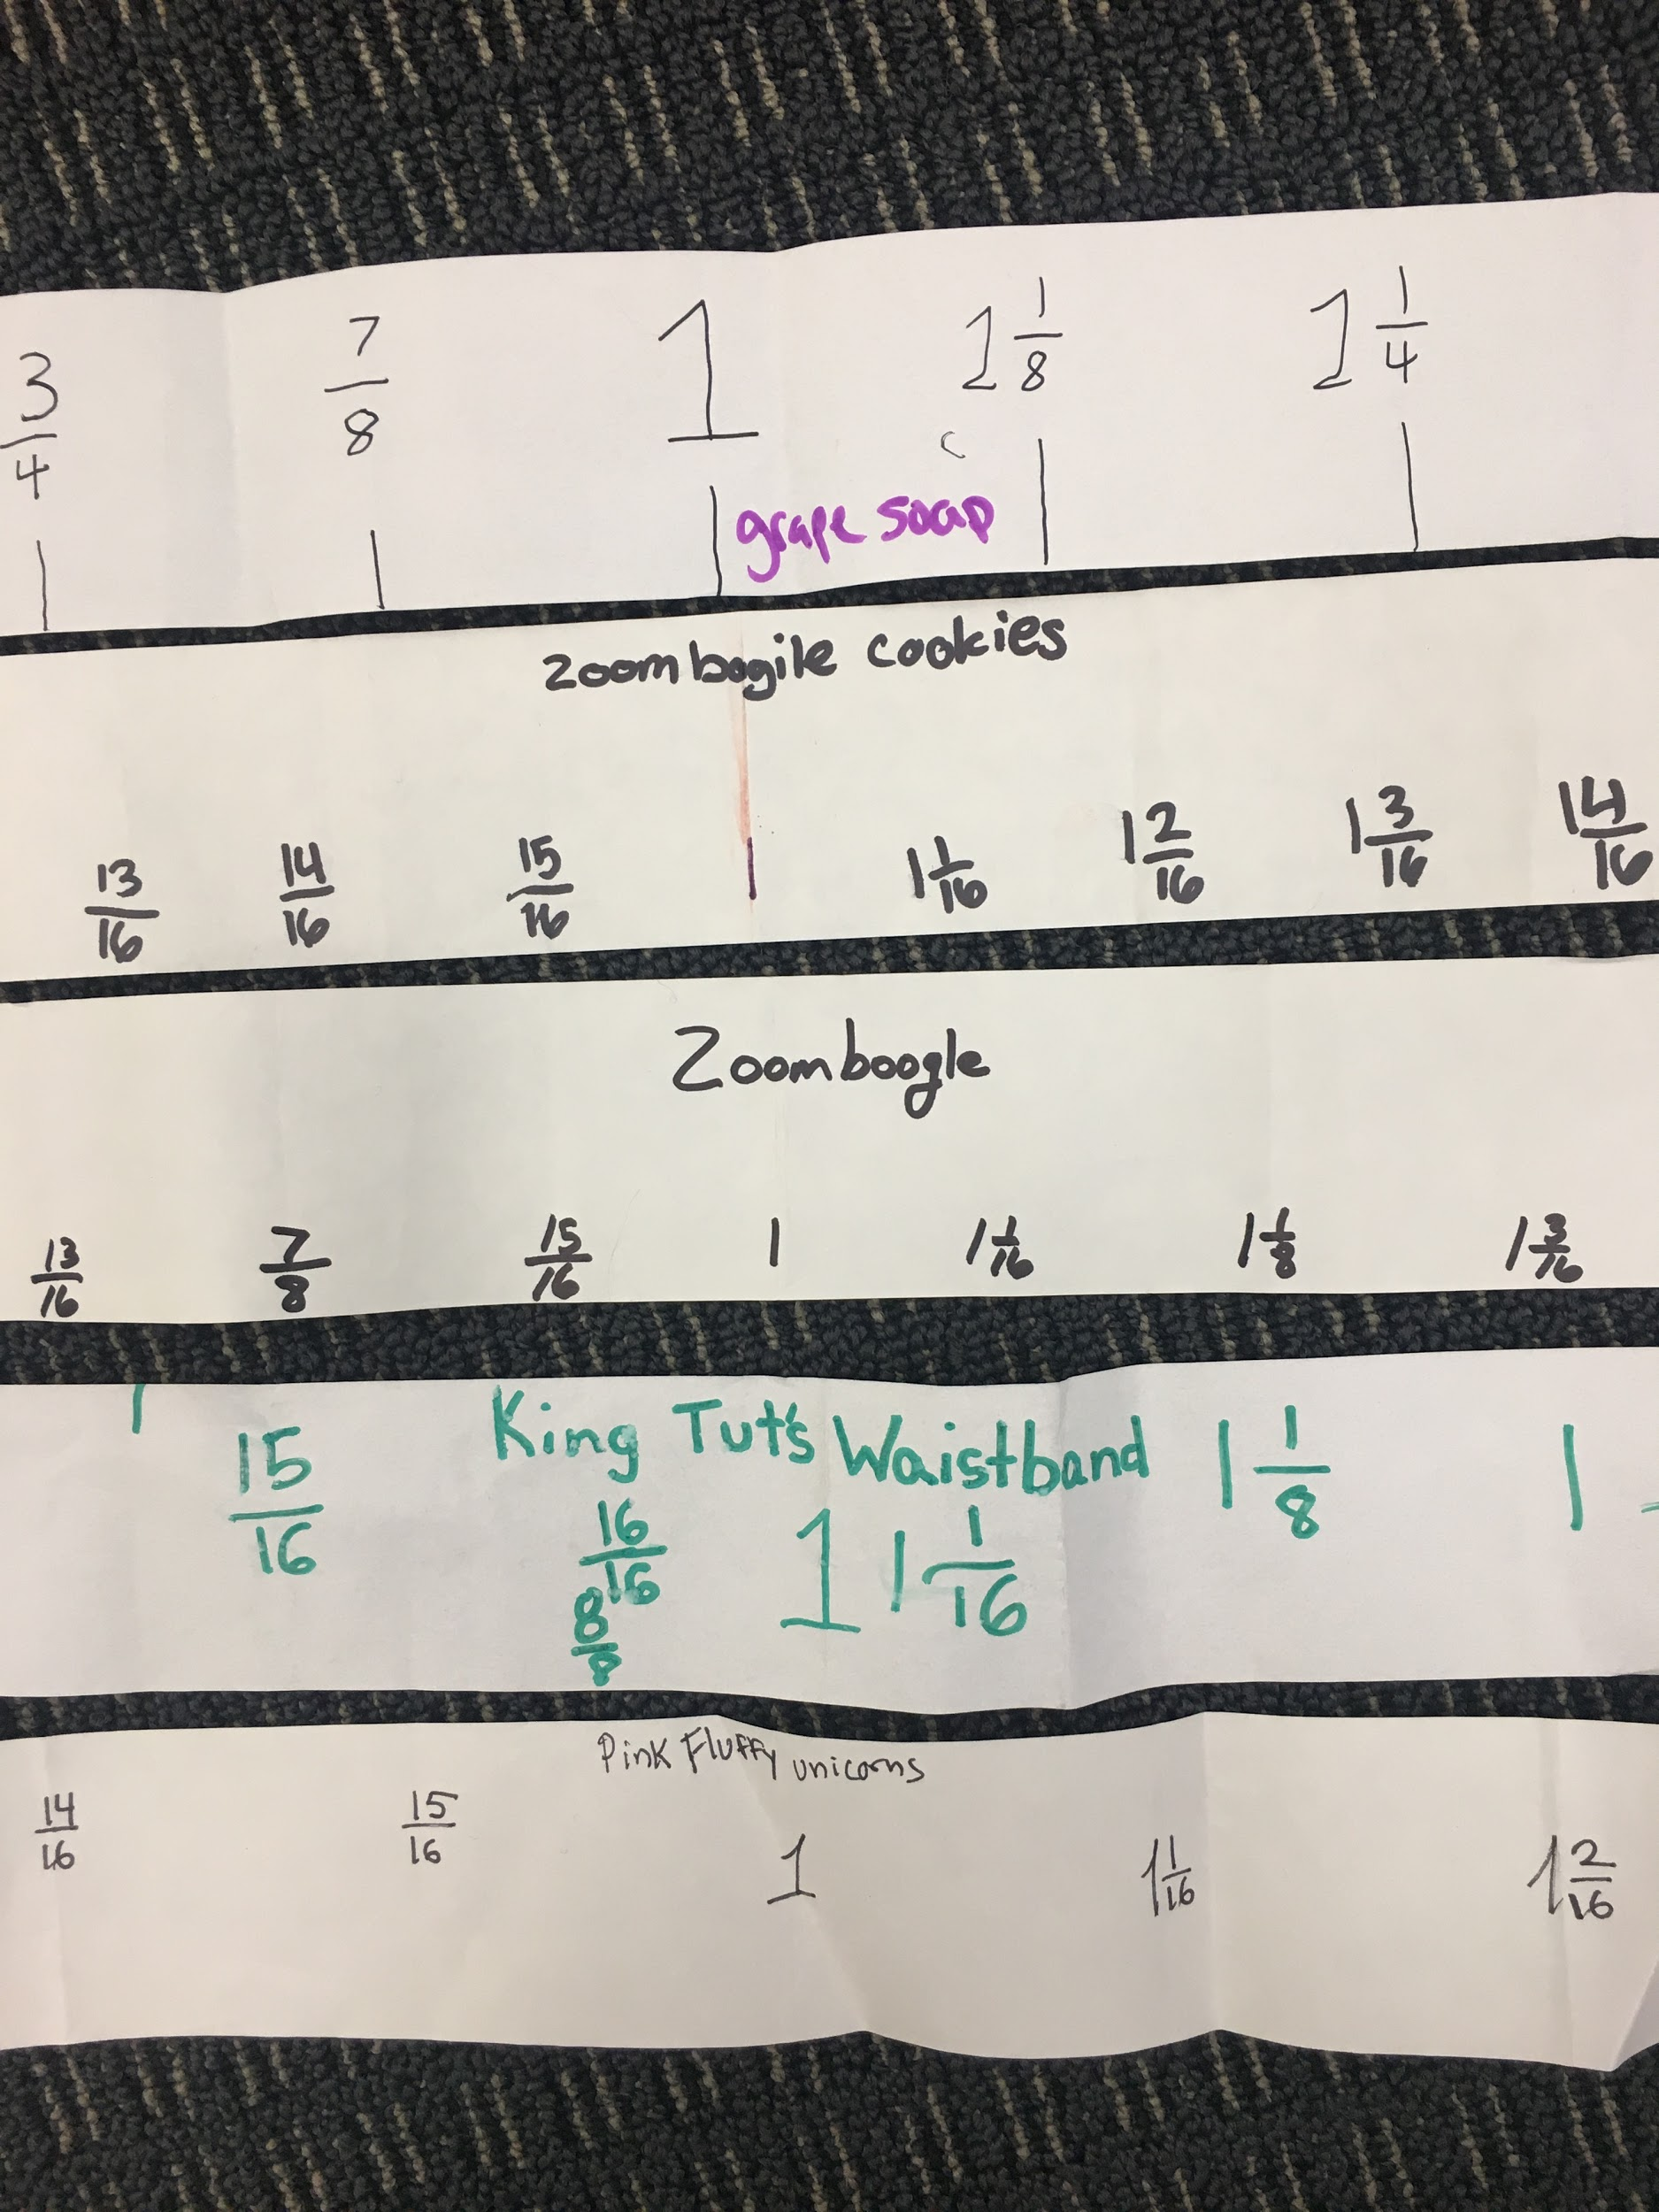
Ms. Kamala encouraged her students to give convincing arguments and to listen carefully to each other, which also provided rich language learning opportunities. Model sentence frames were provided (offering additional support for English learners and other students needing that support), and the teacher dedicated individual and small-group time to ensure student comprehension and to provide oral coaching of the sentence frames. To conclude the activity, Ms. Kamala asked students to write in their journals. The prompt she gave them was: “How are fractions useful when measuring an object?”

Grade Eight Vignette: Teaching to Big Ideas
This activity from the Mathematics Framework includes the grade 8 big idea: “Interpret scatter plots,” which includes standards from the different domains, of “Statistics and probability,” “Expressions and equations,” and “Functions.” It also connects to other big ideas, such as “Data graphs and tables,” “Data explorations,” and “Linear equations.” The low-floor/high-ceiling nature of the task means it could also be used in high school courses of algebra 1 and integrated 1. The activity supports learning inside the Standards of Mathematical Practices: 1. Make sense of problems and persevere in solving them, 2. Reason abstractly and quantitatively, 3. Construct viable arguments and critique the reasoning of others, 4. Model with mathematics, 5. Use appropriate tools strategically, 6. Attend to precision, and 7. Look for and make use of structure. This activity can easily be conducted online, with students drawing from different technology tools as they work.
Investigating Mammals. Grade 8.
Students are introduced to the Common Online Data Analysis Platform (CODAP), a website providing free educational software for data analysis. After a brief introduction to the technical capabilities of CODAP and a review of terms and concepts to help English learners, students are invited to explore a CODAP database of 27 mammals. The database provides variables, such as the height, mass, speed, life-span, and sleep hours of the mammals. The students quickly become curious and ask questions such as, “Do bigger animals sleep longer?” They plot the two variables with the graph tool and start to notice a relationship; contradictory to what they thought, it seems the bigger animals sleep less. The students start an animated conversation discussing the reasons this might be: “Is it because they are more likely to be predators?” They then move on to investigate another relationship—who sleeps more, plant or animal eaters? The students again notice a relationship as well as an outlier (the rabbit), so they wonder about the rabbit and look at more rabbit data. The students’ investigation of bivariate data and their relationships is filled with moments of curiosity and excitement, as well as important learning. Before concluding the lesson, the teacher dedicates individual and small-group time with the EL students to ensure comprehension and to answer any questions. This activity is well positioned for virtual exploration by students working in small groups. Groups can meet in a Google Hangout room together to discuss and share their findings while they are each working inside the online CODAP data set.
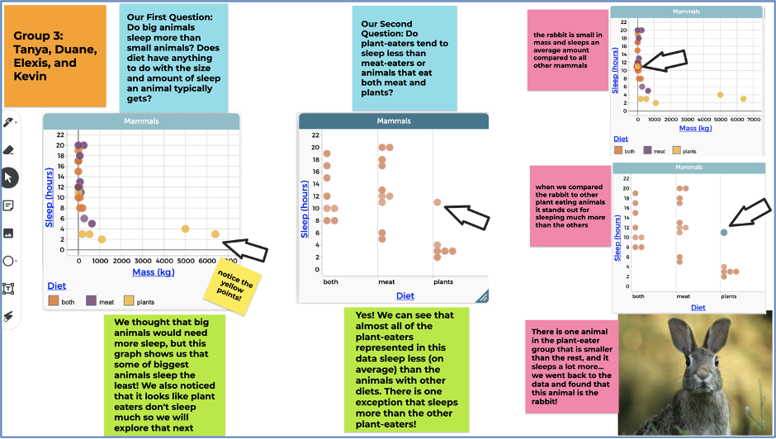
Long description: Sample student data collection board with sticky notes, charts, and pictures. One sticky note has the student names. Another sticky note shares one of the students' question: Do big animals sleep more than small animals? The students answer this question in another sticky note, saying that their graph shows that some of the biggest animals sleep the least. In another sticky note, students ask a second question: do plant eaters sleep less than meat eaters? They answer this in another sticky note that says: Yes! We can see that almost all plant eaters represented sleep less on average. Three more sticky notes share other data findings about the rabbit— One says: the rabbit is small in mass and sleeps an average amount compared to other mammals. Another says that when comparing the rabbit to other plant eaters it stands out for sleeping much more. And a third says: There is one animal smaller than the rest in the plant eaters that sleeps a lot more - the animal is a rabbit. The students also share graphs that show the different relationships they investigated (sleep v. diet, mass v. sleep and diet v. sleep).
Grade Ten Vignette: Teaching to Big Ideas
Vignette from Integrated Course 2: Cable Ready - from high school teachers Lisa Doak, Sally Collins, and Kenny Reisman, from the Interactive Mathematics Program (IMP).
This is an activity that satisfies IM2 big idea: “Equations to predict and model,” which includes standards from the different domains: “Creating equations,” “Reasoning with equations and inequalities,” “Interpreting functions,” “Building functions,” and “Arithmetic with polynomials and rational expressions.” Depending on the directions students decide to take the investigation, the task may also address the big idea of “Circle relationships” and the domain of “Circles,” or the big idea of “Trig Functions” and the domain of “Trigonometric Functions.” The activity supports learning inside the Standards of Mathematical Practices: 1. Make sense of problems and persevere in solving them, 2. Reason abstractly and quantitatively, 3. Construct viable arguments and critique the reasoning of others, 4. Model with mathematics, 5. Use appropriate tools strategically, 6. Attend to precision, 7. Look for and make use of structure, and 8. Look for and express regularity in repeated reasoning.
Activity: Cable Ready
When Madie and Clyde bought their orchard, a straight electrical cable ran along the ground from the center of the orchard, at (0, 0) in their coordinate system, to the point (30, 20).
1. They wanted to start their planting while they waited for the electrical company to move the cable safely underground, but they had to be sure not to plant trees right on the cable. Keep in mind that Madie and Clyde plant trees at every lattice point in the orchard.
Could they plant a complete mini-orchard of radius 1 at the center of their lot without planting right on the cable?
b. Answer the same question for a mini-orchard of radius 2.
c. What is the radius of the biggest complete mini-orchard Madie and Clyde could plant without planting on the cable? Assume the tree trunks are very thin.
2. Suppose Madie and Clyde plant the biggest possible mini-orchard from Question 1c. How big will the tree trunks have to become before one of them bumps into the cable? With your group, prepare a presentation that summarizes your work on Question 2 for presentation to the class. (Interactive Mathematics Program, Activate Learning)
Mathematically, students are trying to find the distance from a point to a line. In this example, they are trying to find the radius of the circle which is tangent to the line AB. In a virtual setting, students can work together in small groups organized in a breakout room. They can work together discussing their strategies and working towards creative solutions using DESMOS or other geometric software.
Figure 5.7. A Visual Representation of the Problem
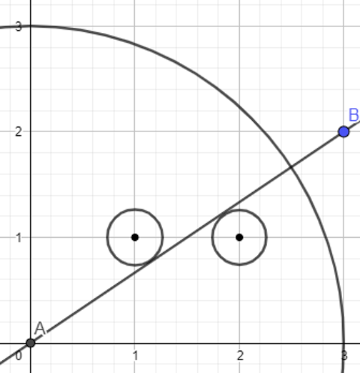
Students have presented several different methods for solving the problem. A sample of those methods are provided below:
(1) Algebraic: As shown in Figure 5.8, students find the equation of the line represented by the cable and then find the equation of the line perpendicular to it through the point (1, 1). They then find the intersection point of those two lines by solving a system of equations. Finally, they find the distance between that intersection point and the center of the tree at (1, 1).
Figure 5.8. An Algebraic Solution
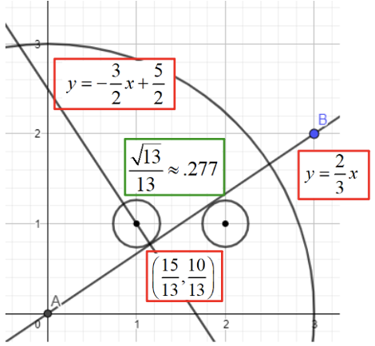

Long description: An algebraic solution to the problem shown visually. A quarter circle is drawn with center at the origin labeled point A with a radius of 3 units. A line is drawn from the origin and through point B located at (3,2). The equation of Line AB is y equals two-thirds x. Another line is constructed through a point located at 15 thirteenths and 10 thirteenths that is perpendicular to line AB. The equation of this line is y equals negative three halves x plus five halves.
(2) Geometric: As shown in Figure 5.9, students use similar triangles found with alternate interior angles of parallel lines, as well as the Pythagorean Theorem, to find the hypotenuse of the larger triangle. The .5 length is established by showing that any line through the midpoint of a segment connecting 2 points is equidistant from the 2 points.
Figure 5.9. A Geometric Solution
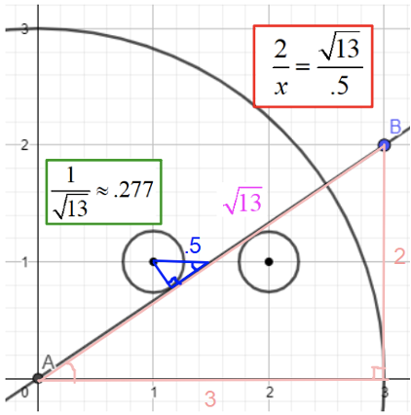
Long description: A geometric solution to the problem shown visually. It shows a quarter circle with center at (0,0) and a radius of 3 units. A line is drawn from the origin to point B at point (3,2). The hypotenuse of the triangle formed by points A,B has a radius of square root of 13.
(3) Trigonometric: As shown in Figure 5.10, students use alternate interior angles of parallel lines for congruent angles.
Figure 5.10. A Trigonometric Solution
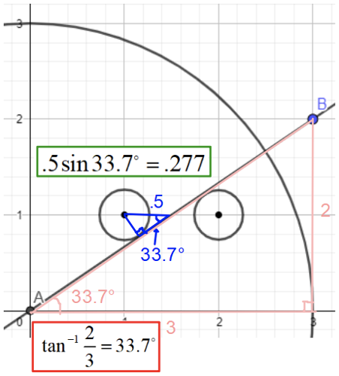
Long description: A trigonometric solution to the problem shown visually. A quarter circle is drawn with center at the origin and labeled point A with a radius of 3 units. A line is drawn from the origin and through point B located at point (3,2). A triangle is constructed from points A, B and a point at (3,0). A circle is drawn with center at point (1,1) with a point on the circle tangent to line AB. A triangle is constructed showing the distance from the circle perpendicular to line AB is .277.

Mathematics through the Key Themes of ELA/Literacy and English Language Development
The relationship between this document and the key themes of the ELA/ELD Framework, can be found in these areas:
Meaning Making: Mathematics, as a lens and a language, has meaning and sense-making as its central purpose. As a lens, mathematics brings patterns, connections, and relationships into focus, allowing students to describe, inspect, and, in many cases, apply these relationships in novel contexts, expanding mathematical knowledge in infinite directions. Mathematics is integral to understanding important human endeavors, such as public health, economic growth, and sustaining the environment, among many others. The recommendation of the Mathematics Framework is that teachers give mathematics problems to students that encourage them to investigate and connect ideas, through the three drivers of investigation shown in Figure 5.1. These drivers give mathematics purpose, as they invite students to use mathematics to understand and explain the world, to describe patterns that can help predict what comes next, or to consider a range of actions to impact the future. Meaning and sense-making is an active process for learners that is intellectually satisfying, propelled by challenging mathematics tasks, supportive instruction, and opportunities to use a full range of classroom and language resources, including collaborators and tools.
Foundational Skills: A foundational skill in mathematics is flexibility. In the area of numbers, the foundational skill is not rote memorization of number facts, but rather numerical flexibility, which leads to number sense (Boaler, 2016). As students learn to investigate with numbers by composing and decomposing numbers, and using different strategies, they learn to make sense of the base-10 number system. The same flexibility is developed with symbol sense in algebra, thinking visually in geometry, and data sense in data science, and onwards. Flexibility allows students to orient themselves and navigate within mathematical terrains.
Language Development: Like all disciplines, mathematics has its own specialized system of encoding and communicating its concepts, knowledge, and understandings over time. This system includes words, numbers, symbols, graphs, diagrams, and, increasingly, many other forms of visual displays. Knowing a term or expression is to have a clear understanding of how to use it in a particular context and be aware of its relationship to other words. For students, and in particular for EL students, it is useful to identify and develop the high-utility academic vocabulary within units of study. Students can also be provided opportunities to utilize their native tongue when they are initially learning concepts (see also Gutierrez, 2018). Teachers can build understanding of how these words are enacted, defined, and used in mathematical ways, text, and tasks over time. Academic vocabulary includes general abstract words used across disciplines (e.g., compare, measure, evaluate, analyze, induce, deduce), abstract discipline-specific words (e.g., proportionality, equivalency, function), and technical discipline-specific words (e.g., variable, diameter, volume, cube, monomial, segment, numerator, hypotenuse). To engage in effective disciplinary discourse and produce using the mathematical register, students need multiple experiences with the forms and structures of the discipline’s genres: problem solving, argument, explanation, and procedure. Teachers can support students who are English learners by examining the language demands and language opportunities of texts and tasks and by guiding the deconstruction and/or co-construction of text and tasks for a particular purpose. Over time, students learn to read and write using the particulars of grammar and syntax of mathematics conventions, while also inventing their own representations, visuals, and inscriptions to express their emerging ideas. In this way, students develop their own mathematical voice and mathematical perspective, which they use to express themselves.
Effective Expression: While outdated stereotypes cast mathematics as a solitary enterprise, mathematics is continually built from and with a community of learners. By participating in classroom communities, for example, students learn to express themselves mathematically in a variety of forms. Reasoning is at the heart of the discipline of mathematics, and students learn to reason when they share their emerging ideas with each other, justify their thinking, act as skeptics for each other, and defend their methods and approaches. Classrooms are effective when teachers encourage students to share their conjectures, or mathematical ideas that students are not yet sure about, which other students can then discuss. Teachers can increase the level of expression for students who are linguistically and culturally diverse learners of English by strategically grouping them with peers who support and/or enhance their sharing of emerging ideas using their language assets, providing purposefully planned and “just-in-time” scaffolds for sustained communications, making explicit the academic language goals, and supporting the development and use of academic vocabulary (general, abstract, and technical discipline-specific). Mathematical communication is an important part of all mathematical work, in employment and in the discipline of mathematics. As students learn to formulate conjectures and then set out to explore and explain their ideas with increasing detail and examples, such as cases, they will learn mathematical communication. As ideas take shape, students may also develop models and arguments to engage stakeholders, audiences, and skeptics. When ideas have sufficiently matured, students may formalize their ideas in the form of proof, constructing a logical chain of reasoning that is validated by the members of the mathematics community. Proofs and other forms of derived results become the basis of new conjectures.

Content Connections in the Mathematics Framework
The big ideas set out in this document have been organized according to the Content Connections (CC) of the Mathematics Framework. Each of these CCs is outlined below:

CC1. Communicating Stories with Data
Data is all around, and an important goal for teachers is helping their students develop data literacy so that they can read and understand data in the world. In the older grades, this develops into an understanding of the important new discipline: data science. In the younger grades, students learn to identify data, measure and classify objects, and make and read data visualizations. In the middle grades, students learn to reason with data using statistical methods, collecting and using data from their lives, and continuing to interpret and make data visualizations. In the high school years, students continue to reason about and with data, and many of the algebraic concepts students learn, particularly functions, can be learned through data investigations. This area of mathematics lends itself to integration of mathematics with other disciplines, such as science and social sciences, as well as with data students meet and care about in their lives. It also provides extensive opportunities to show how mathematics and data science can be utilized to address social injustices and inequities, as students investigate topics such as redlining voter suppression, wealth gaps, food insecurity, agriculture, the environment, and healthcare (Berry III et al., 2020; Gutstein, 2007).
The Mathematics Framework defines data science:
Data Science is the process of uncovering the stories hidden within data. It involves collecting, cleaning, wrangling, analyzing, and visualizing data (that is often massive in size) to uncover patterns and trends and communicate them to others. Professional data scientists draw upon mathematics, statistics, and computer science, and think critically about the qualitative features of a data set to find meaning and communicate the results of their inquiries. Data scientists work together to address uncertainty in data while avoiding bias. The terms statistics and data science both refer to the processes and tools of finding meaning in data, and some people use them interchangeably. Statistics traditionally uses theoretical tools to build and evaluate proposed mathematical models, using data from a population of interest. Data science highlights the expansion in computing and visualization tools that have made many more techniques available for finding meaning in data—many relying on innovative visualizations of data that enable major features to be spotted and explored further. Because statistics has become synonymous in much of TK-12 education with a very limited set of procedures (mean, median, standard deviation, interquartile range, correlation, and linear regression, along with a few data visualizations, such as line plots and scatter plots), this Framework uses data science to emphasize the full statistical and data science investigation process (see Figure 5.12). Students experience statistical tools in the process of investigating authentic questions.
Figure 5.12. The statistical and data science investigation process, from GAISE 2020 (Franklin & Bargagliotti, 2020)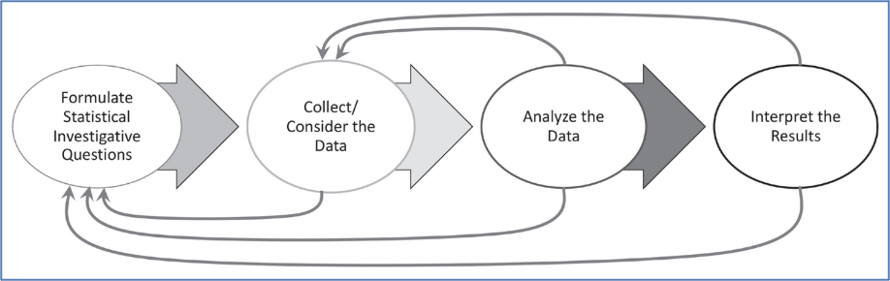

CC2. Exploring Changing Quantities
One of the most powerful uses of mathematics in school and in the world is making sense of change. In the early grades, students are fascinated to learn that adding to a group of objects gives a different number and that the number can be arrived at in many different ways. As students learn number flexibility and number sense, they will learn to change numbers through the use of different operations, such as addition, subtraction, multiplication, and division. They will also learn about the ways mathematics can be applied to changed quantities in the world (e.g., weight, length, value, and in later grades, speed, and acceleration). Mathematicians must find ways to represent the relationships between quantities in order to make sense of and model complex situations. To explore and make sense of changing quantities is an important area of mathematics that applies across mathematical grades and situations.

CC3. Taking Wholes Apart, Putting Parts Together
An important practice that is a tool for the solving of most mathematical problems is the act of breaking a large problem into smaller parts, which are investigated, solved, then put back together into a whole. All mathematical content can be considered in this way; in this document, and within the Mathematics Framework, the content chosen provides particular insights when it is decomposed into manageable pieces and then re-assembled. When an investigation is included in this area, it is crucial that decomposing and re-assembly is a student task, not one that is taken on by a teacher or a textbook. As students learn to “take wholes apart and put parts together,” they will learn an important mathematical approach to the solving of complex problems.

CC4. Discovering Shape and Space
Visual thinking is an essential part of mathematics, as it helps all students learn and develop important brain connections (Boaler, 2019) and can be encouraged in all mathematical investigations. In all grades, it is important to realize that “visual thinking” or “geometric reasoning” is as legitimate as algebraic or computational thinking. In the early grades, students describe their worlds using geometric ideas, taking time to explore the nature of shapes and spaces in the world. As students move through the grades, they should continue this focus, also breaking shapes apart, and combining them, and relating them to measurement. Three-dimensional visualization and modeling are important 21st century understandings intrinsic to many jobs. Geometry software helps this area of mathematics come to life and is especially important in the high school years. The Mathematics Framework supports visual thinking by defining congruence and similarity in terms of dilations and rigid motions of the plane, and emphasizing physical models, transparencies, and geometry software.

Number Talks through the Grades TK–12
Number sense—the ability to use, adapt and think flexibly with numbers—is an important mathematical foundation and a precursor to higher level mathematics achievement. Number sense is a “big idea” that extends across all of the grades. A pedagogical practice that is highly effective for encouraging number sense is a “number talk,” sometimes referred to as a “math talk” and related to the practice of a “number string.” These can be used with students of all grade levels, including college students. The structure of a number talk is the following: The teacher gives a number problem to the class of students and asks students to think, mentally, about a way to solve it, without pen and paper. The teacher then asks for the different answers that may be produced and asks students to defend their answers using mathematical reasoning. Teachers can engage EL students in number talks by providing purposeful sentence frames and open-ended questions to build extended conversations, build fluency, and encourage struggle, which is important for brain development. Number talks provide powerful language models for EL students. This structure may be adapted in different ways. For example, students can turn and talk to partners before sharing their solutions. Students who are English learners are encouraged to use their language assets in English and native languages and might be partnered with peers accordingly. As students are using language to convey mathematical ideas, it helps with the development of language and reasoning as set out in the California English Language Development (CA ELD) Standards. In the course of a number talk, students often adopt methods that another student has presented that make sense to them. Number talks, designed to highlight a particular type of problem or useful strategy, serve to advance the development of efficient, generalizable strategies for the class. These class discussions provide an interesting challenge, and teachers can create a safe place in which students can explore, compare, and develop strategies.
Effective number talks can advance students’ capacity for collaborative, interpretive, and productive communication, helping them develop a positive mathematical identity. They show something important - that mathematics problems can be approached in different ways; they highlight mathematical creativity, and they support the development of number sense. Number talks also integrate mathematics content and mathematical practices, especially Standards collaborative for Mathematical Practice (SMP) 2, 3, 4, 6, 7, and 8.
Number talks can be enacted using technology during distance learning. A teacher can put the number problem on a Jamboard or other interactive white board space, and ask the class to share their thinking, recording the student work onto the Jamboard. The following examples include excerpts from the Mathematics Framework.

Number Talks TK–2
Several types of number talks are appropriate for grades TK–2. Some possibilities include the following:
- Dot talks: A collection of dots is projected briefly (just for a few seconds), and students explain how many they saw and the method they used for counting the dots. A teaching example can be seen at this link.
- Ten frame pictures: An image of a partially filled 10-frame is projected briefly, and students explain various methods they used to figure out the quantity shown in the 10 frames.
- Number problems: Written in horizontal format, either an addition or subtraction problem is presented, involving numbers that are appropriate for the students’ current understanding. Presenting problems in horizontal format increases the likelihood that students will think strategically rather than limit their thinking to an algorithmic approach. For example, first graders might solve 7 + ? = 11 by thinking “7 + 3 = 10, and 1 more makes 11.” Second graders subtract two-digit numbers. To solve 54 - 25 mentally, they can think about 54 - 20 = 34, and then subtract the 5 ones, finding 34 - 5 = 29.

Number Talks 3-5
Number talks in grades 3–5 can strengthen, support, and extend place value understanding, calculation strategies, and fraction concepts.
Some examples of problem types might include the following:
- Students can perform multiplication calculations using known facts and place value understanding and apply properties to solve a two-digit by one-digit problem. For example, if students know that 6 x 10 = 60 and 6 x 4 = 24, they can calculate 6 x 14 = 84 mentally. Presenting such calculation problems in horizontal format increases the likelihood that students will think strategically rather than limit their thinking to an algorithmic approach.
- Students can use relational thinking to consider whether 42 + 19 is greater than, less than, or equal to 44 + 17, and explain their strategies.
- Asking students to order several fractions mentally encourages the use of strategies, such as common numerators and benchmark fractions. For example, students can arrange in order, least to greatest, and explain how they know: 4/5, 1/3, 4/8.

Number Talks 6-8
In grades 6–8, number talks can include a focus on order of operations, and involve irrational numbers, as well as percents and decimals.
Some examples of problem types for Math Talks at the 6–8 grade level might include the following:
- Order of operation calculations allow students to apply properties to help simplify complicated numerical expressions. For example, 3(7 – 2)^2 + 8 ÷ 4 – 6 x 5.
- Students can use operations involving irrational numbers to ask the following questions: “2/3 of pi is approximately how much?” and “Four times sqrt(8) is closest to which integer?”
- Students can solve percent and decimal problems, reflecting on the following questions: “What is 45% of 80?,” “Calculate the percent increase from 80 to 100,” or “0.2% of 1000 is how much?”

Number Talks 9–12
Number talks in grades 9–12 can strengthen, support, and extend algebraic simplification strategies involving expressions, connect algebra concepts to geometry, and provide opportunities to practice estimation of answers. Also, many number talks from grades 6–8 (see previous section) are still readily applicable in grades 9–12, as they can lay valuable groundwork for algebraic understanding. For example, strategies that make use of place value and expanded form of multiplication problems, such as 134 times 36, can be employed to understand multiplication of binomials.
Some examples of number talks appropriate for grades 9 and upwards include the following:
- Which graph doesn’t belong? Various collections of graphs could be used, where all but one graph agree on various characteristics. The ensuing conversations help students attend to precision in the graphs and with their language (SMP.6) as they talk out the underlying causes of the differences between the graphs. For example, four graphs of polynomial functions could be displayed, with three odd-degree polynomial and one even-degree polynomial, which can highlight the notion of how the terms even and odd are used with regard to polynomials. Another example could be where one function displayed has multiple real roots, while the others have single or no real roots.
- Students can rewrite expressions using radical notation. There are often multiple approaches to simplifying expressions, so these can serve as excellent discussion points for students to see a variety of ways to approach simplification.
- Similarly, there is merit in sharing and discussing the myriad of ways to approach multiplying monomials, binomials, and trinomials (e.g. (x+y)(3x-2y)), including algebraic properties, such as the distributive property and generic rectangles.

Number Talk Resources
Some additional number talk resources include, but are not limited to, the following:
- San Francisco Unified School District has compiled a comprehensive page of resources for using Number Talks.
- Inside Mathematics includes video examples of number talks from classrooms, grade one through grade seven.
- Activities, videos, and research findings for number talks can be found on YouCubed, a website that includes a page with resources dedicated to number sense and number talks.

Data Talks TK-12
Like “number talks,” data talks offer a short pedagogical routine to help students develop data literacy. Instead of sharing a number problem, teachers can show a data visualization and ask students open questions such as “What do you notice?” or “What do you wonder?” or “What is going on in this data visualization?” Students can be engaged with real data from the world, and it is an ideal opportunity to help develop awareness of social justice issues. Teachers can encourage student noticing and questions, without needing to have knowledge of the topic of the data visualization. The idea of a data talk was inspired by a New York Times weekly section called, “What’s Going on in this Graph?” in collaboration with the American Statistical Association. If teachers cannot answer student questions, they can model the important practice of being comfortable with uncertainty and being curious to find out more. The New York Times data visualizations are mainly suitable for students in middle school and older grades. For students from the TK-12 grades, YouCubed shares several “data talks.” Many of the data visualizations illustrate how multiple variables can be incorporated into one graphic, which allows students to think in multivariable ways.

Data Talk Resources
- YouCubed provides activities, videos, and research findings for data talks.
- The New York Times provides various visualizations of real data that educators and students can discuss to foster a mathematics discourse.
- Educators can use various visualizations featured on the Slow Reveal Graphs website to facilitate discourse about data and their implications.

Chapter 6: Mathematics in Transitional Kindergarten through Grade Two
Figure 6.1. A Progression Chart of Big Ideas through Grades TK–2
Content Connections | Big Ideas: Grade TK | Big Ideas: Grade K | Big Ideas: Grade 1 | Big Ideas: Grade 2
Communicating Stories with Data | Measure & Order | Sort & Describe Data | Make sense of Data | Represent  Data
Communicating Stories with Data | Look for Patterns | n/a | Measuring with Objects | Measure & Compare Objects
Exploring Changing Quantities | Measure and Order | How Many? | Measuring with Objects | Dollars and cents
Exploring Changing Quantities | Count to 10 | Bigger or Equal | Clocks and Time | Problem solving with measures
Exploring Changing Quantities | n/a | n/a | Equal Expressions | n/a
Exploring Changing Quantities | n/a | n/a | Reasoning about Equality | n/a
Taking Wholes Apart, Putting Parts Together | Create Patterns | Being flexible within 10 | Tens and Ones | Skip Counting to 100
Taking Wholes Apart, Putting Parts Together | Look for Patterns | Place and position of numbers | n/a | Number Strategies
Taking Wholes Apart, Putting Parts Together | See and use Shapes | Model with numbers | n/a | n/a
Discovering shape and space | See and use shapes | Shapes in the world | Equal parts inside shapes | Seeing fractions in shapes
Discovering shape and space | Make and measure shapes | Making shapes from parts | n/a | Squares in an array
Discovering shape and space | Shapes in space | n/a | n/a | n/a
In the primary grades, students begin the important work of making sense of the number system, implementing SMP.2 to “Reason abstractly and quantitatively.” Students engage deeply with Content Connection 3 (CC3, Taking Wholes Apart and Putting Parts Together), as they learn to count and compare, decompose, and recompose numbers. Building on a TK understanding that putting two groups of objects together will make a bigger group (addition), kindergarteners learn to take groups of objects apart, forming smaller groups (subtraction). Students develop meanings for addition and subtraction, as they encounter problem situations in transitional kindergarten through grade two. They expand their ability to represent problems, and they use increasingly sophisticated methods to find answers.
Big ideas of number in TK–2 include the following (Boaler, Munson, & Williams, 2020):
- Organize and count with numbers.
- Compare and order numbers on a line.
- Operate with numbers flexibly.
The big ideas of data in these early grades include the following:
- Data for understanding: What questions can be asked? What data are needed to answer it?
- Defining data: What is data? How was the data collected?
- Representing and interpreting data: What does data look like, and what does it mean?
In grades TK–2, students learn to distinguish between categorical (non-numerical) data and measurement or quantitative data. For instance, consider a set of colored blocks in the classroom. “Color” is a categorical variable that students could observe about each block. “This block is 15 centimeters long” is a measurement data point. The standards develop categorical data in grades K–3 and measurement data beginning in grade two.
Figure 6.2. Examples of Categorical and Quantitative Data
Types of Data | Examples
Quantitative (or Measurement) data | - Color (red, green, blue, yellow) of blocks in the class set  - Species of trees on the school grounds  - Ice cream flavors, such as strawberry, chocolate, and vanilla
Quantitative (or Measurement) data | - The temperature of different drinks  - Number of pages (or weight, or height) of books in the classroom  - Number of students in different classrooms
Shape and space are important parts of TK–2 since students are learning to make sense of the world around them, while noticing patterns, common shapes, along with their attributes. As students develop their understanding of plane figures, while noting sides, angles, and similarities and differences across plane figures, students move on to see that plane shapes make up the faces of solids. The importance of shape and space is heightened by the mathematical thinking that goes into defining and describing the world, as well as students building their academic vocabulary and ability to communicate their reasoning. Patterning is another critical area. Recognizing a pattern well enough to continue it or fill in missing pieces and then generalizing the pattern is crucial to mathematical development. It is important that students focus on the unit that repeats and makes the pattern since the idea of a “unit” is used throughout TK–12 mathematics.
Students can be surrounded with a wealth of two dimensional (2-D) and three dimensional (3-D) manipulatives where they can build and create, noting the composition and decomposition of the shapes that make up the world. In an online environment, teachers can ask students to look through their area for 2-D and 3-D objects. Pebbles, stones, boxes, or other items can be stacked. Describing and noticing the shapes that make up other complex shapes is an important creative way to make sense of the space around them. Students can upload pictures of what they create and describe and classify their creations. In a purely online environment, students can use the geometry in Desmos to create 2-D and 3-D shapes. Creating 2-D images of 3-D shapes is a wonderful learning experience. TapTap Blocks is a free and fun space for building in 3-D on an Apple device. Tinkercad is another option for 3-D building.
The following interview highlights an educator who is using digital tools to help students build foundational concepts introduced in this grade span.
Voices from the Field: Lisa Nowakowski | King City Union School District | King City, CA
“Helping teachers find engaging and effective ways to teach mathematics via distance learning comes down to finding the right tools for the job,” says technology coach Lisa Nowakowski. Just as she teaches students to build on existing knowledge and skills when solving math problems, Nowakowski tailors her educational technology recommendations to teachers based on what they and their learners already know. She looks for tools that are easy to adapt to existing practices and readily enhance learning experiences without putting additional strain on teachers and students.
In her 26 years as an educator, Nowakowski has taught everything from kindergarten through fifth grade and is currently a technology coach for the King City Union School District in California’s central coast. She shares how she collaborates with teachers to integrate technology efficiently and dynamically to teach math to elementary students.
How have you been helping teachers and students thrive through distance learning?
Several years ago, I developed MathReps for my fifth graders. The idea was to help them practice and retain math skills because, by the end of the year, they would get rusty and forget concepts they learned at the beginning of the year. As I developed the lessons, which were making a huge difference with my own students, I posted them online, free for other teachers to use. When we went to distance learning, teachers have shared with me that they’ve been adapting these resources using digital tools. For example, Flipgrid [video-based discussion software] and Jamboards [collaborative digital whiteboards] were used to allow students to not only show their work, but also explain and talk to each other about how they got their answers.
In what ways do you employ digital tools to enhance what may be done in a traditional classroom setting?
I just ran this activity in a class of first graders with a puzzle that had pictures of four dogs. They learned to articulate the similarities and differences they saw—this one had spots, or this one was tiny or extra-long, or all of these other dogs are the same height. The activity is adaptable, too, because I then leveled it up for a class of second graders, where they had to verbalize their rationale and also type it out on Nearpod’s [a formative assessment platform] collaborative board. We talked it out so that, just like in a traditional classroom, if you weren’t sure what to do, you could hear other examples and see how other students were thinking about it virtually.
What we're trying to do is still have those group conversations, which are so powerful and needed—and not just for developing math sense. My district has a high number of students who are English learners; it’s really important for them to be talking about these things just to hear the different vocabulary and to practice speaking and listening. Having activities and dedicated space to be able to talk things out is simple, but so powerful.
What’s the best way to balance synchronous and asynchronous learning experiences for students?
What we do is try and make asynchronous assignments engaging and fun—something that isn’t boring and that they may already have familiarity and success with. For the synchronous work, we schedule in the higher level, harder concepts that they need more guidance through. Once they get more proficient at those skills, then those get moved to asynchronous assignments, and so on. The teachers in our district are really just trying to balance the learning experience to make it as engaging and interesting as possible.
How are you using technology to help students learn foundational math concepts?
If you’re having students solve 36+45, for example, and asking them to think about different ways to break these numbers apart, you can use Jamboard [collaborative digital whiteboards], and they can write out their reasoning, like 30+40 and then 6+5 on virtual sticky notes, or if they already know Google Slides, you can have them each make their own presentation or make videos on Flipgrid [video-based discussion software] to explain their logic. Just like when solving math problems, there are multiple paths to the right answer—it’s really whatever tool works best for you and your students.
As the technology coach, people often ask me what the best tool is, and I always tell them it’s really about what they are trying to do and how. We’ll talk about the tools they’re already using and then build from there. I don’t rely on one-size-fits-all recommendations for everyone because, just like we have to be flexible with numbers, we have to be flexible with the tools we use. It’s about finding the right tool for the job.

Transitional Kindergarten
The work of learning to count typically begins in the preschool years. The California Preschool Learning Foundations, Volume 1 includes foundations in mathematics that cover five strands: Number Sense, Algebra and Functions (Classification and Patterning), Measurement, Geometry, and Mathematical Reasoning. These foundations in mathematics support the developmental progression of students from preschool through TK.
In TK, students are working out what numbers mean and how numbers connect to fingers, objects, movement, and each other. Students learn to count objects meaningfully by touching objects one-by-one as they name the quantities, recognizing that the total quantity is identified by the name of the last object counted (cardinality). As students compare numbers, they will later be able to locate them on a line. Number lines are really helpful for students’ learning and have even been found to eliminate differences in numerical reasoning between middle income and lower income students in preschool (Ramani & Siegler, 2008).
Figure 6.3. A Number Line
In TK, kindergarten, and first grade, a more accessible model is a number path. Whereas a number line shows numbers in terms of measurement, a number path is a counting model, which shows numbers as rectangles.
Figure 6.4. A Number Path
When young students count on a number line, they can miss the numbers and land on the spaces, whereas a number path allows students to count the rectangles.
In TK, students start to compare data and numbers using objects and learn relational vocabulary, such as more, fewer, less, same as, greater than, less than, and more than. Dot card number talks (see Figure 6.4) are an ideal activity for students to learn to subitize, identifying a small group, in this case dots, without counting. Activities can be designed in ways that provide students with a variety of structures to practice, engage with, and eventually master the vocabulary. In TK, students learn to distinguish between categorical (non-numerical) data, such as color, and measurement or quantitative data, such as the height of a plant.
Young children love to build and create. Students can be encouraged to develop creative scenes using 2-D shapes, as well as create linear patterns and arrays of shapes, including composing simple shapes to form complex ones. An important concept for students to learn is that shapes can transform in space and maintain their congruence. For example, a triangle can spin and flip, but it is still the same triangle just oriented in space differently. Allow students time and space to play with shapes. They can be encouraged to describe a shape’s position in space compared to other shapes and start to use language that describes similarities and differences in shapes, as well as magnitude, direction, and distance.
Patterns are a natural beginning to mathematical thinking for young children. This is a time where seeing patterns supports a young learner in making sense of their world. Students can be encouraged to notice patterns in everything they experience, in school and at home, and can be encouraged to describe and communicate the attributes they see and the ways they see the patterns. Students can be asked to describe what would come next, solidifying that they have recognized a pattern. The physical act of building or continuing the pattern is the next important piece in their growth, culminating in their ability to communicate a generalized statement about the pattern. Students who are English learners are encouraged to use their developing English and native language assets and draw on their prior knowledge. Teachers can provide purposefully planned and “just-in-time” scaffolds and supports to engage EL students in sustained mathematical oral discourse in multiple contexts to build academic vocabulary and knowledge.
TK instruction can create rich, effective discussion where students use developing skills to clarify, inform, question, and eventually employ these conversational behaviors without direct prompting. Such instruction supports all students, including EL students, and ensures all learners develop both mathematics content and language. TK students can compare collections of small objects as they play fair share games, deciding who has more; by lining up the two collections side by side, children can make sense of the question and practice the relevant vocabulary. As the students develop understanding in recognizing numerals, they can play games with cards. The use of fingers is particularly important for students of this age, as they can represent early ideas of a number line. For a range of finger numerical activities, see YouCubed.
Critical Areas of Instructional Focus
Figure 6.5. Grade TK Big Ideas
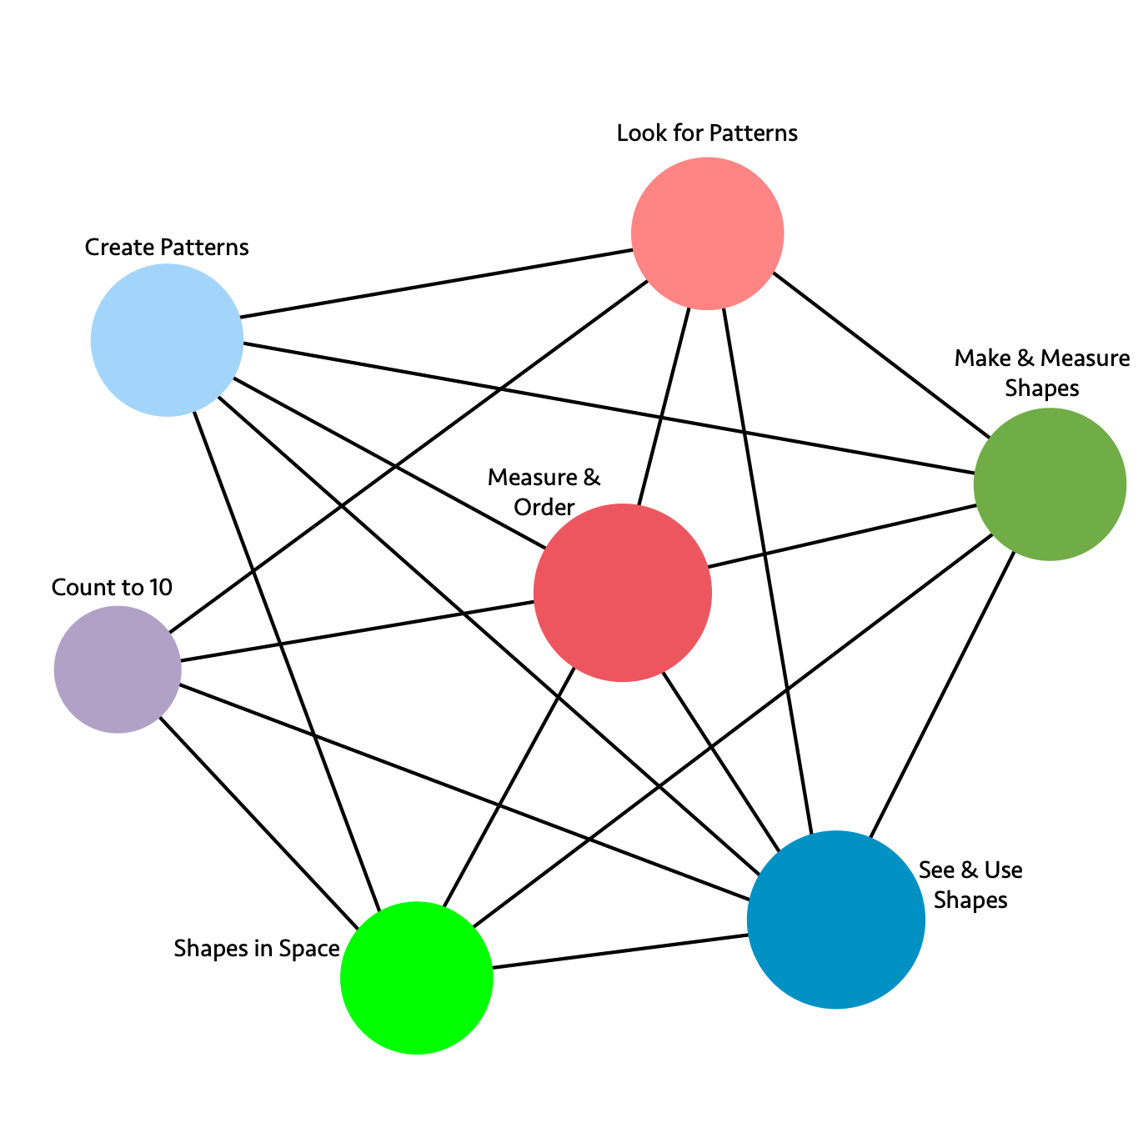
Long description: The graphic illustrates the connections and relationships of some transitional-kindergarten mathematics concepts. Direct connections include:
- Look for Patterns directly connects to: Create Patterns, Count to 10, Measure & Order, See & Use Shapes, Make & Measure Shapes
- Make & Measure Shapes directly connects to: Look for Patterns, Create Patterns, Measure & Order, Shapes in Space, See & Use Shapes
- See & Use Shapes directly connects to: Make & Measure Shapes, Look for Patterns, Measure & Order, Create Patterns, Count to 10, Shapes in Space
- Shapes in Space directly connects to: See & Use Shapes, Make & Measure Shapes, Measure & Order, Create Patterns, Count to 10
- Count to 10 directly connects to: Shapes in Space, See & Use Shapes, Measure & Order, Look for Patterns
- Create Patterns directly connects to: Look for Patterns, Make & Measure Shapes, See & Use Shapes, Measure & Order, Shapes in Space
- Measure & Order directly connects to: Look for Patterns, Make & Measure Shapes, See & Use Shapes, Shapes in Space, Count to 10, Create Patterns
Figure 6.5a. Grade TK Content Connections, Big Ideas, and Standards
Content Connection | Big Idea | TK Standards
Communicating Stories with Data  &  Exploring Changing Quantities | Measure and Order | AF1.1, M1.1, M1.2, M1.3, NS2.1, NS2.3, NS1.3, G 1.1, G2.1 NS1.4, NS1.5, MR1.1, NS1.1, NS1.2: Compare, order, count, and measure objects in the world. Learn to work out the number of objects by grouping and recognize up to 4 objects without counting.
Communicating Stories with Data  &  Taking Wholes Apart, Putting Parts Together | Look for patterns | AF2.1, AF2.2: NS1.3, NS1.4, NS1.5, NS2.1, NS2.3, G1.1, M1.2: Recognize and duplicate patterns - understand the core unit in a repeating pattern. Notice size differences in similar shapes.
Exploring Changing Quantities | Count to 10 | NS1.4, MR1.1, AF1.1, NS2.2: Count up to 10 using one to one correspondence. Know that adding or taking away 1 makes the group larger or smaller by 1.
Taking Wholes Apart, Putting Parts Together | Create patterns | AF2.2, AF2.1, M1.2, G1.1, G1.2, G2.1: Create patterns - using claps, signs, blocks, shapes. Use similar shapes to make a pattern and identify size differences in the patterns.
Taking Wholes Apart, Putting Parts Together  &  Discovering Shape and Space | See and use shapes | G1.1, G1.2, NS2.3, NS1.4, MR1.1: Combine different shapes to create a picture or design & recognize individual shapes, identifying how many shapes there are.
Discovering Shape and Space | Make and measure shapes | G1.1, M1.1, M1.2, NS1.4: Create and measure different shapes. Identify size differences in similar shapes.
Discovering Shape and Space | Shapes in space | G2.1, M1.1, MR1.1: Visualize shapes and solids (2-D and 3-D) in different positions, including nesting shapes, and learn to describe direction, distance, and location in space.
Figure 6.5a includes Preschool Foundations in mathematics for students at around 60 months of age. The related kindergarten standards for TK are identified in the next section.

Kindergarten
In kindergarten, instructional time focuses on two critical areas: (1) representing and comparing whole numbers, initially with sets of objects, and (2) describing shapes and space. In kindergarten, as in TK, students are working out what numbers mean – how numbers connect to fingers, objects, movement, and each other. As students compare numbers, they will later be able to locate them on a line. Number lines are really helpful for students’ learning and have even been found to eliminate differences in numerical reasoning between middle income and lower income students in preschool (Ramani & Siegler, 2008).
Figure 6.6. A Number Line
In kindergarten and first grade, a more accessible model is a number path. Whereas a number line shows numbers in terms of measurement, a number path is a counting model, which shows numbers as rectangles.
Figure 6.7. A Number Path
When young students count on a number line, they can miss the numbers and land on the spaces, whereas a number path allows students to count the rectangles.
Number talks are a particularly effective way for students to learn to compose and decompose numbers. In kindergarten, children become familiar with numbers from 1–20, and they count quantities up through 10 accurately when presented in various configurations. The use of fingers is particularly important for students of this age, as they can represent early ideas of a number line. Dot card number talks (see Figure 6.7) are an ideal activity for students to learn to subitize, identifying a group of dots without counting. As students begin seeing groups of dots as a quantity without the need for counting, they are able to partition larger groups of dots in known subitized groups, forming an important part of their number flexibility journey. Of particular importance is how numbers (and the objects they represent) and shapes can be put together and taken apart to create something new, but related. These are important ideas for the area: Taking wholes apart, putting parts together. These are powerful early steps in encouraging students to look for and name mathematical connections. As students engage in number sense explorations, activities, and games, they develop the capacity to reason abstractly and quantitatively (SMP.2) and model mathematical situations symbolically and with words (SMP.4).
As kindergarten students consider “Which has more?” questions, they can work with data, asking questions, such as “I wonder which shape has more sides?” and “Which kind of block is heaviest?” In addition to questions that can be answered with a single value, students can start to pose statistical investigative questions that involve multiple variables, such as “I wonder if plants grow more with additional sunlight?” or “I wonder if age affects which color people like?” Across the learning of different mathematical areas, students can be encouraged to use words and drawings to make convincing arguments to justify work. Students who are English learners are encouraged to use their developing English and native language assets and draw on their prior knowledge. Teachers can provide purposefully planned and “just-in-time” scaffolds and supports to engage EL students in sustained mathematical oral discourse in multiple contexts to build academic vocabulary and knowledge.
Students in kindergarten continue their exploration of geometric shapes by noticing similarities and differences in the shapes. Students can use the geometry in Desmos to create 2-D and 3-D shapes. Creating 2-D images of 3-D shapes is a wonderful learning experience. TapTap Blocks is a free space for building in 3-D on an Apple device. Tinkercad is another good option for 3-D building. When students are initially allowed to use their own words and engage with others, their use of academic vocabulary increases as they learn to describe these similarities and differences. Shapes can be beautifully connected with categorical data as students organize shapes that are squares, triangles, and circles, as well as numerical data as they note which shapes have 3 sides or 4 angles, for example. Sorting activities support students’ growth in mathematics, especially when students are given sets of objects where they, themselves, determine the categorical or numerical variables and communicate their reasoning to others. As students sort and label the attributes, they are also pattern seeking. Three dimensional shapes, solids, can be introduced, and students again can be asked to sort sets of 2-D and 3-D objects. Through this activity, they will notice that the 3-D shape faces are similar to the 2-D shapes, as composing and decomposing shapes allows students opportunities to see shapes within shapes. As students progress to seeing the relevance of 2-D shapes within 3-D shapes, they can be encouraged to combine different 3-D shapes, composing more complex shapes. It is important to include composing and decomposing shapes so students can see shapes within shapes.
Patterns are an important part of all grade levels, especially in the primary grades, as pattern seeking is the essence of mathematics (Devlin, 1996). Minds seek patterns to make sense of the world. As students work with AB and ABA patterns and more, they are forming an important knowledge set. Attention can be paid to the repetitive unit. While it is important to fill in the gaps in a pattern or predict what comes next, careful attention can be paid to the set of items that form the base unit of the pattern. For example, a pattern where students are asked to fill in the blank (e.g., square, triangle, square, ?, square, triangle) should include a conversation about the unit that repeats. Students note that “square, triangle” is the unit that repeats itself. Pattern exploration can extend to students’ homes and lives as they learn to see and explore patterns all around them.
Critical Areas of Instructional Focus
Figure 6.8. Grade K Big Ideas
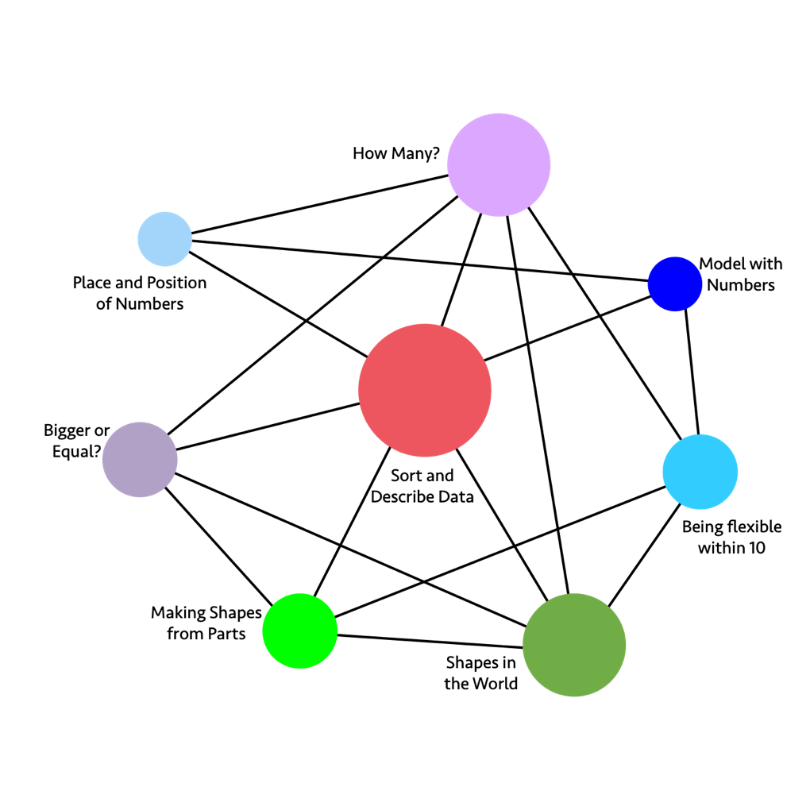
Long description: The graphic illustrates the connections and relationships of some kindergarten mathematics concepts. Direct connections include:
- How Many directly connects to: Being flexible within 10, Shapes in the World, Sort and Describe Data, Bigger or Equal, Place and Position of Numbers
- Model with Numbers directly connects to: Being flexible within 10, Sort and Describe Data, Place and Position of Numbers
- Being Flexible within 10 directly connects to: Model with Numbers, How Many, Making Shapes from Parts, Shapes in the World
- Shapes in the World directly connects to: Being flexible within 10, How Many, Sort and Describe Data, Bigger or Equal, Making Shapes from Parts
- Making Shapes from Parts directly connects to: Shapes in the World, Being flexible within 10, Sort and Describe Data, Bigger or Equal
- Bigger or Equal directly connects to: Making Shapes from Parts, Shapes in the World, Sort and Describe Data, How Many
- Place and Position of Numbers directly connects to: How Many, Model with Numbers, Sort and Describe Data
- Sort and Describe Data directly connects to: How Many, Model with Numbers, Shapes in the World, Making Shapes from Parts, Bigger or Equal, Place and Position of Numbers
Figure 6.8a. Grade K Content Connections, Big Ideas, and Standards
Content Connection | Big Idea | K Standards
Communicating Stories with Data | Sort & Describe Data | MD.1, MD.2, MD.3, CC.4, CC.5, G.4: Sort, count, classify, compare, and describe objects using numbers for length, weight, or other attributes.
Exploring Changing Quantities | How Many? | CC.1, CC.2, CC.3, CC.4, CC.5, CC.6, CC.7, MD.3: Know number names and the count sequence to determine how many are in a group of objects arranged in a line, array, or circle. Fingers are important representations of numbers. Use words and drawings to make convincing arguments to justify work.
Exploring Changing Quantities | Bigger or Equal? | CC.4, CC.5, CC.6, MD.2, G.4: Identify a number of objects as greater than, less than, or equal to the number of objects in another group. Justify or prove your findings with number sentences and other representations.
Taking Wholes Apart, Putting Parts Together | Being Flexible within 10 | OA.1, OA.2, OA.3, OA.4, OA.5, CC.6, G.6: Make 10, add and subtract within 10, compose and decompose within 10 (find 2 numbers to make 10). Fingers are important.
Taking Wholes Apart, Putting Parts Together | Place and position of numbers | CC.3, CC.5, NBT.1: Get to know numbers between 11 and 19 by name and expanded notation to become familiar with place value, for example: 14 = 10 + 4.
Taking Wholes Apart, Putting Parts Together | Model with numbers | OA.1, OA.2, OA.5, NBT.1, MD.2: Add, subtract, and model abstract problems with fingers, other manipulatives, sounds, movement, words, and models.
Discovering  Shape and Space | Shapes in the World | G.1, G.2, G.3, G.4, G.5, G.6, MD.1, MD.2, MD.3: Describe the physical world using shapes. Create 2-D and 3-D shapes, and analyze and compare them.
Discovering Shape and Space | Making shapes from parts | MD.1, MD.2, G.4, G.5, G.6: Compose larger shapes by combining known shapes. Explore similarities and differences of shapes using numbers and measurements.

Grade One
Organizing and seeing equivalence are ideas that pervade first grade. Students develop ways to organize to help them with counting and comparing and ultimately understanding the place value system. Grade 1 students will compare two, two-digit numbers based on the meanings of the tens and the ones digits, which is an important concept (SMP.1, 2; 1.NBT.3). To gain this understanding, students have worked extensively creating tens from collections of ones and have internalized the idea of a “ten.” Younger learners typically count by ones, and may show little or no grouping or organization of objects as they count. As they acquire greater confidence and understanding, children can progress to counting some of the objects in groups of five or ten. Teachers may support student learning by providing interesting, varied, and frequent counting opportunities using games, group activities, and a variety of tools, along with focused mathematical discourse. Students who are English learners are encouraged to use their developing English and native language assets and draw on their prior knowledge. Teachers can provide purposefully planned and “just-in-time” scaffolds and supports to engage EL students in sustained mathematical oral discourse in multiple contexts to build academic vocabulary and knowledge.
Equivalence means learning to assess what makes things different and the same. For instance, 4 + 1 and 5 are equivalent, even though they look different, and students may develop a dozen strategies for adding 4 and 1 to arrive at 5. Those strategies are different but related and equivalent in the result they produce. Grappling with equivalence and organization is important work in first grade.
Posing questions as students are engaged in the activities can help a child see relationships and further develop place value concepts. Some questions might include the following:
- What do you notice?
- What do you wonder?
- What will happen if we count these by ones?
- What if we counted them in groups of ten?
- How can we be sure there really are 43 here?
- I see you counted by groups of 10 and ones. What if you counted them all by ones? How many would we get?
Teachers can have students assemble bundles of ten objects (popsicle sticks or straws, for example), or snap together linking cubes to make tens as a means of developing the concept and noting how the quantities are related. Note that while students in first grade do begin to add two-digit numbers, they do so using strategies as distinguished from formal algorithms. The California Common Core State Standards for Mathematics (CA CCSSM) intentionally place the introduction of a standard algorithm for addition and subtraction in fourth grade (4.NBT.4). Examples of useful manipulatives at this age include 10-frames, Rekenreks, comparison bars, Cuisenaire rods, and useful visuals include hundreds charts, 0–99 charts, and number paths. Fingers continue to be important. NRICH provides online Cuisenaire Rods, and other moveable shapes.
In first grade, students can conduct data investigations, generating questions to study, using measurements of length and time, along with continued work categorizing and counting objects, and categorizing geometric objects by attributes. When conducting data investigations, it is important to avoid questions about students’ physical attributes or possessions, even those that seem innocuous, such as height or arm length. Instead, some good questions to wonder about might be “I wonder what time it will be when the next person walks into the classroom?” or “I wonder which book in the classroom is the most read?,” comparing events or objects rather than personal characteristics. Guidance cards can provide additional support to help EL students engage in structured explorations of the big ideas (What you can do) and communicate (What you can say) with peers.
Students extend their work from kindergarten, focusing on two dimensional shapes in a flat surface, to considering ways these shapes are the faces of 3-D shapes that make up the world. Students can work qualitatively and quantitatively with shapes, using their language to describe the similarities and differences, and counting and joining numbers to describe the shapes. For example, a student might notice a cube has 4 corners when looking directly at the square that forms one of its 6 faces. Students can count the corners, or vertices, and notice that a cube has 8 vertices and 6 square faces. A student may then notice that a prism has the same number of faces and vertices, but four of the faces are rectangles and the other two faces are squares. Including the circle as an additional shape brings in discussion about cylinders and cones. The circle is an important shape to discuss, as all circles are similar. Students also see the circle as an item that can be constructed from sectors or pieces. Constructing circles, and playing with pieces that combine to make a circle, begins an important journey towards fractions and telling the time on an analog clock.
Critical Areas of Instructional Focus
Figure 6.9. Grade 1 Big Ideas
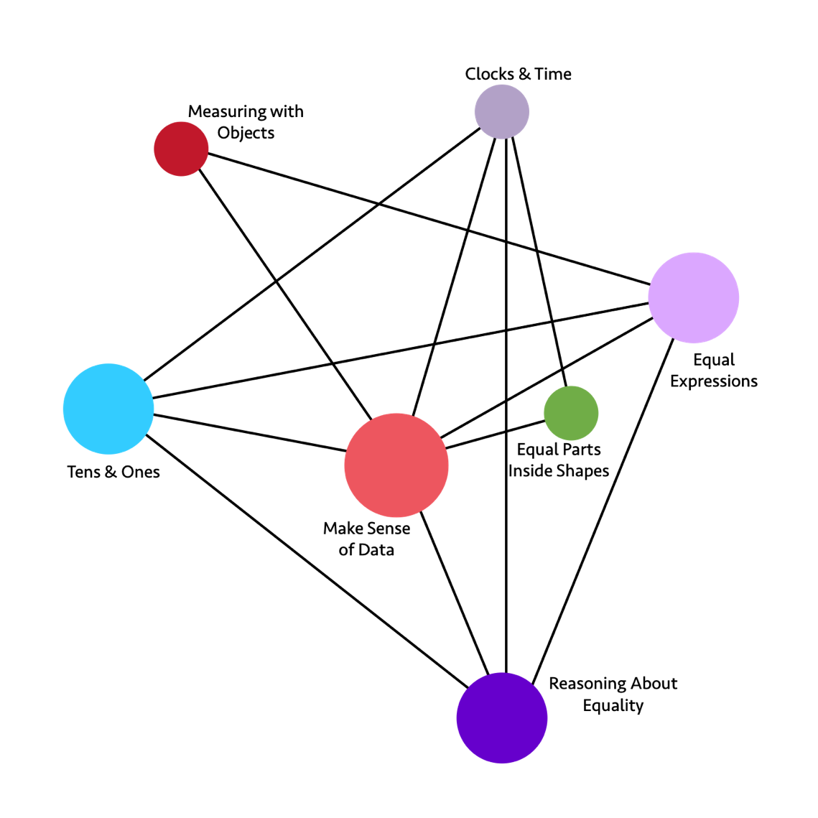
Long description: The graphic illustrates the connections and relationships of some first-grade mathematics concepts. Direct connections include:
- Clocks & Time directly connects to: Equal Parts Inside Shapes, Reasoning About Equality, Make Sense of Data, Tens & Ones
- Equal Expressions directly connects to: Reasoning About Equality, Make Sense of Data, Tens & Ones, Measuring with Objects
- Reasoning About Equality directly connects to: Equal Expressions, Clocks & Time, Make Sense of Data, Tens & Ones
- Tens & Ones directly connects to: Reasoning About Equality, Make Sense of Data, Equal Expressions, Clocks & Time
- Measuring with Objects directly connects to: Equal Expressions, Make Sense of Data
- Equal Parts Inside Shapes directly connects to: Clocks & Time, Make Sense of Data
- Make Sense of Data directly connects to: Reasoning About Equality, Tens & Ones, Measuring with Objects, Clocks & Time, Equal Expressions, Equal Parts Inside Shapes
Figure 6.9a. Grade 1 Content Connections, Big Ideas, and Standards
Content Connection | Big Idea | Grade 1 Standards
Communicating Stories with Data | Make Sense of Data | MD.2, MD.4, MD.3, MD.1, NBT.1, OA.1, OA.2, OA.3: Organize, order, represent, and interpret data with two or more categories; ask and answer questions about the total number of data points, how many are in each category, and how many more or less are in one category than in another.
Communicating Stories with Data  &  Exploring Changing Quantities | Measuring with Objects | MD.1 MD.2, OA.5: Express the length of an object by units of measurement e.g., the stapler is 5 red Cuisenaire rods long, the red rod representing the unit of measure. Understand that the measurement length of an object is the number of units used to measure.
Exploring Changing Quantities | Clocks & Time | MD.3, NBT.2, G.3: Read and express time on digital and analog clocks using units of an hour or half hour.
Exploring Changing Quantities | Equal Expressions | OA.6, OA.7, OA.2, OA.1, OA.8, OA.5, OA.4, OA.3, NBT.4: Understand addition and subtraction, using various models, such as connected cubes. Compose and decompose numbers to make equal expressions, knowing that equals means that both sides of an expression are the same (and it is not simply the result of an operation).
Exploring Changing Quantities | Reasoning about Equality | OA.3, OA.6, OA.7, NBT.2, NBT.3, NBT.4: Justify reasoning about equal amounts, using flexible number strategies (e.g., students use compensation strategies to justify number sentences, such as 23 - 7 = 24 - 8).
Taking Wholes Apart, Putting Parts Together | Tens & Ones | NBT.4, NBT.3, NBT.1, NBT.2, NBT.6, NBT.5: Think of whole numbers between 10 and 100 in terms of tens and ones. Through activities that build number sense, students understand the order of the counting numbers and their relative magnitudes.
Discovering Shape and Space | Equal Parts inside Shapes | G.3, G.2, G.1, MD.3: Compose 2D shapes on a plane as well as in 3D space to create cubes, prisms, cylinders, and cones. Shapes can also be decomposed into equal shares, as in a circle broken into halves and quarters defines a clock face.

Grade Two
In second grade students start to think deeply about familiar benchmark or “friendly” numbers, so they can use them to compose, decompose, and compare numbers. In second grade, students extend their understanding of place value and number comparison to include three-digit numbers. To compare two three-digit numbers, second graders can take the number apart by place value and compare the number of hundreds, tens, and ones, or they may use counting strategies. Thinking with numbers, such as ones, tens, and hundreds, and negotiating how to use them as groups and as positions on the number line to solve problems, is central to this grade. Students continually anchor their thinking about number to all the real-world places where numbers are used to describe and wonder, including estimating lengths and quantities and thinking with data. Note that while students in second grade do begin to subtract numbers, they do so using strategies as distinguished from formal algorithms.
In second grade, students can conduct data investigations and interpret data visuals through data talks. Students continue to use measurement of length and time as contexts in generating questions, along with continued work categorizing and counting objects and categorizing geometric objects by attributes. In second grade, students also start to use the context of money. When conducting data investigations, it is important to avoid questions about students’ physical attributes or possessions, even those that seem innocuous, such as hair color or shoe type. Instead, some good questions to wonder about might be “I wonder what time it will be when the next person walks into the classroom?” or “I wonder which book in the classroom is the most read?,” comparing events or objects rather than personal characteristics. Students who are English learners are encouraged to use their developing English and native language assets and draw on their prior knowledge. Teachers can examine text and tasks for key language forms and structures, and general as well as discipline-specific, high-utility academic vocabulary words linked to the big ideas and connections. Teachers can provide purposefully planned and “just-in-time” scaffolds and supports to engage EL students in sustained mathematical discourse in multiple contexts to build academic language and knowledge.
Grade 2 begins more formal vocabulary use and the connections between numbers and shapes. Students continue to work with 2-D and 3-D shapes, composing and decomposing within a plane or space, as they refine their understanding of figures that have area and those that have volume. Students begin to partition shapes into equal units, known as unit fractions. This is especially important in circles and will be the base understanding of navigating time using an analog clock.
Students learn in second grade that they can partition rectangles into arrays of equal squares and quantify the lengths of sides by using a unit to measure. For example, a student may use a light green Cuisenaire rod to approximate the length of a stapler or a stack of 5 Unifix cubes to measure the same length. This can lead to discussion of the importance of a base unit as the length that is used to quantify. Equal partitions are also of utmost importance, as students begin to understand the idea of a fraction.
Critical Areas of Instructional Focus
Figure 6.10. Grade 2 Big Ideas
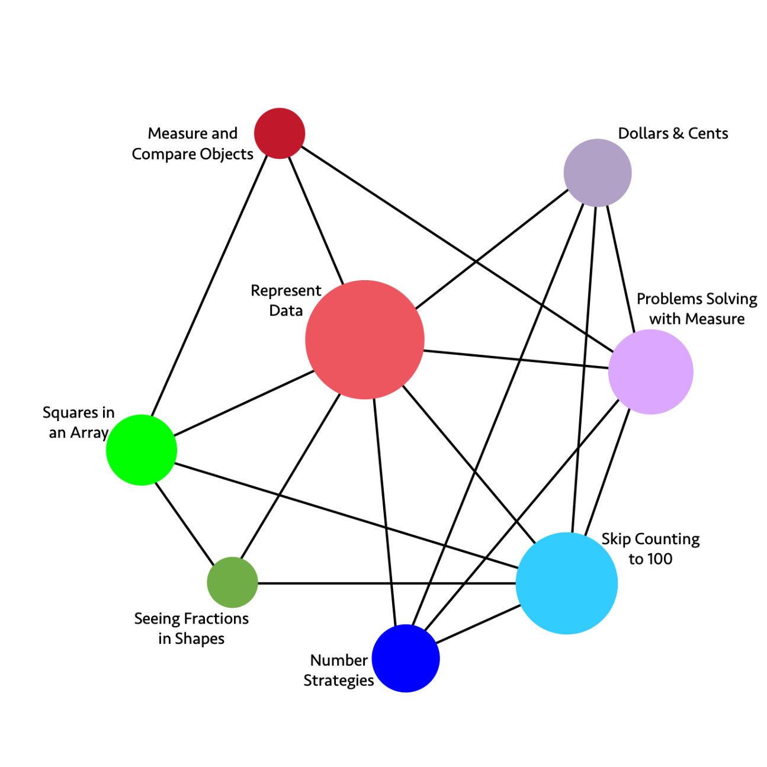
Long description: The graphic illustrates the connections and relationships of some second-grade mathematics concepts. Direct connections include:
- Dollars & Cents directly connects to: Problems Solving with Measure, Skip Counting to 100, Number Strategies, Represent Data
- Problems Solving with Measure directly connects to: Skip Counting to 100, Number Strategies, Represent Data, Measure and Compare Objects, Dollars & Cents
- Skip Counting to 100 directly connects to: Number Strategies, Seeing Fractions in Shapes, Squares in an Array, Represent Data, Dollars & Cents, Problems Solving with Measure
- Number Strategies directly connects to: Skip Counting to 100, Problems Solving with Measure, Dollars & Cents, Represent Data
- Seeing Fractions in Shapes directly connects to: Skip Counting to 100, Represent Data, Squares in an Array
- Squares in an Array directly connects to: Seeing Fractions in Shapes, Skip Counting to 100, Represent Data, Measure and Compare Objects
- Measure and Compare Objects directly connects to: Squares in an Array, Represent Data, Problems Solving with Measure
- Represent Data directly connects to: Measure and Compare Objects, Dollar & Cents, Problems Solving with Measure, Skip Counting to 100, Number Strategies, Seeing Fractions in Shapes, Squares in an Array
Figure 6.10a. Grade 2 Content Connections, Big Ideas, and Standards
Content Connection | Big Idea | Standards
Communicating Stories with Data | Measure & Compare Objects | MD.1, MD.2, MD.3, MD.4, MD.6, MD.9: Determine the length of objects using standard units of measures, and use appropriate tools to classify objects, interpreting and comparing linear measures on a number line.
Communicating Stories with Data | Represent Data | MD.7, MD.9, MD.10, G.2, G.3, NBT.2: Represent data by using line plots, picture graphs, and bar graphs, and interpret data in different data representations, including clock faces to the nearest 5 minutes.
Exploring Changing Quantities | Dollars & Cents | MD.8, MD.5, NBT.1, NBT.2, NBT.5, NBT.6, NBT.7: Understand the unit values of money and compute different values when combining dollars and cents.
Exploring Changing Quantities  &  Discovering Shape and Space | Problem Solving with Measure | NBT.7, NBT.1, MD.1, MD.2, MD.3, MD.4, MD.5, MD.6, MD.9, OA.1: Solve problems involving length measures using addition and subtraction.
Taking Wholes Apart, Putting Parts Together | Skip Counting to 100 | NBT.1, NBT.3, NBT.7, OA.4, G.2: Use skip counting, counting bundles of 10, and expanded notation to understand the composition and place value of numbers up to 1,000. This includes ideas of counting in fives, tens, and multiples of hundreds, tens, and ones, as well as number relationships involving these units, including comparing.
Taking Wholes Apart, Putting Parts Together | Number Strategies | MD.5, NBT.5, NBT.6, NBT.7, OA.1, OA.2: Add and subtract 2-digit numbers, within 100, without using algorithms - instead encouraging different strategies and justification. Compare and contrast the different strategies using models, symbols, and drawings.
Discovering Shape and Space | Seeing Fractions in Shapes | G.1, G.2, G.3, MD.7: Divide circles and rectangles into equal shares and know them to be standard unit fractions. Identify and draw 2D and 3D shapes, recognizing faces and angles.
Discovering Shape and Space | Squares in an Array | OA.4, G.2, G.3, MD.6: Partition rectangles into rows and columns of unit squares to find the total number of square units in an array.

Chapter 7: Mathematics in Grades Three through Five
Figure 7.1. A Progression Chart of Big Ideas through Grades 3–5
Content Connections | Big Ideas: Grade 3 | Big Ideas: Grade 4 | Big Ideas: Grade 5
Communicating Stories with Data | Represent Multivariable data | Measuring and plotting | Plotting patterns
Communicating Stories with Data | Fractions of shape and time | Rectangle Investigations | Telling a data story
Communicating Stories with Data | Measuring | n/a | n/a
Exploring Changing Quantities | Addition and subtraction patterns | Number and shape patterns | Telling a data story
Exploring Changing Quantities | Number flexibility to 100 | Factors & area models | Factors and groups
Exploring Changing Quantities | n/a | Multi-digit numbers | Modeling
Exploring Changing Quantities | n/a | n/a | Fraction connections
Exploring Changing Quantities | n/a | n/a | Shapes on a plane
Taking Wholes Apart, Putting Parts Together | Square tiles | Fraction flexibility | Fraction connections
Taking Wholes Apart, Putting Parts Together | Fractions as relationships | Visual fraction models | Seeing Division
Taking Wholes Apart, Putting Parts Together | Unit fraction models | Circles, fractions and decimals | Powers and place value
Discovering shape and space | Unit fraction models | Circles, fractions and decimals | Telling a data story
Discovering shape and space | Analyze quadrilaterals | Shapes and symmetries | Layers of cubes
Discovering shape and space | n/a | Connected problem solving | Shapes on a plane
The upper-elementary grades present new opportunities for developing and extending number sense. There are four big ideas related to number sense for grades 3–5 including:
- extending flexibility with numbers,
- understanding the operations of multiplication and division,
- making sense of operations with fractions and decimals, and
- using number lines as tools.
As students learn to think about numbers flexibly, by composing and decomposing numbers, they will learn to recognize the inverse relationship between addition and subtraction and between multiplication and division. An important component of “fluency” is being flexible with numbers; rather than a focus on being fast with computation or the use of damaging timed tests (Boaler, 2019). If students are given meaningful explorations with numbers and number patterns, they will develop memories of mathematics facts, and the memories will be meaningful and conceptual. As students learn in these grades to identify and express patterns, both visually and numerically, they will build foundations for proportional reasoning when thinking about the connections between units. In fifth grade, the flexibility students have developed with numbers can be applied to fractions and to the place value system.
Students in the upper-elementary grades learn to conduct data investigations, which include asking and answering questions that are of interest to them. They learn to collect and analyze data, determine, and confirm results, and communicate their findings. While the data visualizations set out in the standards in these grades only include picture graphs, bar graphs, and line plots, students do not need to be restricted to these.
Students investigate patterns and relationships in two- and three-dimensional space, and they begin to use the coordinate plane to represent and question relationships. As students learn about three-dimensional space, they build understanding of the volume as a quantity of unit cubes that fill the space of a solid. Students study time as a measure and connect the central angles of a circle to the clock face and hands. The study of the clock face is another area for connections between numbers and fractions, as students learn about and communicate detailed measures of time.
Students who are English learners are encouraged to use their developing English and native language assets and draw on their prior knowledge. Teachers can examine text and tasks for key language forms and structures, and general as well as discipline-specific, high-utility academic vocabulary words linked to the big ideas and connections. Teachers can provide purposefully planned and “just-in-time” scaffolds and supports to engage EL students in sustained mathematical discourse in multiple contexts to build academic language and knowledge.
The following vignette highlights an educator who is using digital tools to allow students to better visualize concepts introduced at this grade span.
Vignette: Pace, Flexibility, and Grace—Teaching Math During Times of Change
At the end of the 2015-16 school year, 32-year veteran math teacher Jean Maddox participated in a three-year professional development program with the County of Tulare Office of Education. The Central Valley Network Improvement Community program or CVNIC was, as the Visalia Unified teacher reflects, “The best professional development I have ever participated in.” Jean, who has taught 5th grade for the last 20 years, worked with other teachers in the program and mathematics researchers, Jo Boaler and Graham Fletcher, to learn new math strategies while applying their knowledge using the PDSA cycle (Plan, Do, Study, Act). Little did she know then just how useful those skills would become in 2020.
Forced by the pandemic to teach remotely in 2020, Jean rose to the challenge by adapting, collaborating, and innovating. Even though much had changed with respect to how Jean connected with her students this past year, the more important stuff—the motivation behind her work, the aspirations that motivate her students, even the personal character of her outreach—remained.
Flexibility with numbers is a crucial aspect of Jean’s work with her students, making sure they are confident and comfortable with the way they see and manipulate numbers. Often, Jean encourages students to explain the problem they are working on in two ways, with numbers and then visually. “How they see it, in my opinion, also shows how flexible they are with numbers,” Jean says. “This especially helps when we are solving math stories with fractions. How the story makes sense in their head, to match it up with a visual they have drawn; finally, their thinking allows me to see their true understanding (or misconceptions) of the problem.” In the distance learning setting, Jean works with tasks from YouCubed that are a “low-floor/high-ceiling” and fit well for 5th graders beginning to look for patterns to explain their thinking–both visually and numerically.
Using flexibility allows Jean’s students to develop the idea of efficiency when doing long division, a key concept developed at this grade span. “For a lot of my students, using the area model, whether it be for multiplication or division, allows them the chance for a visual/conceptual image with numbers, especially division,” Jean states. For long division, the area model is a way to organize the method of Partial Quotients, which allows Jean’s students to work with numbers they are comfortable with when they are dividing. The model enables them to connect to the understanding of areas that they learned in third grade.
Jean’s teaching method engages all learners. For EL students, Jean has found success through math stories (word problems). “Students draw out what they understand first (because visualizing the math before calculation shows true understanding),” says Jean. “I provide a process where students can share their thinking, whether it be by partner discussions, acting out the problem, explaining their drawings, and then finally doing the number work (calculations) is the last step.” The process allows Jean to drop in on her students’ thinking process, which indicates to her what the next steps are for working with each student.
Math manipulatives to represent concepts introduced at this grade span are central in Jean’s students’ work. “Anything from fraction strips, tangrams, Unifix cubes, centimeter cubes, rulers, protractors are used daily; the students can use the manipulatives they are the most comfortable with,” says Jean. It is a norm in her classroom that students may choose the appropriate tools that they need during math. Jean innovated to ensure the pandemic didn’t change the norm. “With technology, during our full-distance learning time, students have access to digital manipulatives because they still need to be able to see and create the math they are being asked to conceptualize.” Jean found the solution in the Math Learning Center website and the Toy Theater website to access manipulatives for her students’ use. “They have been quite successful in sharing their thinking, so I can see what their misconceptions are and what they understand (formative assessments).”
On the first day of math instruction, Jean makes sure students have a clear understanding of whole numbers on a number line, allowing them to make a smoother transition to placing fractions on a number line. Jean found the Math Learning Center website to be a valuable resource for using digital number lines.
For foundational algebra skills, Jean uses Jamboard [collaborative digital whiteboard] to have students manipulate equations and SolveMe Mobiles [game-based mathematics website] to help students establish algebraic thinking and reinforce Operations and Algebraic standards from previous grades.
Pace is another critical factor in Jean’s teaching. In her classes, whether online or in-person, speed is not an indicator of success. “I strongly disagree with timed tests,” she says. “It only heightens a student's math anxiety. Watching the anxious look on kids' faces with the knowledge that they may not finish, which then leads them to feel like a failure and that they are not a math person.” For Jean, timed-tests give students the impression that math is about speed and getting the correct answer - the very opposite of what math is. “In my class, we take time as we are doing math because I want students to think deeply and realize that their math ability does not connect to how fast they can get something done.”
Success for Jean is the lightbulb moment when a student connects with the work. “When a student can take a number and decompose it so they can add or multiply in a way that makes sense to them, one that is not necessarily the standard algorithm. When they get the correct answer, they look at the teacher and say, ‘This is how I see it!’ That is an amazing experience–especially as their teacher.”

Grade Three
In third grade, students extend their work from second grade, thinking with groups, to equal groups and rows and columns in multiplication. As students learn to think about numbers flexibly, by composing and decomposing numbers, they will learn to recognize the inverse relationship between multiplication and division. Being flexible with numbers is an important component of fluency, rather than a focus on being fast with computation. The Mathematics Framework defines fluency:
Students who are comfortable with numbers and who have learned to compose and decompose numbers strategically develop fluency along with conceptual understanding. In the past, fluency has sometimes been equated with speed, which may account for the common, but counterproductive, use of timed tests for practicing facts. But in fact, research has found that, “Timed tests offer little insight about how flexible students are in their use of strategies or even which strategies a student selects. And evidence suggests that efficiency and accuracy may actually be negatively influenced by timed testing.”
To learn more about why timed tests can be replaced with number sense activities see Boaler, Williams, and Confey (2015). Being flexible is a big idea and one which draws from connections between numbers and patterns. When students develop number sense, they have a flexible internal framework that they can draw upon when working with any mathematics. Note that while students in third grade do begin to divide numbers, they do so using strategies as distinguished from formal algorithms.
Third grade is also the time when fractional thinking begins to become robust and can begin with a deep understanding of one-half that students can build on to understand and visualize other unit fractions.
Students can be given plenty of time to “play” with numbers and fractions, to think about their relative size, and to estimate and reflect on whether their answers make sense (SMP.3, 7, 8). Students in third grade focus on understanding fractions as equal parts of a whole and as numbers located on the number line. They also use reasoning to compare unit fractions (3.NF.1, 2, 3).
In third grade, students can conduct data investigations and interpret data visuals through data talks. Contexts for questions to investigate should expand to include volume and mass measurement (grams, kilograms, and liters, but not compound units, such as cm³) in addition to the length, time, and money contexts from earlier grades (3.MD.A.2). Time measurements are refined to the nearest minute (3.MD.A.1), and length now includes half- and quarter-inches (3.MD.B.4). Beginning ideas of area give another possible context, limited here to areas that can be covered by a whole number of unit squares (3.MD.C.5, 3.MD.C.6).
Students continue refining their understanding of two-dimensional shapes, focusing on the similarities and differences between quadrilaterals. Students make sense of the attributes that make up these important shapes, that can all be composed by triangles. Students will recognize the importance of the triangle as the base unit, which connects with later learning of trigonometry and the method of dividing complex shapes into smaller triangles to find their area. Students investigate and quantify quadrilaterals and learn that area and perimeter are important measures, where perimeter is one dimensional and area is two dimensional. Having conversations about the base unit of measure helps students connect to the ideas of multiplication and division. Connecting numbers and shapes helps students to make other connections and build number sense.
Students who are English learners are encouraged to use their developing English and native language assets (e.g., cognates) and draw on their prior knowledge. Teachers can examine text and tasks for key language forms and structures, in addition to general and discipline-specific, high-utility academic vocabulary words linked to the big ideas and connections. Teachers can provide purposeful scaffolds and supports to engage EL students in sustained mathematical discourse in multiple contexts to build academic language and knowledge. Planned and “just-in-time” scaffolds and supports provide multiple entry points for meaning-making and sharing of ideas in mathematical ways and include representations, expression starters and builders, and targeted vocabulary and language structures (e.g., explanation, descriptions, comparisons, methods, and connections).
Critical Areas of Instructional Focus
Figure 7.2. Grade 3 Big Ideas
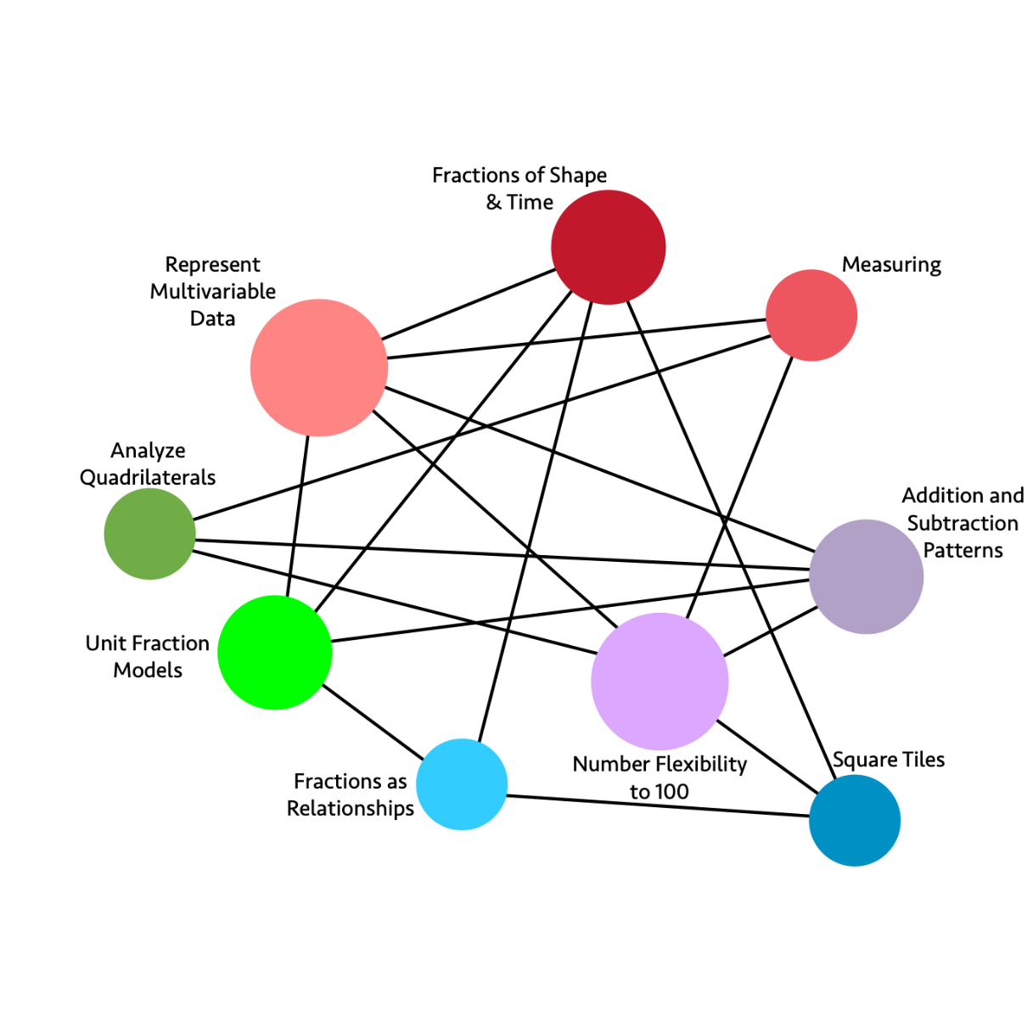
Long description: The graphic illustrates the connections and relationships of some third-grade mathematics concepts. Direct connections include:
- Fractions of Shape & Time directly connects to: Square Tiles, Fractions as Relationships, Unit Fractions Models, Represent Multivariable Data
- Measuring directly connects to: Number Flexibility to 100, Analyze Quadrilaterals, Represent Multivariable Data
- Addition and Subtraction Patterns directly connects to: Number Flexibility to 100, Unit Fraction Models, Analyze Quadrilaterals, Represent Multivariable Data
- Square Tiles directly connects to: Fractions as Relationships, Number Flexibility to 100, Fractions of Shape & Time
- Fractions as Relationships directly connects to: Square Tiles, Fractions of Shape & Time, Unit Fraction Models
- Unit Fraction Models directly connects to: Fractions as Relationships, Addition and Subtraction Patterns, Fractions of Shape & Time, Represent Multivariable Data
- Analyze Quadrilaterals directly connects to: Number Flexibility to 100, Addition and Subtraction Patterns, Measuring
- Represent Multivariable Data directly connects to: Unit Fraction Models, Number Flexibility to 100, Addition and Subtraction Patterns, Measuring, Fractions of Shape & Time
- Number Flexibility to 100 directly connects to: Square Tiles, Analyze Quadrilaterals, Represent Multivariable Data, Measuring, Addition and Subtraction Patterns
Figure 7.2a. Grade 3 Content Connections, Big Ideas, and Standards
Content Connection | Big Idea | Grade 3 Standards
Communicating Stories with Data | Represent Multivariable Data | MD.3, MD.4, MD.1, MD.2, NBT.1: Collect data and organize data sets, including measurement data; read and create bar graphs and pictographs to scale. Consider data sets that include three or more categories (multivariable data) for example, when I interact with my puppy, I either call her name, pet her, or give her a treat.
Communicating Stories with Data  &  Taking Wholes Apart, Putting Parts Together  &  Discovering Shape and Space | Fractions of Shape & Time | MD.1, NF.1, NF.2, NF.3, G.2: Collect data by time of day, show time using a data visualization. Think about fractions of time and of shape and space, expressing the base unit as a unit fraction of the whole.
Communicating Stories with Data | Measuring | MD.2, MD.4, NBT.1: Measure volume and mass, incorporating linear measures to draw and represent objects in two-dimensional space. Compare the measured objects, using line plots to display measurement data. Use rounding where appropriate.
Exploring Changing Quantities | Addition and Subtraction Patterns | NBT.2, , OA.8, OA.9, MD.1: Add and subtract within 1000 - Using student generated strategies and models, such as base 10 blocks. e.g., use expanded notation to illustrate place value and justify results. Investigate patterns in addition and multiplication tables, and use operations and color coding to generalize and justify findings.
Exploring Changing Quantities | Number Flexibility to 100 | OA.1, OA,2, OA.3, OA.4, OA.5, OA.6, OA.7, OA.8, NBT.3, MD.7, NBT.1: Multiply and divide within 100 and justify answers using arrays and student generated visual representations. Encourage number sense and number flexibility - not “blind” memorization of number facts. Use estimation and rounding in number problems.
Taking Wholes Apart, Putting Parts Together | Square Tiles | MD.5, MD.6, MD.7, OA.7, NF.1: Use square tiles to measure the area of shapes, finding an area of n squared units, and learn that one square represents 1/nth of the total area.
Taking Wholes Apart, Putting Parts Together | Fractions as Relationships | NF.1, NF.3: Know that a fraction is a relationship between numerators and denominators – and it is important to consider the relationship in context. Understand why 1/2=2/4=3/6.
Taking Wholes Apart, Putting Parts Together  &  Discovering Shape and Space | Unit Fraction Models | NF.2, NF.3, MD.1: Compare unit fractions using different visual models including linear models (e.g., number lines, tape measures, time, and clocks) and area models (e.g., shape diagrams encourage student justification with visual models).
Discovering  Shape and Space | Analyze Quadrilaterals | MD.8, G.1, G.2, NBT.1, OA.8: Describe, analyze, and compare quadrilaterals. Explore the ways that area and perimeter change as side lengths change, by modeling real world problems. Use rounding strategies to approximate lengths where appropriate.

Grade Four
Patterning and examining relationships are at the heart of fourth grade. Students begin to think about how to identify and express patterns, both visually and numerically, and build foundations for proportional reasoning when thinking about the connections between units. Students look within fractions and decimals for the relationships represented there—relationships between numerator and denominator, fraction and decimal, and decimal and place value. Fourth graders use relationships to connect multiplication and division and think flexibly across all operations.
After their introduction to multiplication in third grade, fourth-grade students employ that understanding to identify prime and composite numbers and to recognize that a whole number is a multiple of each of its factors. An excellent way for students to see the composition of numbers is the visual number activity. Students can also explore the multiplication table and highlight multiples with color or shape, looking for patterns and relationships
At this grade, students develop an understanding of fraction equivalence by illustrating and explaining reasons for their conjectures and ideas. Students can strengthen their knowledge of fraction equivalence by engaging in games that provide practice, such as Matching Fractions or Fractional Wall, created by Nrich Maths. Students represent their thinking with diagrams (number lines, strip diagrams), pictures, and equations. This work lays the foundation for further operations with fractions in fifth grade.
Data investigations in fourth grade should include topics of student interest as students learn the ways to collect, analyze, and represent data. Line plots are introduced in fourth grade, and students can learn to create, read, and interpret different data displays, including line plots. When creating line plots, students can include fractional measurements to help bring fractions to life with real data, such as measurement of objects in the classroom or home.
In grade four, students move from seeing vertices as made up of an angle to more formal understandings of angles made of two rays with a common endpoint. The concept of a ray can lead to fascinating discussions of infinity that can captivate students. As students think about the addition of angles, they will again be connecting geometric ideas to number sense. The idea of a central angle of a circle, formed when two rays are joined at the center of a circle can connect with learning about the hands of a clock face. Students can investigate with angles in myriad of ways. Students continue refining their work in measuring and quantifying the world around them by investigations, such as connecting the unit of measure from a square to a cube, as they use area, perimeter of shapes, and the volume of solids. These ideas connect to the operations of addition, subtraction, multiplication, and division. Students connect the unit of measure from a square to a cube as they use area and volume to make sense of space. These ideas can also be connected to fractions and decimals, building visual understandings and helping with the meaning of these operations.
Students who are English learners are encouraged to use their developing English and native language assets (e.g., cognates, morphological awareness) and draw on their prior knowledge. Teachers can examine text and tasks for key language forms and structures, and general as well as discipline-specific, high-utility academic vocabulary words linked to the big ideas and connections. Teachers can provide purposeful scaffolds and supports to engage EL students in sustained mathematical discourse in multiple contexts to build academic language and knowledge. Planned and “just-in-time” scaffolds and supports provide multiple entry points for meaning making and sharing of ideas in mathematical ways and include representations, expression starters and builders, and targeted academic vocabulary and language structures (e.g., problems, explanations, arguments, descriptions, procedures). Teachers guide deconstruction and/or co-construction of problems, investigations, arguments, explanations, descriptions, and procedures.
Critical Areas of Instructional Focus
Figure 7.3. Grade 4 Big Ideas
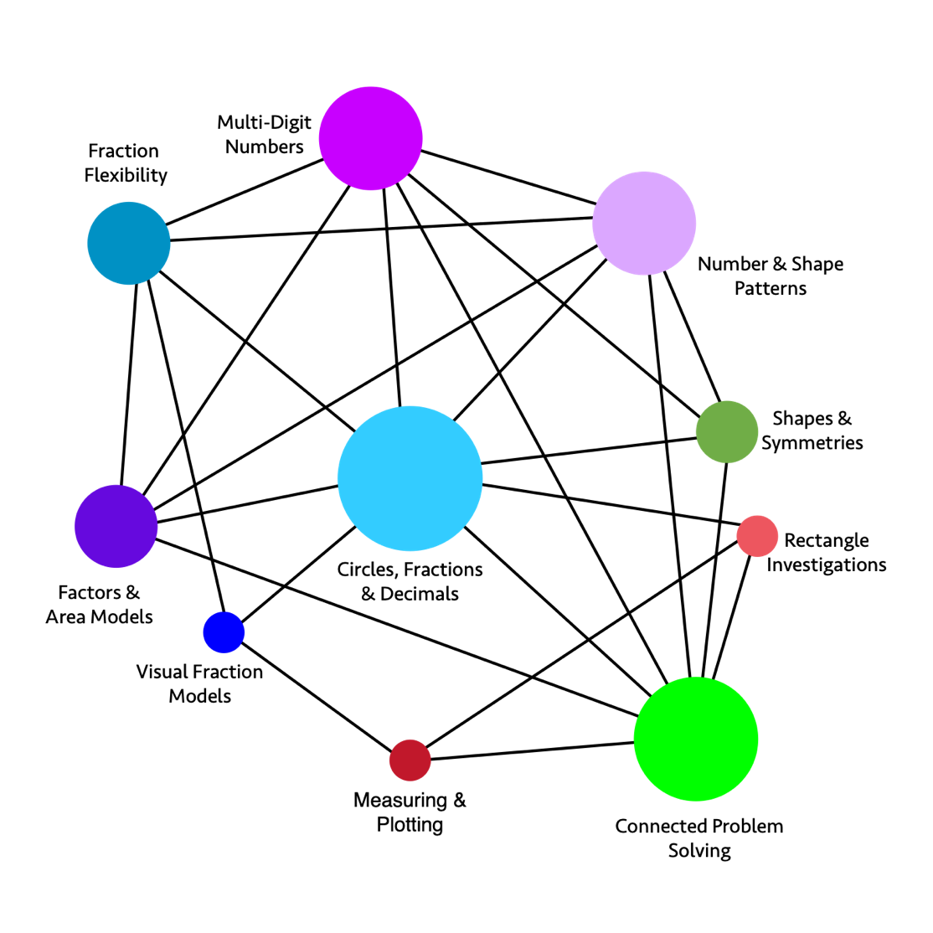
Long description: The graphic illustrates the connections and relationships of some fourth-grade mathematics concepts. Direct connections include:
- Number & Shape Patterns directly connects to: Shapes & Symmetries, Connected Problem Solving, Circles Fractions & Decimals, Factors & Area Models, Fraction Flexibility, Multi-Digit Numbers
- Shapes & Symmetries directly connects to: Connected Problem Solving, Circles Fractions & Decimals, Multi-Digit Numbers, Number & Shape Patterns
- Rectangle Investigations directly connects to: Connected Problem Solving, Measuring & Plotting, Circles Fractions & Decimals
- Connected Problem Solving directly connects to: Rectangle Investigations, Shapes & Symmetries, Number & Shapes Patterns, Multi-Digit Numbers, Circles Fractions & Decimals, Factors & Area Models, Measuring & Plotting
- Measuring & Plotting directly connects to: Connected Problem Solving, Rectangle Investigations, Visual Fraction Models
- Visual Fraction Models directly connects to: Measuring & Plotting, Circles Fractions & Decimals, Fraction Flexibility
- Factors & Area Models directly connects to: Connected Problem Solving, Circles Fractions & Decimals, Number & Shape Patterns, Multi-Digit Numbers, Fraction Flexibility
- Fraction Flexibility directly connects to: Factors & Area Models, Circles Fractions & Decimals, Number & Shape Patterns, Multi-Digit Numbers
- Multi-Digit Numbers directly connects to: Number & Shape Patterns, Shapes & Symmetries, Connected Problem Solving, Circles Fractions & Decimals, Factors & Area Models, Fraction Flexibility
- Circles Fractions & Decimals directly connects to: Multi-Digit Numbers, Number & Shape Patterns, Shapes & Symmetries, Rectangle Investigations, Connected Problem Solving, Visual Fraction Models, Factors & Area Models, Fraction Flexibility
Figure 7.3a. Grade 4 Content Connections, Big Ideas, and Standards
Content Connection | Big Idea | Grade 4 Standards
Communicating Stories with Data | Measuring & Plotting | MD.1, MD.4, NF.1, NF.2: Collect data consisting of distance, intervals of time, volume, mass, or money. Read, interpret, and create line plots that communicate data stories where the line plot measurements consist of fractional units of measure. For example, create a line plot showing classroom or home objects measured to the nearest quarter inch.
Communicating Stories with Data | Rectangle Investigations | MD1, MD2, MD3, MD5, MD6: Investigate rectangles in the world, measuring lengths and angles, collecting the data, and displaying it using data visualizations.
Exploring Changing Quantities | Number & Shape Patterns | OA.5, OA.1, OA.2, NBT.4: Generalize number and shape patterns that follow a given rule. Communicate understanding of how the pattern changes in words, symbols, and diagrams - working with multi-digit numbers.
Exploring Changing Quantities | Factors & Area Models | OA.1, OA.2, OA.4, NBT.5, NBT.6: Break numbers inside of 100 into factors. Illustrate whole number multiplication and division calculations as area models and rectangular arrays that illustrate factors.
Exploring Changing Quantities | Multi-Digit Numbers | NBT.1, NBT.2, NBT 3, NBT.4, OA.1: Read and write multi-digit whole numbers in expanded form and express each number component of the expanded form as a multiple of a power of ten.
Taking Wholes Apart, Putting Parts Together | Fraction Flexibility | NF.3, NF.1, NF.4, NF.5, OA.1: Understand that addition and subtraction of fractions as joining and separating parts that are referring to the same whole. Decompose fractions and mixed numbers into unit fractions and whole numbers, and express mixed numbers as a sum of unit fractions.
Taking Wholes Apart, Putting Parts Together | Visual Fraction Models | NF.2, NF.1, NF.3, NF.5, NF.6, NF.7: Use different ways of seeing and visualizing fractions to compare fractions using student generated visual fraction models. Use >, < and = to compare fraction size, through linear and area models, and determine whether fractions are greater or less than benchmark numbers, such as ½ and 1.
Taking Wholes Apart, Putting Parts Together  &  Discovering Shape and Space | Circles, Fractions & Decimals | NF.5, NF.6, NF.7, OA.1. MD2, MD5, MD7: Understand, compare, and visualize fractions expressed as decimals. Recognize fractions with denominators of 10 and 100, e.g., 25 cents can be written as 0.25 or 25/100. Connect a circle fraction model to the clock face. Example 3/10 + 4/100 = 30/100 + 4/100 = 34/100
Discovering Shape and Space | Shapes & Symmetries | MD.5, MD.6, MD.7, G.1, G.2, G.3, NBT.3, NBT.4, Draw and identify shapes, looking at the relationships between rays, lines, and angles. Explore symmetry through folding activities.
Discovering Shape and Space | Connected Problem Solving | OA.3, MD.1, MD.2, OA2, MD.3, NBT.3 place value, NBT.4, NBT.5, NBT.6, OA.2, OA.3, G.3: Solve problems with perimeter, area, volume, distance, and symmetry, using operations and measurement.

Grade Five
In fifth grade, equivalence and flexibility are big ideas, with both particularly relating to operations and fractions. Using relationships in the world to make meaning out of multiplication, division, fractions, and estimation requires a great deal of exploration. Using portion sizes to estimate with fractions is helpful because thinking about portions is a useful and underdeveloped idea that gives fractions meaning and utility. At this grade, students work with powers of ten, use exponential notation, and can explain patterns in the placement of the decimal point when a decimal is multiplied by a power of 10.
Fifth-grade students are expected to fully understand the place value system, including decimal values to thousandths, building from the foundation laid in earlier grades. Ideas to help with decimal understanding include using base ten blocks, with the 3-dimensional cube representing one unit so that students have a tactile, visual model to consider the value of the small cube, the rod, and the 10 by 10 flat. In a virtual environment, students can use a CAD, Tinkercad, or other program to design and build complex shapes. While they are building 3-D representations in a 2-D space, it is important to ask students to think about what makes their 2-D drawings appear to be 3-D. Shapes in this environment may appear to be a parallelogram or a rhombus when they are representing a 3-D object—what the shape of the face really is in 3-D space is a square. Asking students to build their CAD designs out of cardboard or paper is a good way to have them explore the way shapes look when they change the angle of their view.
Another useful tool is a printed 10 x 10 grid. Students visualize the whole grid as representing the whole and can shade in various decimal values. Fifth-grade students use equivalent fractions to solve problems; so, it is important that they have a strong grasp of equality and can use benchmark fractions (e.g., 1/2, 2/3, 3/4) to reason about, compare, and calculate with fractions. Experiences with placing whole numbers, fractions, and decimals on the same number line contribute to building fraction number sense. Students need time and opportunity to collaborate, critique, and reason about where to place the numbers on the number line.
When students in fifth grade conduct data investigations, they ask questions, collect data, analyze results, and communicate their findings. While the data visualizations included in the fifth-grade standards only include picture graphs, bar graphs, and line plots, students do not need to be restricted to these; data in the modern world is represented in many creative and non-standard ways, and it is important that students learn to read such data representations. Also, while standard data representations, such as bar graphs, show repeated measurements of a single varying quantity, science curricula in particular, and many questions of interest in general, require the consideration of relationships between two or more different changing quantities, such as erosion and time (NGSS 4-ESS2-1 Earth’s Systems) or length or direction of shadows and time (NGSS 5-ESS1-2 Earth's Place in the Universe). Such reasoning involves multiple variables, which is an important aspect of modern encounters with data that students experience. Although the scatter plot, a crucial data representation tool for two varying quantities, is not expected to be fully understood until later grades (8.SP.1), it can be explored informally much earlier for students to be prepared for middle school content. For example, students can plot quantities changing over time (e.g., height of a plant, length of the day, high temperature for the day), with time on the horizontal axis and the changing quantity on the vertical. Once such a plot is created, it is an excellent context for a “notice and wonder” discussion.
Moving to the fore in fifth grade are ideas about patterns and relationships in two- and three-dimensional space. Students begin to use the coordinate plane to represent and question relationships, and they begin to think about how to count and represent volume using cubic units. Providing investigations where students see volume as a visual model of unit cubes contained inside a 3-D shape is important work. Students have ample opportunities to study the volume of complex shapes, e.g., a pyramid, where they construct the volume as layers of unit cubes and grapple with the fractions of unit cubes that make up the volume. This is a way to further connect the meaning of a unit with fractions of a unit. In a virtual environment, students can build complex shapes in Tinkercad or other similar apps. Ask students to create and then hand draw their designs since this will engage different areas of their brain. If students are building complex 3-D designs virtually in a CAD (Computer-Aided Design) space, it is a good idea to ask them to try to construct their designs outside of the computer environment. Ask if they can construct their shape out of cardboard or paper. Was it possible to build the shapes they had drawn? What challenges did you face?
Students who are English learners are encouraged to use their developing English and native language assets (e.g., cognates, morphological awareness) and draw on their prior knowledge. Teachers can examine text and tasks for key language forms and structures, and general as well as discipline-specific, high-utility academic vocabulary words linked to the big ideas and connections. Teachers can provide purposeful scaffolds and supports to engage EL students in sustained mathematical discourse in multiple contexts to build academic language and knowledge. Planned and “just-in-time” scaffolds and supports provide multiple entry points for meaning making and sharing of ideas in mathematical ways and include representations, expression starters and builders, and targeted and high-utility academic vocabulary and language structures (e.g., problems, explanations, arguments, descriptions, procedures). Teachers guide deconstruction and/or co-construction of problems, investigations, arguments, explanations, descriptions, methods, and connections.
Critical Areas of Instructional Focus
Figure 7.4. Grade 5 Big Ideas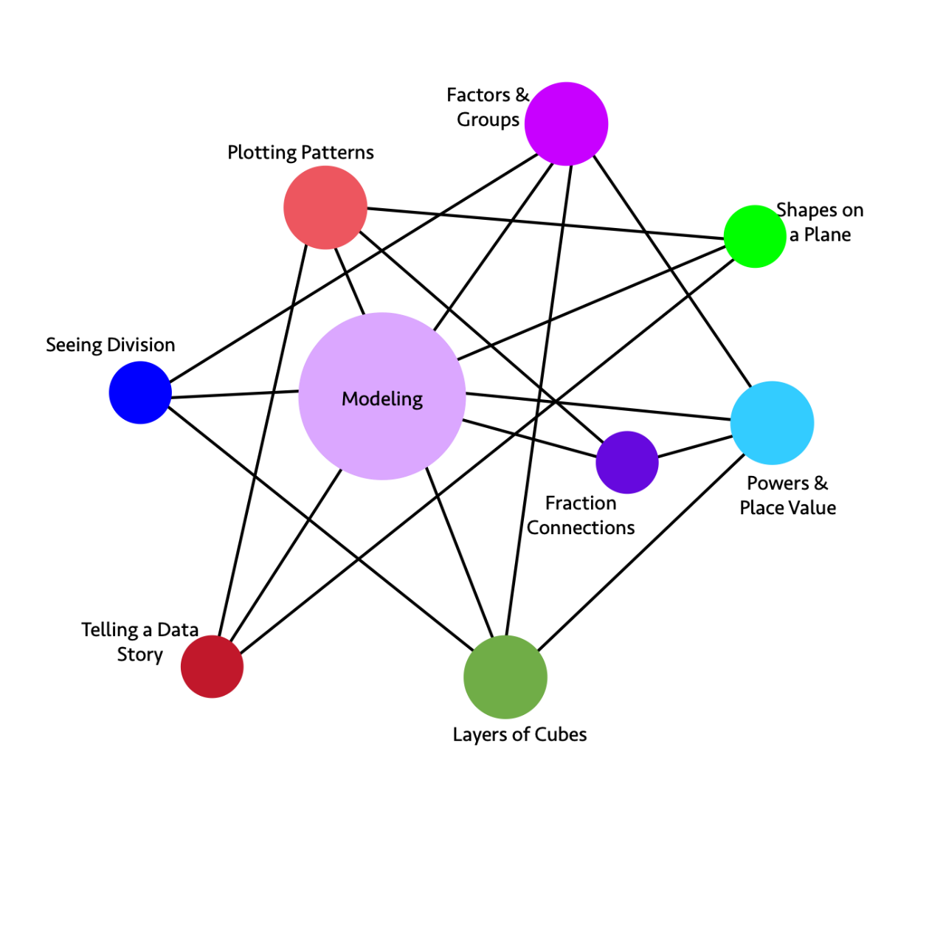
Long description: The graphic illustrates the connections and relationships of some fifth-grade mathematics concepts. Direct connections include:
- Factors & Groups directly connects to: Powers & Place Values, Layers of Cubes, Modeling, Seeing Division
- Shapes on a Plane directly connects to: Telling a Data Story, Modeling, Plotting Patterns
- Powers & Place Value directly connects to: Layers of Cubes, Fraction Connections, Modeling, Factors & Groups
- Layers of Cubes directly connects to: Powers & Place Value, Factors & Groups, Modeling, Seeing Division
- Telling a Data Story directly connects to: Shapes on a Plane, Modeling, Plotting Patterns
- Seeing Division directly connects to: Layers of Cubes, Modeling, Factors & Groups
- Plotting Patterns directly connects to: Telling a Data Story, Modeling, Fraction Connections, Shapes on a Plane
- Fraction Connections directly connects to: Powers & Place Value, Modeling, Plotting Patterns
- Modeling directly connects to: Plotting Patterns, Factors & Groups, Shapes on a Plane, Powers & Place Value, Fraction Connections, Layers of Cubes, Telling a Data Story, Seeing Division
Figure 7.4a. Grade 5 Content Connections, Big Ideas, and Standards
Content Connection | Big Idea | Grade 5 Standards
Communicating Stories with Data | Plotting Patterns | G.1, G.2, OA.3: MD.2, NF.7: Students generate and analyze patterns, plotting them on a line plot or coordinate plane, and use their graph to tell a story about the data. Some situations should include fraction and decimal measurements, such as a plant growing.
Communicating Stories with Data  &  Exploring Changing Quantities  &  Discovering Shape & Space | Telling a Data Story | G.1, G.2, OA.3: Understand a situation, graph the data to show patterns and relationships, and to help communicate the meaning of a real-world event.
Exploring Changing Quantities | Factors & Groups | OA.1, OA.2, MD.4, MD.5: Students use grouping symbols to express changing quantities and understand that a factor can represent the number of groups of the quantity.
Exploring Changing Quantities | Modeling | NBT.3, NBT.5, NBT.7, NF.1, NF.2, NF.3, NF.4, NF.5, NF.6, NF.7, MD.4, MD.5, OA.3: Set up a model and use whole, fraction, and decimal numbers and operations to solve a problem. Use concrete models and drawings and justify results.
Exploring Changing Quantities  &  Taking Wholes Apart, Putting Parts Together | Fraction connections | NF.1, NF.2, NF.3, NF.4, NF.5, NF.7, MD.2, NBT.3: Make and understand visual models, to show the effect of operations on fractions. Construct line plots from real data that include fractions of units.
Taking Wholes Apart, Putting Parts Together | Seeing Division | MD.3, MD.4, MD.5, NBT.4, NBT.6, NBT.7: Solve real problems that involve volume, area, and division, setting up models and creating visual representations. Some problems should include decimal numbers. Use rounding and estimation to check accuracy and justify results.
Taking Wholes Apart, Putting Parts Together | Powers and Place Value | NBT.3, NBT.2, NBT.1, OA.1, OA.2: Use whole number exponents to represent powers of 10. Use expanded notation to write decimal numbers to the thousandths place and connect decimal notation to fractional representations, where the denominator can be expressed in powers of 10.
Discovering Shape and Space | Layers of Cubes | MD.5, MD.4, MD.3, OA.1, MD.1: Students recognize volume as an attribute of three-dimensional space. They understand that a 1-unit by 1-unit by 1-unit cube is the standard unit for measuring volume. They decompose three-dimensional shapes and find volumes of right rectangular prisms by viewing them as decomposed into layers of arrays of cubes.
Discovering Shape & Space  &  Exploring Changing Quantities | Shapes on a Plane | G.1, G.2, G.3, G4, OA.3, NF.4, NF.5, NF.6: Graph 2-D shapes on a coordinate plane, notice and wonder about the properties of shapes, parallel and perpendicular lines, right angles, and equal length sides. Use tables to organize the coordinates of the vertices of the figures and study the changing quantities of the coordinates.

Chapter 8: Mathematics in Grades Six through Eight
Figure 8.1. A Progression Chart of Big Ideas through Grades 6-8
Content Connections | Big Ideas: Grade 6 | Big Ideas: Grade 7 | Big Ideas: Grade 8
Communicating Stories with Data | Variability in data | Visualize Populations | Data explorations
Communicating Stories with Data | The shape of distributions | Populations and samples | Data graphs and tables
Communicating Stories with Data | n/a | Probability Models | Interpret scatter plots
Exploring Changing Quantities | Fraction relationships | Proportional Relationships | Multiple representations of functions
Exploring Changing Quantities | Patterns inside numbers | Unit rates in the world | Linear equations
Exploring Changing Quantities | Generalizing with multiple representations | Graphing relationships | Slopes and intercepts
Exploring Changing Quantities | Relationships between variables | Scale Drawings | Interpret scatter plots
Taking Wholes Apart, Putting Parts Together | Model the world | Shapes in the world | Cylindrical investigations
Taking Wholes Apart, Putting Parts Together | Nets and Surface Area | 2-D and 3-D connections | Pythagorean explorations
Taking Wholes Apart, Putting Parts Together | n/a | Angle relationships | Big and small numbers
Discovering shape and space | Nets and Surface Area | Shapes in the world | Shape, number, and expressions
Discovering shape and space | Distance and direction | 2-D and 3-D connections | Pythagorean explorations
Discovering shape and space | Graphing shapes | Scale drawings | Cylindrical investigations
Discovering shape and space | n/a | Angle relationships | Transformational geometry

As students enter the middle grades, the number sense they acquired in the elementary grades deepens with the content. Students transition from exploring numbers and arithmetic operations in K–5 to exploring relationships between numbers (CC2—Exploring Changing Quantities and CC3—Taking Wholes Apart and Putting Parts Together) and making sense of contextual situations using various representations. SMP.2 is especially critical at this stage, as students represent a wide variety of real-world situations through the use of real numbers and variables in expressions, equations, and inequalities. Big ideas in number sense for the middle grades include:
- number line understanding;
- proportions, ratios, percents, and relationships among these; and
- and generalized numbers as leading to algebra.
The big ideas of data science include the following:
- Data in the world: exploration, interpretation, decision making, ethics
- Variability: describing, displaying, and comparing
- Sampling to understand a population: randomness, bias, how many?
- Are they related? Multivariate thinking
- What are the chances? Probability as the basis for data-based claims
As in earlier grades, students experience data science as a tool to help understand their worlds via a process that begins with wondering questions. This is also the beginning of the mathematical modeling cycle, the statistical and data science exploration process, and investigations in science.
The sixth through eighth grade span is an important time for further development of important mathematical concepts needed for high school. Students are introduced to irrational numbers through investigations using the Pythagorean Theorem. Students work with right triangles and apply their learning to further investigations of plane figures and solids, where the Pythagorean Theorem is useful in finding unknown measures. Students explore cylinders, cones, and spheres, while noticing radius as a useful component of right triangles. Students continue investigating 3-D shapes as they consider these shapes to be made up of slices of 2-D shapes. Students begin their formal study of transformational geometry as the study of shapes that twist, turn, and grow in the plane. Students investigate and make meaning of these transformations as they connect them to similarity and congruence.
The following interview highlights an educator who is using digital tools to help students in this grade span express their thinking and provide feedback and supports as necessary.
Voices from the Field: Martin Joyce | Taylor Middle School | Millbrae, CA
Joyce—a 12-year veteran who currently teaches pre-algebra at Taylor Middle School—leverages technology integration, collaboration, and feedback to engage all of his learners.
Describe some of the challenges that you and your students have experienced with the implementation of distance learning. How have you turned those into opportunities for success?
In terms of success, the most prominent example for me has been around using Desmos—imagine having an interactive PowerPoint with graphs, sketch capabilities, and fantastic feedback options. I’ve been fortunate to be part of their pilot sixth through eighth grade math curriculum. Students get real-time feedback and can use the data to continually revise their work. We can take snapshots of students’ work and use those as models to demonstrate to the entire class. In other words, it’s not just me showing them the successful way to problem solve.
Desmos complements monitoring, selecting, sequencing, and connecting extremely well. I really focus on questions to support those students who may struggle. As I monitor their work in real time, I see what they are doing (sketching) and then identify whose work I want to share. I select and invite participation from diverse learners who may not just volunteer. When it comes to their problem solving, I often start with the most common mistakes or the methods of success.
In terms of challenges, the primary one for me has been around pacing. I think teachers have had to accept that we are often not going to get as much done as we had in years past. I’ve had to continually ask myself reflective questions such as, “What do I skip?” or “Where do I compress?” I’ve really had to allow for more time, and I’ve had to learn to be more patient. I’ve also had to be flexible with when and how students may respond to questions.
Another challenge is that some students don’t participate in places like virtual breakout rooms versus how they might in face-to-face environments. Overall, I think the student discourse has lessened during distance learning. I’ve had to intervene and facilitate more. I’ve had to prompt them more to connect with one another. I’ve had to teach them more communication and collaboration skills.
One small tip I recently picked up is facilitating a Zoom [video conferencing platform] chat waterfall. I ask students to answer a question in the chat box but instruct them to not hit enter until told to do so. I honor time to wait or think and then have them hit enter to create a cascade (a waterfall) of responses all at once. Otherwise, we are influenced by one another’s responses or thoughts.
How do you strike a balance between analog and digital tools or synchronous and asynchronous learning experiences for your students?
This year, our school has scheduled asynchronous time Tuesday through Friday, 1:30-3:00 pm. Our classes are 80 minutes long. Students have three of these classes per day. We created the asynchronous opportunities to address the amount of screen time and to develop independence. We have used this time for office hours focused on intervention and support. For math, I take the practice problems and do a screencast recording for these asynchronous times. Although there are plenty of great YouTube tutorial videos for math, I think it’s valuable for students to have access to videos I create.
Synchronous time for me is focused on instruction and students working with me in real time. I use warm-ups to activate prior knowledge, we do some problems together with discussion, and then we have lesson synthesis after all of the activities. I have started to incorporate cool-downs or exit tickets. I use one or two problems for quick formative assessments.
How are you using technology to help students build foundational algebra skills and understand key concepts?
Desmos and game-like applications are helpful. Technology allows students to see these math principles in concrete representations. It allows them to visualize. They can try things and see if they are right or wrong. This works well with both horizontal and vertical number lines.
In eighth grade, we work with ratios and the slope of a graph. Desmos would be the key here for the graphing. Google Sheets [collaborative online spreadsheets] work well for the percentages and two-way tables.
I have a year-end project on the Pythagorean Theorem, which has traditionally been challenging for students who have been absent. I now use Edpuzzle [video-based lessons] to record myself and share videos on how they can get started. It’s great to voice over (audio record) my instruction and demonstrations.
What are your main priorities or concerns when selecting technology for your classes?
My primary considerations are both access and ease of use. I’m really starting to think that less is more when it comes to educational technology. I like to have a baseline app or an interface that I can use. It can’t always be about adding an entirely new thing.
For example, Flipgrid [video-based discussion software] is a great add-on, and it works extremely well with Desmos. It’s easy to use, and it creates opportunities for student voice. I use it from the first days of school, where students record themselves demonstrating the correct pronunciation of their name, as well as throughout the year for demonstrations of mastery. I will still use Desmos for the assessment, but if a student wants to increase their score, they can record themselves in Flipgrid discussing their mistakes and how to arrive at the right answer. I want them to convince me what they know now and didn’t know before. It doesn’t matter when one knows it, just that one knows it. I want to value the work and the learning.
I’ve really found HyperDocs [digital lesson plans] to be especially helpful during distance learning and think it will continue to have significant value as we return to face-to-face. It really gives students a structure to follow when doing a multi-step project.
There are a lot of great tools out there, but I don’t want to overwhelm my students with too many. I think teachers need to be more careful and intentional with introducing new technologies. I try to have a core application with a couple great add-ons.

Grade Six
Proportional reasoning, unit rates, and generalizing relationships are central to sixth grade. This represents a major shift for students and is worthy of deep, sustained attention. Students build new ways to represent the world symbolically, on the number line, and through data that add nuance to the mathematical terrain. In sixth grade, students are introduced to the concepts of ratios and unit rates, and they use tables of equivalent ratios, double number lines, tape diagrams, and equations to solve real-world problems. A critical feature to emphasize for students is the ability to think multiplicatively, as well as additively.
Students are often introduced to the idea of a variable, not through the concept of variation, but through exercises that ask them to find a missing number that is represented by x or another variable. Unfortunately, this gives them the idea that a variable stands for a single number, rather than something that varies - which causes students problems when they later need to learn about functions and other uses of algebra where a variable varies. The best way to introduce students to the idea of a variable is to give them examples of pattern growth that they can analyze, represent in words, and eventually as variables. The Path problem—finding how many squares are in the path that borders different sized squares—is an ideal way to introduce the concept of a variable. Ideas of equivalence and operations, laid before in earlier grades, now take on new meaning, as students apply properties of operations to generate equivalent expressions and identify when two expressions are equivalent.
Sixth-grade students engage in data investigations to help them understand variability. If they are given opportunities to develop curiosity and ask questions about the world, they can collect and analyze data, determine and confirm results, and represent findings with different representations. Teachers can ask students to collect data and/or bring in real data sets from the world that students are invited to investigate. The Common Online Data Analysis Platform (CODAP) is a website providing free educational software for data analysis. CODAP is an ideal tool for introducing students to data exploration. CODAP includes many interesting data sets and lessons, and students can look visually at the shape of data distributions, leading to consideration of measures of center and variability.
Students in grade six also develop new ways to compose and decompose with two- and three-dimensional shapes, thinking about volume and area as additive and using nets to explore the surfaces that create solids. Moving from 3-D solids to 2-D representations of 3-D solids is a topic where students explore, construct, and take apart, building with unit cubes and drawing representations. In a virtual environment, students can use a CAD, Tinkercad, or other programs to design and build complex shapes. While they are building 3-D representations in a 2-D space, it is important to ask students to think about what makes their 2-D drawings appear to be 3-D. Shapes in this environment may appear to be a parallelogram or a rhombus when they are representing a 3-D object—what the shape of the face really is in 3-D space is a square. Asking students to build their CAD designs out of cardboard or paper is a good way to have them explore the way shapes look when they change the angle of their view. Students in grade six also learn about absolute value. An ideal opportunity to learn absolute value is an exploration of the shapes on a 4-quadrant coordinate grid, with absolute value used as a measure of distance, while integer coordinates represent the vertices of the shapes.
Students who are English learners are encouraged to use their developing English and native language assets (e.g., cognates, morphological awareness) and draw on their prior knowledge. Teachers can examine text and tasks for key language forms and structures, and general as well as discipline-specific, high-utility academic vocabulary words linked to the big ideas and connections. Teachers can provide purposeful scaffolds and supports to engage EL students in sustained mathematical discourse in multiple contexts to build academic language and knowledge. Planned and “just-in-time” scaffolds and supports provide multiple entry points for meaning making and sharing of ideas in mathematical ways and include representations, expression starters and builders, and targeted and high-utility academic vocabulary and language structures (e.g., problems, explanations, arguments, descriptions). Teachers guide deconstruction and/or co-construction of problems, investigations, arguments, explanations, descriptions, and connections.
Critical Areas of Instructional Focus
Figure 8.2. Grade 6 Big Ideas
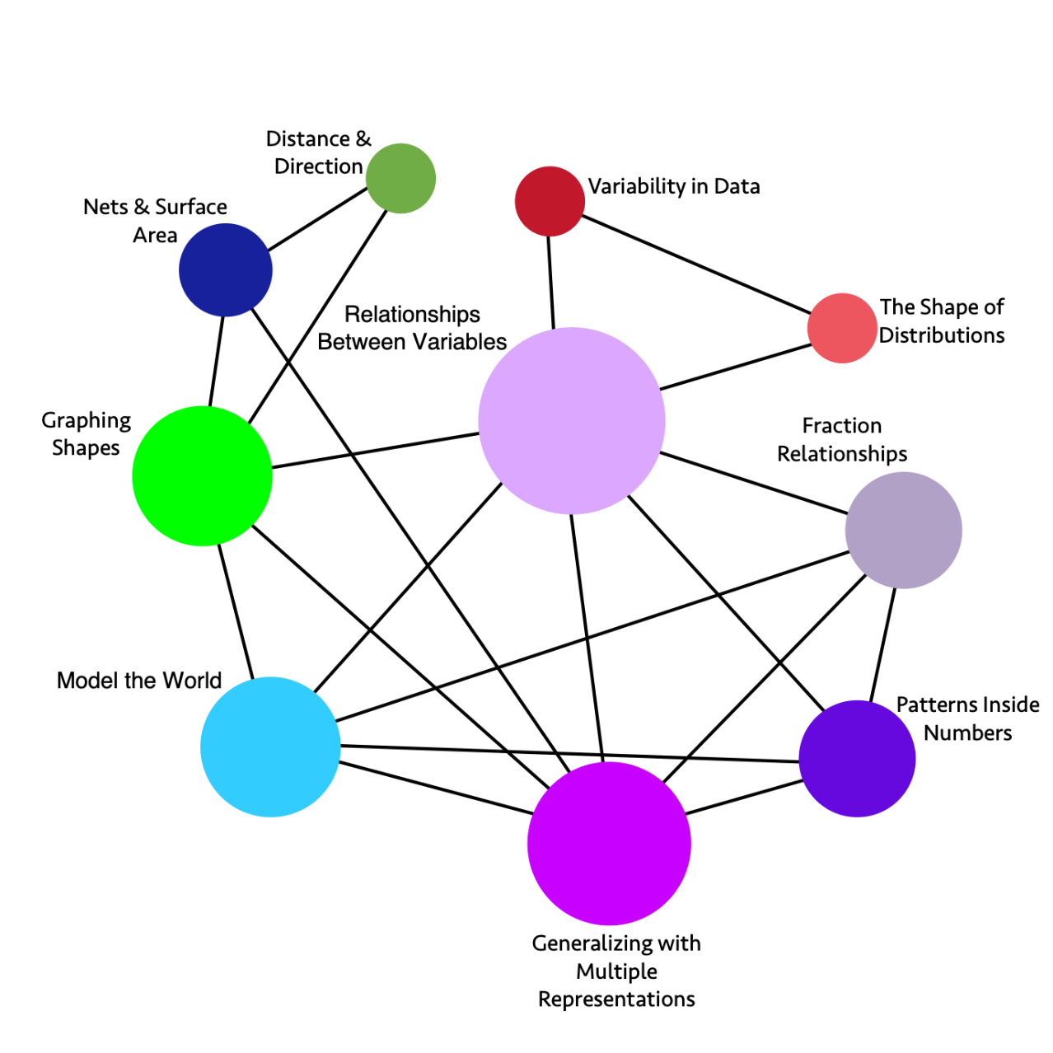
Long description: The graphic illustrates the connections and relationships of some sixth-grade mathematics concepts. Direct connections include:
- Variability in Data directly connects to: The Shape of Distributions, Relationships Between Variables
- The Shape of Distributions directly connects to: Relationships Between Variables, Variability in Data
- Fraction Relationships directly connects to: Patterns Inside Numbers, Generalizing with Multiple Representations, Model the World, Relationships Between Variables
- Patterns Inside Numbers directly connects to: Fraction Relationships, Generalizing with Multiple Representations, Model the World, Relationships Between Variables
- Generalizing with Multiple Representations directly connects to: Patterns Inside Numbers, Fraction Relationships, Model the World, Relationships Between Variables, Nets & Surface Area, Graphing Shapes
- Model the World directly connects to: Fraction Relationships, Relationships Between Variables, Patterns Inside Numbers, Generalizing with Multiple Representations, Graphing Shapes
- Graphing Shapes directly connects to: Model the World, Generalizing with Multiple Representations, Relationships Between Variables, Distance & Direction, Nets & Surface
- Nets & Surface directly connects to: Graphing Shapes, Generalizing with Multiple Representations, Distance & Direction
- Distance & Direction directly connects to: Graphing Shapes, Nets & Surface Area
- Relationships Between Variables directly connects to: Variability in Data, The Shape of Distributions, Fraction Relationships, Patterns Inside Numbers, Generalizing with Multiple Representations, Model the World, Graphing Shapes
Figure 8.2a. Grade 6 Content Connections, Big Ideas, and Standards
Content Connection | Big Idea | Grade 6 Standards
Communicating Stories with Data | Variability in Data | SP.1, SP.5, SP.4: Investigate real world data sources, ask questions of data, start to understand variability - within data sets and across different forms of data, consider different types of data, and represent data with different representations.
Communicating Stories with Data | The Shape of Distributions | SP.2, SP.3, SP.5: Consider the distribution of data sets - look at their shape and consider measures of center and variability to describe the data and the situation which is being investigated.
Exploring Changing Quantities | Fraction Relationships | NS.1, RP.1, RP.3: Understand fractions divided by fractions, thinking about them in different ways (e.g., how many 1/3 are inside 2/3?), considering the relationship between the numerator and denominator, using different strategies and visuals. Relate fractions to ratios and percentages.
Exploring Changing Quantities | Patterns inside Numbers | NS.4, RP.3: Consider how numbers are made up, exploring factors and multiples, visually and numerically.
Exploring Changing Quantities | Generalizing with Multiple Representations | EE.6, EE.2, EE.7, EE.3, EE.4, RP.1, RP.2, RP.3: Generalize from growth or decay patterns, leading to an understanding of variables. Understand that a variable can represent a changing quantity or an unknown number. Analyze a mathematical situation that can be seen and solved in different ways and that leads to multiple representations and equivalent expressions. Where appropriate in solving problems, use unit rates.
Exploring Changing Quantities | Relationships Between Variables | EE.9, EE.5, RP.1, RP.2, RP.3, NS.8, SP.1, SP.2: Use independent and dependent variables to represent how a situation changes over time, recognizing unit rates when it is a linear relationship. Illustrate the relationship using tables, 4 quadrant graphs and equations, and understand the relationships between the different representations and what each one communicates.
Taking Wholes Apart, Putting Parts Together | Model the World | NS.3, NS.2, NS.8, RP.1, RP.2, RP.3: Solve and model real world problems. Add, subtract, multiply, and divide multi-digit numbers and decimals, in real-world and mathematical problems - with sense making and understanding, using visual models and algorithms.
Taking Wholes Apart, Putting Parts Together  &  Discovering Shape and Space | Nets and Surface Area | EE.1, EE.2, G.4, G.1, G.2, G.3: Build and decompose 3-D figures using nets to find surface area. Represent volume and area as expressions involving whole number exponents.
Discovering Shape and Space | Distance and Direction | NS.5, NS.6, NS.7, G.1, G.2, G.3, G.4: Students experience absolute value on numbers lines and relate it to distance, describing relationships, such as order between numbers using inequality statements.
Discovering Shape and Space | Graphing Shapes | G.3, G.1, G.4, NS.8, EE.2: Use coordinates to represent the vertices of polygons, graph the shapes on the coordinate plane, and determine side lengths, perimeter, and area.

Grade Seven
A big idea for seventh grade is proportional reasoning, which students experience in many different ways as they consider fractions, decimals, percents, and integers. An important idea for students is that every fraction, decimal, percent, integer, and whole number can be written as a rational number defined to be the ratio of two integers and understandings of fractions, decimals, percents, integers, and whole numbers can all be subsumed into a larger understanding of rational numbers. This unified understanding is achieved, in part, through students’ use of number lines to represent operations on rational numbers, such as the addition and subtraction of rational numbers on a number line. Students can be introduced to a host of representations as they reason through proportional situations: graphs, equations, verbal descriptions, tables, charts, and double number lines. There are many approaches to solving proportions, and it is important to emphasize that sense-making is more important than answer finding.
Students in seventh grade should continue investigations that involve generalization, allowing them to see and use algebra as a useful problem-solving tool.
A big idea in the Communicating Stories with Data strand is variability, and understanding variability is at the heart of data literacy. When working with visualizations of data, students consider not only the most popular value in a dataset (the mode) but also describe the shape and spread of data distributions. As they engage in experiences where they produce their own data through measurement, teachers can highlight for students the variation that results. For example, if students plant a particular variety of flower seed at multiple locations around the school, then measure the plants’ height and the amount of sunlight each month, they can conduct investigations into the ways plant growth and sunlight relate to each other. They Discuss and describe any patterns in their bivariate data and reasons for the variability. Finally, students consider their own measurement techniques and how confident they are that they all measured the same way (so that if someone else measured, they would get the same height or sunlight). Students can be invited to study populations by taking random samples and determining if the samples accurately represent the population, considering issues of bias and ethics. They can use classroom simulations and computer software to model repeated sampling, analyzing the variation in results. Students can also use measures of center and variability to draw comparative inferences about populations, considering what the visual plots show.
New ideas for grade seven are randomness, probability, and uncertainty. At this point, students can begin to conceive of probability as a measure of the chance that something will happen, seeing it as a basic measure of certainty or uncertainty. They can learn to use sample spaces, lists, tables, and tree diagrams.
Students connect proportional reasoning to the two- and three-dimensional world through the construction of scale figures. Students investigate angles and connections between angles, including supplementary and complementary angles, noticing that increasing one decreases the other.
Students solve problems involving solid figures and develop intuition about 2-D slices of 3-D figures. The idea of sliced objects and the shape produced, as well as measure and area, is important to the further study of mathematics in higher education. Students can be using technology to support their calculations as they are building understanding of the physical shapes. In a virtual environment, students can use a CAD, Tinkercad, or other program to design and build complex shapes. While they are building 3-D representations in a 2-D space, it is important to ask students to think about what makes their 2-D drawings appear to be 3-D. Shapes in this environment may appear to be a parallelogram or a rhombus when they are representing a 3-D object—what the shape of the face really is in 3-D space is a square. Asking students to build their CAD designs out of cardboard or paper is a good way to have them explore the way shapes look when they change the angle of their view.
Measurements that include decimal and fraction numbers can be used throughout their investigations. When considering physical objects and quantifying the objects using measures, students are supported in building important connections between visual models and numbers.
Students who are English learners are encouraged to use their developing English and native language assets (e.g., cognates, morphological awareness) and draw on their prior knowledge. Teachers can examine text and tasks for key language forms and structures, and general as well as discipline-specific, high-utility academic vocabulary words linked to the big ideas and connections. Teachers can provide purposeful scaffolds and supports to engage EL students in sustained mathematical discourse in multiple contexts to build academic language and knowledge. Planned and “just-in-time” scaffolds and supports provide multiple entry points for meaning making and sharing of ideas in mathematical ways and include representations, expression starters and builders, and targeted and high-utility academic vocabulary and language structures (e.g., problems, explanations, arguments, descriptions, and connections). Teachers guide deconstruction and/or co-construction of problems, investigations, arguments, explanations, descriptions, and connections. Clear and precise expressions, as well as cohesive writing, support stronger communication of mathematical concepts and practices.
Critical Areas of Instructional Focus
Figure 8.3 Grade 7 Big Ideas
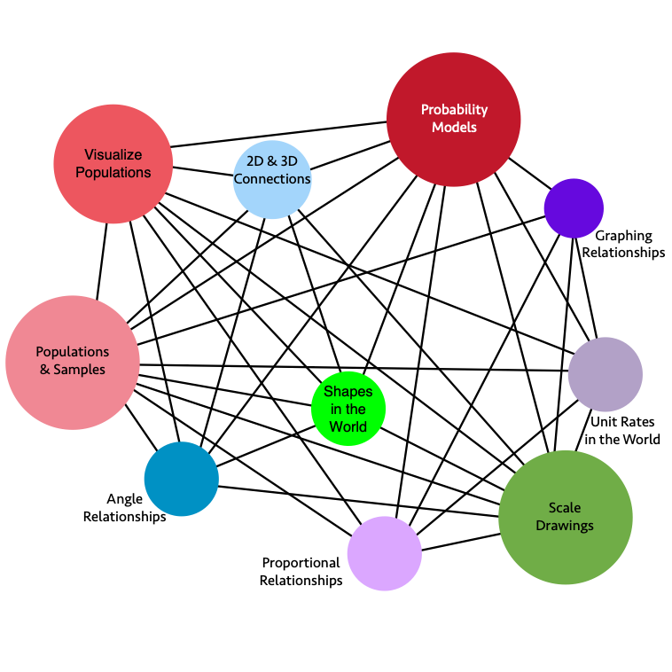
Long description: The graphic illustrates the connections and relationships of some seventh-grade mathematics concepts. Direct connections include:
- Angle Relationships directly connects to: Scale Drawings, 2D & 3D Connections, Populations & Samples, Proportional Relationships, Shapes in the World, Visualize Populations, Probability Models
- Scale Drawings directly connects to: 2D & 3D Connections, Graphing Relationships, Populations & Samples, Unit Rates in the World, Proportional Relationships, Visualize Populations, Probability Models, Angle Relationships
- Graphing Relationships directly connects to: Populations & Samples, Unit Rates in the World, Proportional Relationships, Probability Models, Scale Drawings
- 2D & 3D Connections directly connects to: Scale Drawings, Angle Relationships, Probability Models, Proportional Relationships, Visualize Populations, Shapes in the World, Populations & Samples
- Populations & Samples directly connects to: 2D & 3D Connections, Scale Drawings, Angle Relationships, Probability Models, Proportional Relationships, Visualize Populations, Shapes in the World, Unit Rates in the World, Graphing Relationships
- Unit Rates in the World directly connects to: Populations & Samples, Graphing Relationships, Scale Drawings, Proportional Relationships, Probability Models, Visualize Populations
- Shapes in the World directly connects to: Populations & Samples, 2D & 3D Connections, Proportional Relationships, Scale Drawings, Angle Relationships, Probability Models, Visualize Populations
- Visualize Populations directly connects to: 2D & 3D Connections, Scale Drawings, Angle Relationships, Probability Models, Proportional Relationships, Populations & Samples, Shapes in the World, Unit Rates in the World
- Probability Models directly connects to: 2D & 3D Connections, Scale Drawings, Angle Relationships, Proportional Relationships, Visualize Populations, Shapes in the World, Unit Rates in the World, Graphing Relationships, Populations & Samples
- Proportional Relationships directly connects to: 2D & 3D Connections, Scale Drawings, Angle Relationships, Probability Models, Populations & Samples, Visualize Populations, Shapes in the World, Unit Rates in the World, Graphing Relationships
Figure 8.3a. Grade 7 Content Connections, Big Ideas, and Standards
Content Connection | Big Idea | Grade 7 Standards
Communicating Stories with Data | Populations & Samples | SP.1, SP.2, RP.1, RP.2, RP.3, NS.1, NS.2, NS.3, EE.3: Study a population by taking random samples and determine if the samples accurately represent the population.  - Analyze and critique reports by examining the sample and the claims made to the general population  - Use classroom simulations and computer software to model repeated sampling, analyzing the variation in results.
Communicating Stories with Data | Visualize Populations | SP.3, SP.4, NS.1, NS.2, NS.3, EE.3: Draw comparative inferences about populations - consider what visual plots show, and use measures of center and variability  - Students toggle between the mathematical results and their meaningful interpretation with their given context, considering audiences, implications, etc.
Communicating Stories with Data | Probability Models | SP.5, SP.6, SP.7, SP.8, RP.1, RP.2, RP.3, NS.1, NS.2, NS.3, EE.3: Develop a probability model and use it to find probabilities of events and compound events, representing sample spaces and using lists, tables, and tree diagrams.  - Compare observed probability and expected probability.  - Explore potential bias and over-representation in real world data sets, and connect to dominating narratives and counter narratives used in public discourse.
Exploring Changing Quantities | Proportional Relationships | EE.2, EE.3, RP.1, RP.2, RP.3: Explore, understand, and use proportional relationships: - using fractions, graphs, and tables.
Exploring Changing Quantities | Unit Rates in the World | RP.1, RP.2, RP.3, EE1, EE.2, EE.3, EE.4: Solve real world problems using equations and inequalities, and recognize the unit rate within representations.
Exploring Changing Quantities | Graphing Relationships | EE.4, RP.1, RP.2, RP.3: Solve problems involving proportional relationships that can lead to graphing using geometry software and making sense of solutions.
Taking Wholes Apart, Putting Parts Together  &  Discovering Shape and Space | 2-D and 3-D Connections | G.1,G.2, G.3, NS.1, NS.2, NS.3: Draw and construct shapes, slice 3-D figures to see the 2-D shapes. Compare and classify the figures and shapes using area, surface area, volume, and geometric classifications for triangles, polygons, and angles. Make sure to measure with fractions and decimals, using technology for calculations
Taking Wholes Apart, Putting Parts Together  &  Discovering Shape and Space | Angle Relationships | G.5, G.6, NS.1, NS.2, NS.3: Explore relationships between different angles, including complementary, supplementary, vertical, and adjacent, recognizing the relationships as the measures change. For example, angles A and B are complementary. As the measure of angle, A increases, the measure of angle B decreases.
Discovering Shape and Space  &  Exploring Changing Quantities | Scale Drawings | G.1, EE.2, EE.3, EE.4, NS.2, NS.3, RP.1, RP.2, RP.3: Solve problems involving scale drawings and construct geometric figures using unit rates to accurately represent real world figures. (Use technology for drawing)
Discovering Shape and Space  &  Exploring Changing Quantities | Shapes in the World | G.1, G.2, G.3, G.4, G.5, G.6, NS.1, NS.2, NS.3: Solve real life problems involving triangles, quadrilaterals, polygons, cubes, right prisms, and circles using angle measures, area, surface area, and volume.

Grade Eight
In eighth grade, students’ understanding of rational numbers is extended in two important ways. First, rational numbers have decimal expansions, which eventually repeat, and vice versa. All numbers with decimal expansions, which eventually repeat, are rational numbers. A typical task to demonstrate the first aspect of this standard is to ask students to investigate long division with a calculator, or other technology, to demonstrate that 3/11 has a repeating decimal expansion, and to explain why. As students realize the connection between the remainder and the repeating portion, their understanding of rational numbers can fully integrate with their understanding of decimals and place value.
Second, as students begin to recognize that there are numbers that are not rational, which are called irrational numbers, they can see that these new types of numbers can still be located on the number line and can also be approximated by rational numbers. The foundation for this recognition is actually built through seventh-grade geometry explorations of the relationship between the circumference and diameter of a circle, and formalized into the formula for circumference, where the division of the circumference by the diameter for a given circle always results in a number a little larger than three, irrespective of the size of the circle. In exploring this quotient of circumference by diameter, students get a look at a decimal approximation for their first irrational number, pi. In eighth grade, the notation for numbers expands greatly, with the introduction of integer exponents and radicals to represent solutions of equations. Number sense plays a critical role in eighth grade, as students can check the accuracy of their answers with estimation. They can also use technological tools to work with place value and to express large and small numbers in scientific notation.
Proportional relationships continue to be a hub of mathematical thought in eighth grade, serving as a tool for thinking about patterns of growth, functions, and geometric transformations. Functions are an important addition to the algebraic space in eighth grade. One big idea that challenges students’ notions of clean, linear relationships, after all their work on functions and proportions, is the idea of extracting meaning from data. Data in the real world is rarely neat and lock-step; this is an important moment to develop a lens for looking at scatter plots and genuinely asking what relationships can be found.
Eighth grade students conduct data investigations that allow them to interpret bivariate and multivariate data. They also continue to visualize and represent single-variable data with dot plots, histograms, and box plots; use measures of center and spread to describe such distributions; and compare distributions from different populations or samples using these representations and statistics. Students also construct scatter plots, which show an association between two variables that is visually identifiable. Fitting a function to the data is the creation of a mathematical model. This work begins in eighth grade with visual fitting of a linear model. While the type of function that is used most frequently is a line (a linear function), students also need experiences with plotting associations that are clearly non-linear, as well as experimenting with fitting other types of functions (quadratic, exponential).
Any standard data software (including spreadsheets, Desmos, Geogebra, CODAP) will fit lines, quadratic functions, and exponential functions to given data. Students have experiences fitting lines and some other functions visually (by adjusting parameters on appropriate function types in graphing software) and using appropriate software tools, which perform the regression behind the scenes.
In grade eight, students are introduced to irrational numbers through the study of circles, spheres, and other solids that have a circle as a base. Students investigate the relationships between the side lengths of right triangles and use the Pythagorean Theorem to find a missing side length when two others are known. When studying quadrilaterals and using the Pythagorean Theorem, students can consider rectangles and squares with whole number side lengths and investigate which rectangles have diagonals with irrational side lengths. Students connect their understanding of right triangles and the Pythagorean Theorem to solids where they can use this knowledge to determine distances between two points. Students continue their study of two-dimensional shapes as they learn to move them across a plane, using transformations to investigate similarity and congruence. This initial journey into slides, rotations, reflections, and dilations is intended to be an initial introduction and should include the use of a dynamic geometric software.
Students who are English learners are encouraged to use their developing English and native language assets (e.g., cognates, morphological awareness) and draw on their prior knowledge. Teachers can examine text and tasks for key language forms and structures, and general as well as discipline-specific, high-utility academic vocabulary words linked to the big ideas and connections. Teachers can provide purposeful scaffolds and supports to engage EL students in sustained mathematical discourse in multiple contexts to build academic language and knowledge. Planned and “just-in-time” scaffolds and supports provide multiple entry points for meaning making and sharing of ideas in mathematical ways and include representations, expression starters and builders, and targeted and high-utility academic vocabulary and language structures (e.g., problems, explanations, arguments, descriptions, and connections). Teachers guide deconstruction and/or co-construction of problems, investigations, arguments, explanations, descriptions, and procedures. Clear and precise expressions, as well as cohesive writing, support stronger communication of mathematical concepts and practices.
Critical Areas of Instructional Focus
Figure 8.4. Grade 8 Big Ideas
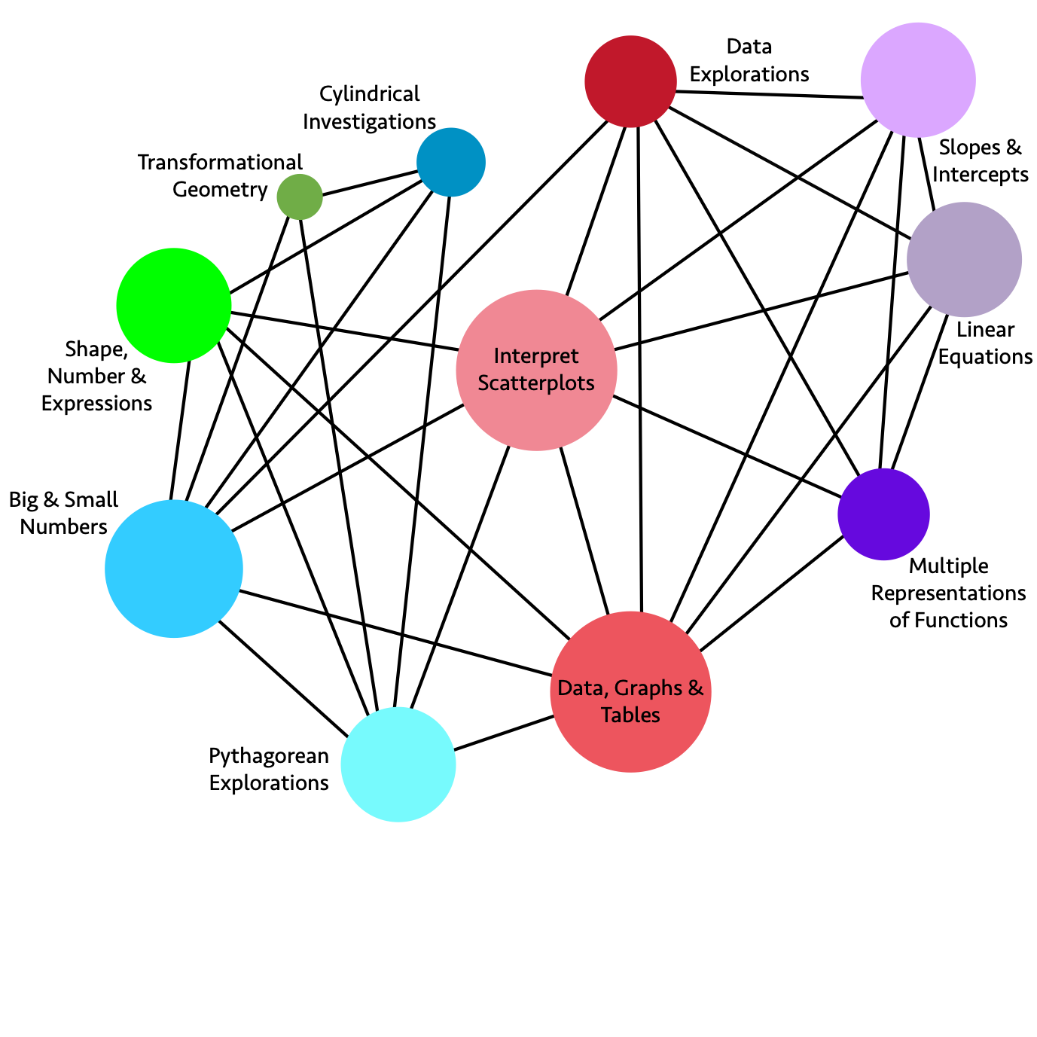
Long description: The graphic illustrates the connections and relationships of some eighth-grade mathematics concepts. Direct connections include:
- Data Explorations directly connects to: Slopes & Intercepts, Linear Equations, Multiple Representations of Functions, Data Graphs & Tables, Interpret Scatter plots, Big & Small Numbers
- Slopes & Intercepts directly connects to: Linear Equations, Multiple Representations of Functions, Data Graphs & Tables, Interpret Scatter plots, Data Explorations
- Linear Equations directly connects to: Slopes & Intercepts, Data Explorations, Multiple Representations of Functions, Data Graphs & Tables, Interpret Scatter plots
- Multiple Representations of Functions directly connects to: Data Graphs & Tables, Interpret Scatter plots, Data Explorations, Slopes & Intercepts, Linear Equations
- Data Graphs & Tables directly connects to: Multiple Representations of Functions, Linear Equations, Slopes & Intercepts, Data Explorations, Interpret Scatter plots, Shape Number & Expressions, Big & Small Numbers, Pythagorean Explorations
- Pythagorean Explorations directly connects to: Data Graphs & Tables, Interpret Scatter plots, Cylindrical Investigations, Transformational Geometry, Shape Number & Expressions, Big & Small Numbers
- Big & Small Numbers directly connects to: Pythagorean Explorations, Data Graphs & Tables, Interpret Scatter plots, Data Explorations, Cylindrical Investigations, Transformational Geometry, Shape Number & Expressions
- Shape Number & Expressions directly connects to: Big & Small Numbers, Pythagorean Explorations, Data Graphs & Tables, Interpret Scatter plots, Cylindrical Investigations
- Transformational Geometry directly connects to: Big & Small Numbers, Pythagorean Explorations, Cylindrical Investigations
- Cylindrical Investigations directly connects to: Big & Small Numbers, Pythagorean Explorations, Shape Number & Expressions, Transformational Geometry
- Interpret Scatter plots directly connects to: Data Explorations, Slopes & Intercepts, Linear Equations, Multiple Representations of Functions, Data Graphs & Tables, Pythagorean Explorations, Big & Small Numbers, Shape Number & Expressions
Figure 8.4a. Grade 8 Content Connections, Big Ideas, and Standards
Content Connection | Big Idea | Grade 8 Standards
Communicating Stories with Data  &  Exploring Changing Quantities | Interpret Scatter plots | SP.1, SP.2, SP.3, EE.2, EE.5, F.1, F.2, F.3: Construct and interpret data visualizations, including scatter plots for bivariate measurement data using two-way tables. Describe patterns noting whether the data appear in clusters, are linear or nonlinear, whether there are outliers, and if the association is negative or positive. Interpret the trend(s) in change of the data points over time.
Communicating Stories with Data | Data, Graphs & Tables | SP.3, SP.4, EE.2, EE.5, F.3, F.4, F.5: Construct graphs of relationships between two variables (bivariate data), displaying frequencies and relative frequencies in a two-way table.  - Use graphs with categorical data to help students describe events in their lives, looking at patterns in the graphs.
Communicating Stories with Data | Data Explorations | SP.1, SP.2, SP.3, SP.4, EE.4, EE.5, F.1, F.2, F.3, F.4, F.5: Conduct data explorations, such as the consideration of seafloor spreading, involving large data sets and numbers expressed in scientific notation, including integer exponents for large and small numbers using technology.  - Identify a large dataset and discuss the information it contains  - Identify what rows and columns represent in a spreadsheet
Exploring Changing Quantities | Linear Equations | EE.5, EE.7, EE.8, F.2, F.4, F.5: Analyze slope and intercepts and solve linear equations including pairs of simultaneous linear equations through graphing and tables and using technology.
Exploring Changing Quantities | Multiple Representations of Functions | EE.5, EE.6, EE.7: Move between different representations of linear functions (i.e., equation, graph, table, and context), sketch and analyze graphs, use similar triangles to visualize slope and rate of change with equations containing rational number coefficients.
Exploring Changing Quantities | Slopes & Intercepts | EE.5, SP.1, SP.2, SP.3: Construct graphs using bivariate data, comparing the meaning of parallel and non-parallel slopes with the same or different y-intercepts using technology.
Taking Wholes Apart, Putting Parts Together  &  Discovering Shape and Space | Cylindrical Investigations | G.9, G.6, G.7, G.8, NS.1, NS.2: Solve real world problems with cylinders, cones, and spheres. Connect volume and surface area solutions to the structure of the figures themselves (e.g., why and how is the area of a circle formula used to find the volume of a cylinder?). Show visual proofs of these relationships, through modeling, building, and using computer software.
Taking Wholes Apart, Putting Parts Together  &  Discovering Shape and Space | Pythagorean Explorations | G.7, G.8, NS.1, NS.2, EE.1, EE.2: Conduct investigations in the coordinate plane with right triangles to show that the areas of the squares of each leg combine to create the square of the hypotenuse and name this as the Pythagorean Theorem. Using technology, use the Pythagorean Theorem to solve real world problems that include irrational numbers.
Taking Wholes Apart, Putting Parts Together | Big & Small Numbers | EE.1, EE.2, EE.3, EE.4, NS.1, NS.2: Use scientific notation to investigate problems that include measurements of very large and very small numbers. Develop number sense with integer exponents (e.g., 1/27 =1/3³ = 3⁻³).
Discovering Shape and Space | Shape, Number & Expressions | G.9, G.6, G.7, G.8, EE.1, EE.2, NS.1, NS.2: Compare shapes containing circular measures to prisms. Note that cubes and squares represent unit measures for volume and surface area. See and use the connections between integer exponents and area and volume.
Discovering Shape and Space | Transformational Geometry | G.1, G.2, G.3, G.4, G.5, G.6, G.7, G.8: Plot two dimensional figures on a coordinate plane, using geometry software, noting similarity when dilations are performed and the corresponding angle measures maintain congruence. Perform translations, rotations, and reflections and notice when shapes maintain congruence.

Chapter 9: Mathematics in High School, Grades Nine and Ten
This section focuses on years 9 and 10, as the Mathematics Framework sets out a few common pathways for grades 9 and 10, followed by a plethora of options for later years, as set out in Figure 9.1:
Figure 9.1: High School Pathways from the Mathematics Framework
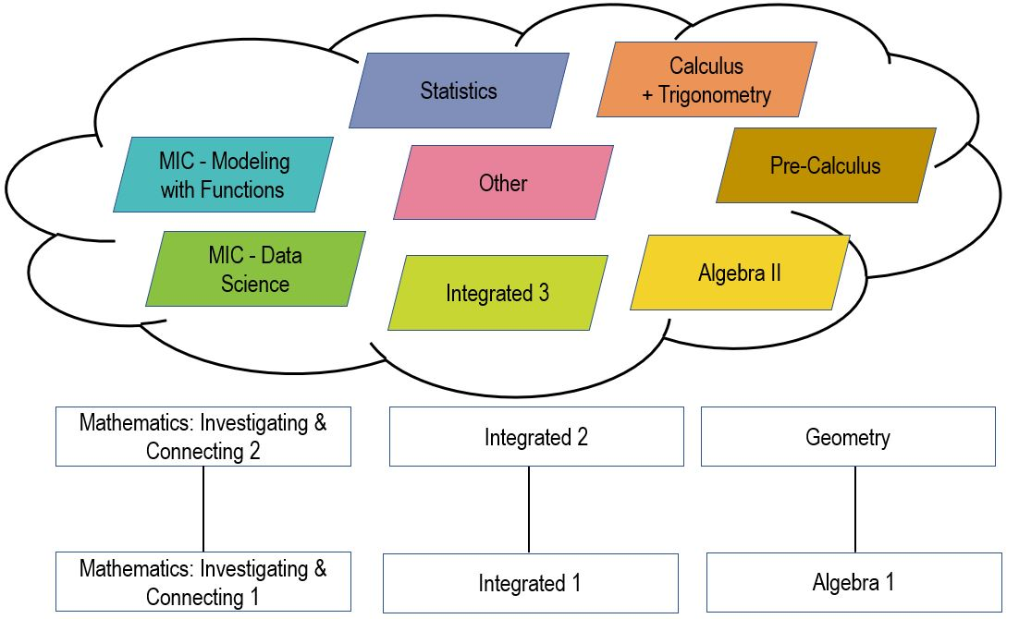
Long description: Diagram indicates three pathways of courses indicating a variety of course offerings. The preparatory courses are indicated at the bottom of the diagram. Starting from the bottom up, these include: Investigating and Connecting 1, Integrated 1, and Algebra 1. These are followed by Investigating and Connecting 2, Integrated 2, and Geometry, respectively. The later course options include: MIC – Modeling with Functions, Statistics, Calculus with Trigonometry, Pre-Calculus, Integrated 3, Algebra II, MIC – Data Science, and Other.
In the first two years of high school, the big ideas of mathematics fall into three main areas, which are ideally taught together rather than as separate courses. When the content is truly integrated, for example, students learning the content of functions through exciting data explorations, or analyzing the design of buildings with great cultural significance by studying and representing patterns of shapes and their transformations and vectors, then the content of high school comes to life. At this time, students can be learning to develop models and to use technological tools, such as geometry software, data modeling tools, such as CODAP, and programs that provide conceptual insights into computation, such as Desmos and Wolfram-Alpha.

Algebra and Functions
The number sense students developed in grades kindergarten through eight help students see the parallels between numbers (and how they interact) and functions, especially polynomials and rational functions. This area of mathematics should develop students’ ability to recognize, represent, and solve problems involving relations among quantitative variables. Students can start to engage in the modelling of problems, using linear, quadratic, exponential, power, and polynomial functions. The investigations with this content, which fall under the area of “Exploring Changing Quantities” will help students to understand rates of change, growth, and decay functions, and many other topics important to solving problems in the world. As students investigate with the power of mathematical modeling, they will see the ways that they can use mathematics to make sense of the world and impact the future, two of the Drivers of Investigation. Many of the important algebraic topics can be taught through data investigations.

Data Literacy leading to Data Science
In the high school years, students develop their understanding of variability, learning how to measure and analyze variation. They can also be introduced to large and complex data sets and encouraged to ask their own questions of the data. Ideally, teachers will bring in data sets from their own communities, so that students can use mathematics to solve important problems that help their communities and develop their sense of mathematical agency (Berry et al., 2020). Randomization is an important high school understanding, leading to probability models and sample spaces. Technology plays an important role as it makes it possible for students to generate plots, regression functions, and correlation coefficients.
This is the beginning of moving from data literacy to the subject known as “data science” for students and a time when they can be using powerful technological tools to help visualize data distributions and analyze data. Data investigations, represented in Figure 9.2, involve many different areas of content, from within and outside mathematics, and students can be encouraged to report on their investigations, communicating their results with words, numbers, and data visualizations. The Mathematics Framework shares many ideas for data investigations that help students learn about social and racial injustices (such as redlining, voter suppression, wealth gap, and food insecurity), agriculture, the environment, healthcare, and other topics of importance for students in California.
Figure 9.2. GAISE Report 2020. (Franklin & Bargagliotti, 2020)
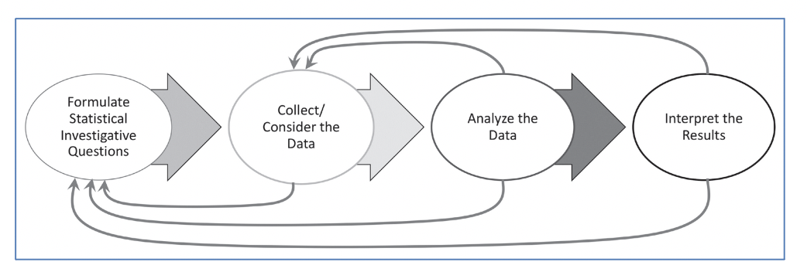

Visual and Geometric Reasoning
The third strand of the high school years with ideas from Discovering Shape and Space & Taking Wholes Apart, Putting Parts Together, is in visual and geometric reasoning. Students learn to construct and interpret mathematical models in visual and physical terms. They learn to describe patterns in shape, size, and location, representing patterns with drawings, coordinates, and vectors. Geometric ideas can be developed through experimentation and reasoning, while probabilistic ideas can be developed through geometric sample spaces.
Students who are English learners are encouraged to use their developing English and native language assets (e.g., cognates, morphological awareness) and draw on their prior knowledge. Teachers can examine text and tasks for key language forms and structures, and general as well as discipline-specific, high-utility academic vocabulary words linked to the big ideas and connections. Teachers can provide purposeful scaffolds and supports to engage EL students in sustained mathematical discourse in multiple contexts to build academic language and knowledge. Planned and “just-in-time” scaffolds and supports provide multiple entry points for meaning making and sharing of ideas in mathematical ways and include representations, expression starters and builders, and targeted and high-utility academic vocabulary and language structures (e.g., problems, explanations, arguments, descriptions, and connections). Teachers guide deconstruction and/or co-construction of problems, investigations, arguments, explanations, descriptions, and connections. Clear and precise expressions, as well as cohesive writing, support stronger communication of mathematical concepts and practices.
The following interview highlights an educator who is using digital tools to help students in this grade span express their thinking and collaborate with peers on problems, as well as to provide feedback and support as necessary.
Voices from the Field: Kristan Morales | Chaparral High School | Temecula, CA
With 25 years of experience in the classroom, math teacher Kristan Morales focuses on engagement, technology integration, and social-emotional learning. She continues to reevaluate and redesign her math instruction, pushing the envelope with what’s possible in math class in order to better serve her diverse learners.
Morales—who teaches geometry and pre-calculus and serves as a technology coach at Chaparral High School in the Temecula Valley Unified School District—has experienced high levels of student engagement, creativity, and learning outcomes.
How have you overcome the challenges of remote instruction, especially balancing synchronous and asynchronous learning experiences for your students?
For me, whether it’s in-person or virtual, my dominant focus is always about student connections and connectivity. Granted, this has proven to be more challenging online. So, I knew right away that I would have to be intentional in creating opportunities to connect in virtual settings.
I created something I call “What’s Up Weekly.” It starts as a blank slideshow where every student creates a slide asynchronously. The students post their submission each week on a class Padlet [collaborative digital presentation software]. So, when I’m online with them, I refer to these slideshows and ask them to share. This is about creating community. I’ve learned so much about them, and they have, in turn, learned so much about one another.
Students buy into the relationship and the connection first, then into the math. One has to create and facilitate situations to hear students’ voices. We have 90-minute classes, and there is no way that we are only going to listen to me talking. Some are reluctant, but I continue to create more ways for students to participate. We have such great tools now—all available to create these different avenues for students to be heard and for teachers to learn from students.
Even our traditional way of sharing our daily agenda has to be rethought. I now use a three-part Hyperdoc: explore, explain, and apply. Everyone can access this—students, parents, special education staff, and counselors.
In what ways are you combining analog and digital tools for distance learning?
There is no way around doing analog work in math. Math teachers have traditionally used notebooks to document student work and check for understanding or mastery. Well, we now can use very dynamic digital notebooks.
Math is built for analog and digital to co-exist and complement one another. For example, we solve problems on paper but can take pictures of them to document. I have my students work in teams and jigsaw the problems. They share with their teams using Jamboards [collaborative digital whiteboards] or Google Slides [collaborative digital presentation software].
There are so many ways to deploy digital tools with analog experiences. For example, while recently learning about radius and 2Pi, I asked my students to find a cylinder at home. It could be anything from lip gloss to a paper towel roll, coffee can, or skateboard wheel. As another example, we recently used household items and photography to study volume and students shared their work on Padlet. I have had success when my students do analog activities but then show their work digitally.
How do these digital tools used during remote instruction enhance what may be done in a traditional classroom setting?
For asynchronous times, I might focus on additional support. I may add a video of me thinking out loud while demonstrating something or working out a math problem. Many teachers will not make a mistake in their problem solving when creating a video. That will leave kids thinking that math is perfect, not messy. When in reality, we need to demonstrate the mistakes. When you make a mistake, neuroscience shows we are learning.
The tools available now can really improve the experience for learners. As an example, I use Desmos for graphing. This amazing free tool allows us to go much further and faster. Recently, we did a lesson using pendulums, and we collected the data in class using pendulums of different lengths. We then used our class data to curve fit the correct function using Desmos and our knowledge of functions. Once we found the best function to match our data, we made a prediction as to how much time it would take for a giant pendulum to swing, and our function from Desmos was very accurate.
We need to see end results more quickly and be able to visualize the learning. My students don’t need to get bogged down in hand graphing. Geogebra is another free tool that is particularly useful for angles and relationships. Like Desmos, students are able to experience the dynamic properties in math. These tools have allowed students to see math in new and powerful ways. Technology doesn’t replace analog but rather enhances the understanding and power of discovery for my students.
I really appreciate incorporating high quality tools that are free and available to all. I also really see value in tools that support all learners. For example, I think tools, such as Google Apps and Pear Deck [a formative assessment platform], are great because of the immersive reader or translation capabilities, making text and images larger and more.
I think tools that provide teachers with high-quality and real-time data and feedback on their students are important, too. Nearpod is a great formative assessment platform that provides teachers insight into what their students are thinking about, learning, or needing is useful. A recent Nearpod focused on special right triangles. Teachers know how to create content, but we need to continue to develop ways for all learners to engage in the content. We’re not spending a lot of money on paper and copies any longer, so let’s keep investing in technology and our students.
Figure 9.3. A Progression Chart of Big Ideas through Integrated 1 & 2
Content Connections | Big Ideas: Integrated 1 | Big Ideas: Integrated 2
Communicating Stories with Data | Modeling with functions | The shape of distributions
Communicating Stories with Data | Comparing models | Geospatial data
Communicating Stories with Data | Variability | Probability modeling
Communicating Stories with Data | Correlation & causation | Experimental models and functions
Exploring Changing Quantities | Modeling with functions | The shape of distributions
Exploring Changing Quantities | Comparing models | Equations to predict & model
Exploring Changing Quantities | Variability | Experimental models & functions
Exploring Changing Quantities | Systems of equations | Transformation & similarity
Taking Wholes Apart, Putting Parts Together | Systems of equations | Functions in the world
Taking Wholes Apart, Putting Parts Together | Composing functions | Polynomial identities
Taking Wholes Apart, Putting Parts Together | Shapes in structures | Function representations
Taking Wholes Apart, Putting Parts Together | Building with triangles | n/a
Discovering shape and space | Shapes in structures | Circle relationships
Discovering shape and space | Building with triangles | Trig functions
Discovering shape and space | Transformations & congruence | Transformation & similarity
Critical Areas of Instructional Focus
Figure 9.4. High School Integrated 1 Big Ideas
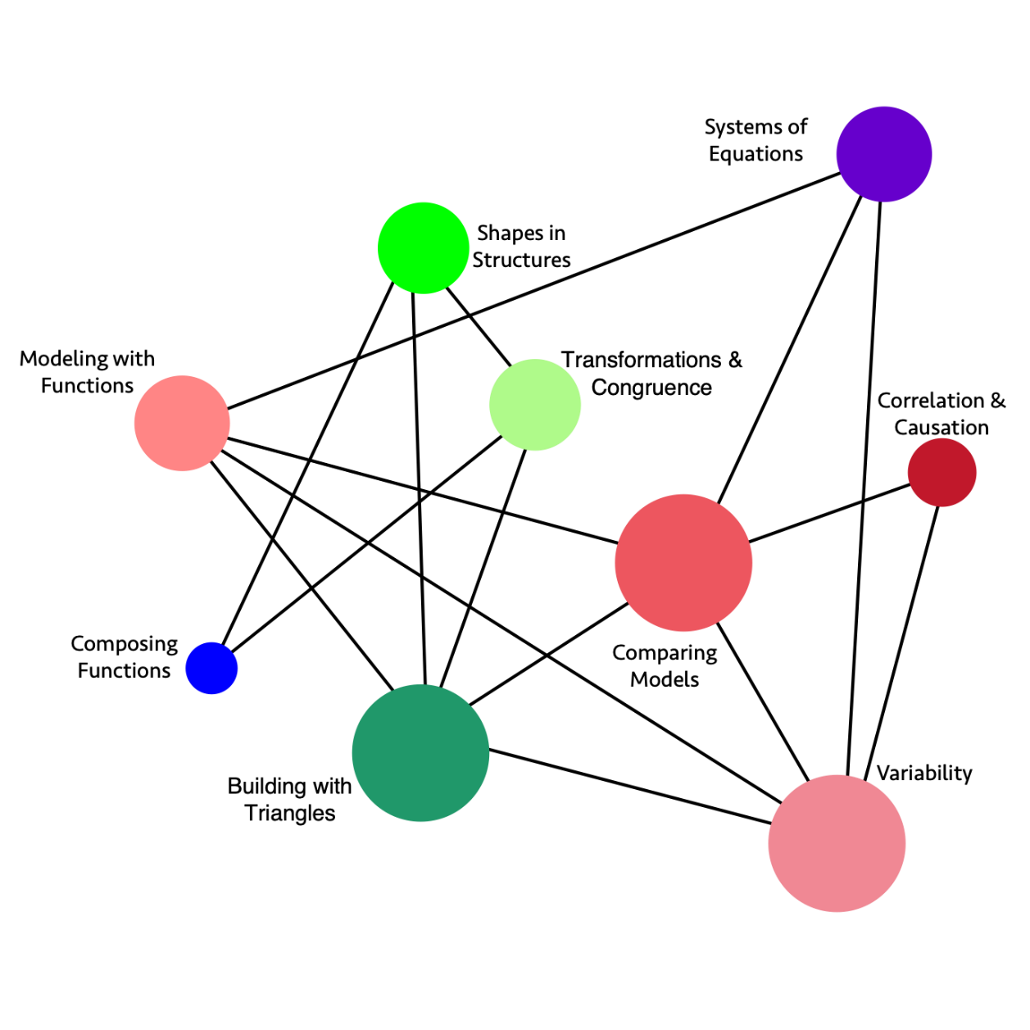
Long description: The graphic illustrates the connections and relationships of some high school integrated mathematics concepts. Direct connections include:
- Systems of Equations directly connects to: Variability, Comparing Models, Modeling with Functions
- Correlation & Causation directly connects to: Variability, Comparing Models
- Variability directly connects to: Correlation & Causation, Comparing Models, Systems of Equations, Modeling with Functions, Building with Triangles
- Building with Triangles directly connects to: Variability, Comparing Models, Transformations & Congruence, Shapes in Structures, Modeling with Functions
- Composing Functions directly connects to: Transformations & Congruence, Shapes in Structures
- Modeling with Functions directly connects to: Building with Triangles, Variability, Comparing Models, Systems of Equations
- Shapes in Structures directly connects to: Transformations & Congruence, Building with Triangles, Composing Functions
- Transformations & Congruence directly connects to: Building with Triangles, Composing Functions, Shapes in Structures
- Comparing Models directly connects to: Correlation & Causation, Variability, Building with Triangles, Modeling with Functions, Systems of Equations
Figure 9.4a. High School Integrated 1 Content Connections, Big Ideas, and Standards
Content Connection | Big Idea | Integrated 1 Standards
Communicating Stories with Data  &  Exploring Changing Quantities | Modeling with Functions | N-Q.1, N-Q.2, N-Q.3, A-CED.2, F-BF.1 ,F-IF.1, F-IF.2, F-IF.4, F-LE.5, S-ID.7, A-CED.1, A-CED.2, A-CED.3, A-SSE.1: Build functions that model relationships between two quantities, including examples with inequalities; using units and different representations. Describe and interpret the relationships modeled using visuals, tables, and graphs.
Communicating Stories with Data  &  Exploring Changing Quantities | Comparing Models | F-LE.1, F-LE.2, F-LE.3, F-IF.4, F-BF.1, F-LE.5, S-ID.7, S-ID.8, A-CED.1, A-CED.2, A-CED.3, A-SSE.1: Construct, interpret, and compare linear, quadratic, and exponential models of real data, and use them to describe and interpret the relationships between two variables, including inequalities. Interpret the slope and constant terms of linear models, and use technology to compute and interpret the correlation coefficient of a linear fit.
Communicating Stories with Data  &  Exploring Changing Quantities | Variability | S-ID.5, S-ID.6, S-ID.7, S-ID.1, S-ID.2, S-ID.3, S-ID.4, A-SSE.1: Summarize, represent, and interpret data. For quantitative data, use a scatter plot and describe how the variables are related. Summarize categorical data in two-way frequency tables and interpret the relative frequencies.
Communicating Stories with Data | Correlation & Causation | S-ID.9, S-ID.8, S-ID.7: Explore data that highlights the difference between correlation and causation. Understand and use correlation coefficients, where appropriate. (see resource section for classroom examples).
Exploring Changing Quantities  &  Taking Wholes Apart, Putting Parts Together | Systems of Equations | A-REI.1, A-REI.3, A-REI.4, A-REI.5, A-REI.6, A-REI.7, A-REI.10, A-REI.11, A-REI.12, NQ.1, A-SEE.1: Students investigate real situations that include data for which systems of 1 or 2 equations or inequalities are helpful, paying attention to units. Investigations include linear, quadratic, and absolute value. Students use technology tools strategically to find their solutions and approximate solutions, constructing viable arguments, interpreting the meaning of the results, and communicating them in multidimensional ways.
Taking Wholes Apart, Putting Parts Together | Composing Functions | F-BF.3, F-BF.2, F-IF.3: Build and explore new functions that are made from existing functions, and explore graphs of the related functions using technology. Recognize sequences are functions and are defined recursively.
Taking Wholes Apart, Putting Parts Together  &  Discovering Shape and Space | Shapes in Structures | G-CO.6, C-CO.7, C-CO.8, G-GPE.4, G-GPE.5, G.GPE.7, F.BF.3: Perform investigations that involve building triangles and quadrilaterals, considering how the rigidity of triangles and non-rigidity of quadrilaterals influences the design of structures and devices. Study the changes in coordinates and express the changes algebraically.
Taking Wholes Apart, Putting Parts Together  &  Discovering Shape and Space | Building with Triangles | G-GPE.4, G-GPE.5, G-GPE.6, GPE.7, F-LE.1, F-LE.2, A-CED.2: Investigate with geometric figures, constructing figures in the plane, relating the distance formula to the Pythagorean Theorem, noticing how areas and perimeters of polygons change as the coordinates change. Build with triangles and quadrilaterals, noticing positions and movement, and creating equations that model the changing edges using technology.
Discovering Shape and Space | Transformations & Congruence | G-CO.1, G-CO.2, G-CO.3, G-CO.4, G-CO.5, G-CO.12, G-CO.13, G-GPE.4, G-GPE.5, G.GPE.7, F-BF.3: Explore congruence of triangles, including quadrilaterals built from triangles, through geometric constructions. Investigate transformations in the plane. Use geometry software to study transformations, developing definitions of rotations, reflections, and translations in terms of angles, circles, perpendicular lines, and parallel lines. Express translations algebraically.
Critical Areas of Instructional Focus
Figure 9.5. High School Integrated 2 Big Ideas
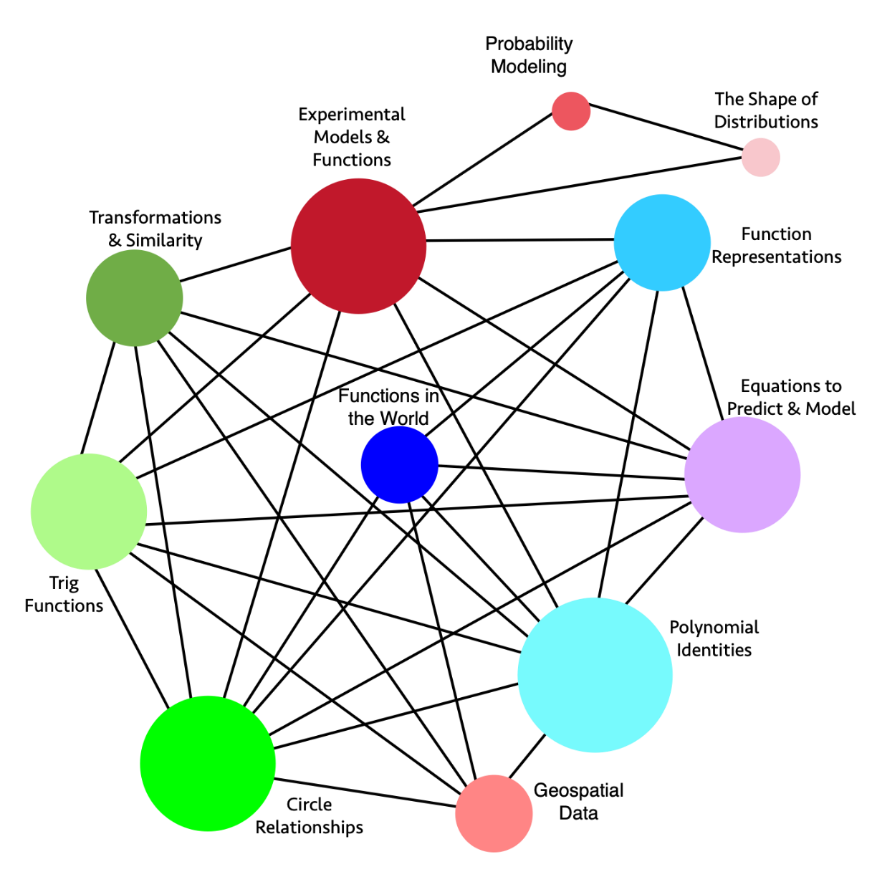
Long description: The graphic illustrates the connections and relationships of some high school integrated mathematics concepts. Direct connections include:
- Function Representations directly connects to: Equations to Predict & Model, Polynomial Identities, Circle Relationships, Functions in the World, Trig Functions, Experimental Models & Functions
- Equations to Predict & Model directly connects to: Polynomial Identities, Circle Relationships, Trig Functions, Functions in the World, Transformations & Similarity, Experimental Models & Functions, Function Representations
- Polynomial Identities directly connects to: Geospatial Data, Circle Relationships, Trig Functions, Transformations & Similarity, Functions in the World, Experimental Models & Functions, Function Representations, Equations to Predict & Model
- Geospatial Data directly connects to: Polynomial Identities, Functions in the World, Transformations & Similarity, Trig Functions, Circle Relationships
- Circle Relationships directly connects to: Geospatial Data, Polynomial Identities, Trig Functions, Transformations & Similarity, Functions in the World, Experimental Models & Functions, Function Representations, Equations to Predict & Model
- Trig Functions directly connects to: Geospatial Data, Circle Relationships, Polynomial Identities, Transformations & Similarity, Experimental Models & Functions, Function Representations, Equations to Predict & Model
- Transformations & Similarities directly connects to: Geospatial Data, Circle Relationships, Trig Functions, Polynomial Identities, Experimental Models & Functions, Equations to Predict & Model
- Experimental Models & Functions directly connects to: Circle Relationships, Trig Functions, Transformations & Similarity, Polynomial Identities, Function Representations, Equations to Predict & Model, The Shape of Distributions, Probability Modeling
- Probability Modeling directly connects to: The Shape of Distributions, Experimental Models & Functions
- The Shape of Distributions directly connects to: Probability Modeling, Experimental Models & Functions
- Functions in the world directly connects to: Functions Representations, Equations to Predict & Model, Polynomial Identities, Geospatial Data, Circle Relationships
Figure 9.5a. High School Integrated 2 Content Connections, Big Ideas, and Standards
Content Connection | Big Idea | Integrated 2 Standards
Communicating Stories with Data | Probability Modeling | S.CP.1, S.CP.2, S.CP.3, S.CP.4, S.CP.5, S-IC.1, S-IC.2, S-IC.3, S.MD.6, S.MD.7: Explore and compare independent and conditional probabilities, interpreting the output in terms of the model. Construct and interpret two-way frequency tables of data as a sample space to determine if the events are independent, and use the data to approximate conditional probabilities. Examples of topics include product and medical testing, and player statistics in sports.
Communicating Stories with Data | The shape of distributions | S-IC.1, S-IC.2, S-IC.3, S-ID.1, S-ID.2, S-ID.3, S-MD.1, S-MD.2: Consider the shape of data distributions to decide on ways to compare the center and spread of data. Use simulation models to generate data, and decide if the model produces consistent results.
Communicating Stories with Data  &  Exploring Changing Quantities | Experimental Models & Functions | S-ID.1, S-ID.2, S-ID.3, S- ID.6, S-ID.7, S-IC.1, S-IC.2, S-IC.3, A-CED.1, A-REI.1, A-REI.4, F-IF.2, F-IF.3, F-IF.4, F-BF.1, F-LE.1, F-TF.2, A-APR.1: Conduct surveys, experiments, and observational studies - drawing conclusions and making inferences. Compare different data sources and what may be most appropriate for the situation. Create and interpret functions that describe the relationships, interpreting slope and the constant term when linear models are used. Include quadratic and exponential models when appropriate, and understand the meaning of outliers.
Communicating Stories with Data | Geospatial Data | G-MG.1, G-MG.2, G-MG.3, F-LE.6, G-GPE.4, G-GPE.6, G-SRT.5, G-CO.1, G-CO.2, G-CO.12, G-C.2, G-C.5: Explore geospatial data that represent either locations (e.g., maps) or objects (e.g., patterns of people’s faces, road objects for driverless cars) and connect to geometric equations and properties of common shapes. Demonstrate how a computer can measure the distance between two points using geometry and then account for constraints (e.g., distance and then roads for directions) and multiple points with triangulation. Model what shapes and geometric relationships are most appropriate for different situations.
Exploring Changing Quantities | Equations to Predict & Model | A-CED.1, A-CED.2, A-REI.4, A-REI.1, A-REI.2, A-REI.3, F.IF.4, F.IF.5, F.IF.6, F.BF.1, F.BF.3, A-APR.1: Model relationships that include creating equations or inequalities, including linear, quadratic, and absolute value. Use the equations or inequalities to make sense of the world or to make predictions, understanding that solving equations is a process of reasoning. Make sense of the real situation, using multiple representations, such as graphs, tables, and equations.
Taking Wholes Apart, Putting Parts Together | Functions in the World | F-LE.3, F-LE.6, F-IF.9, N-RN.1, N-RN.2, A-SSE.1, A-SSE.2:  Apply quadratic functions to the physical world, such as motion of an object under the force of gravity. Produce equivalent forms of the functions to reveal zeros, max and min, and intercepts. Investigate how functions increase and decrease, and compare the rates of increase or decrease to linear and exponential functions.
Taking Wholes Apart, Putting Parts Together | Polynomial Identities | A-SSE.1, A-SSE.2, A-APR.1, A-APR.3, A-APR.4, G-GMD.2, G-MG.1, S-IC.1, S-MD.2: Prove polynomial identities, and use them to describe numerical relationships, using a computer algebra system to rewrite polynomials. Use the binomial theorem to solve problems, appreciating the connections with Pascal’s triangle.
Taking Wholes Apart, Putting Parts Together | Functions Representations | F-IF.4, F-IF.5, F-IF.6, F-IF.7, F-IF.8, F-IF.9, N-RN.1, N-RN.2, F-LE.3, A-APR.1: Interpret functions representing real world applications in terms of the data understanding key features of graphs, tables, domain, and range. Compare properties of two functions each represented in different ways (algebraically, graphically, numerically, in tables or by written/verbal descriptions).
Discovering Shape and Space  &  Exploring Changing Quantities | Transformations & Similarity | G-SRT.1, G- SRT.2, G-SRT.3, , A-CED.2, G-GPE.4, F-BF.3, F-IF.4, A-APR.1: Explore similarity and congruence in terms of transformations, noticing the changes dilations have on figures and the effect of scale factors. Discover how coordinates can be used to describe translations, rotations, and reflections, and generalize findings to model the transformations using algebra.
Discovering Shape and Space | Circle Relationships | G-C.1, G-C.2, G-C.3, G-C.4, G-C.5, G-GPE.1, A-REI.7, A-APR.1, F-IF.9: Investigate the relationships of angles, radii, and chords in circles, including triangles and quadrilaterals that are inscribed and circumscribed. Explore arc lengths and areas of sectors using the coordinate plane. Relate the Pythagorean Theorem to the equation of the circle given the center and radius, and solve simple systems where a line intersects the circle.
Discovering Shape and Space | Trig Functions | G-TF.2, G-GPE.1, G-GMD.2, G-MG.1, A-APR.1: Model periodic phenomena with trigonometric functions. Translate between geometric descriptions and the equation for a conic section. Visualize relationships between 2-D and 3-D objects.
Figure 9.6. A Progression Chart of Big Ideas through Algebra and Geometry
Content Connections | Big Ideas: Algebra | Big Ideas: Geometry
Communicating Stories with Data | Investigate data | Fairness in data
Communicating Stories with Data | Model with functions | Geospatial data
Communicating Stories with Data | n/a | Probability modeling
Exploring Changing Quantities | Function investigations | Trig explorations
Exploring Changing Quantities | Systems of equations | Triangle congruence
Exploring Changing Quantities | Features of functions | Triangle problems
Exploring Changing Quantities | n/a | Circle relationships
Exploring Changing Quantities | n/a | Points & slopes
Taking Wholes Apart, Putting Parts Together | Growth & decay | Triangle congruence
Taking Wholes Apart, Putting Parts Together | n/a | Transformations
Discovering shape and space | Model with functions | Triangle congruence
Discovering shape and space | Investigate data | Transformations
Discovering shape and space | n/a | Circle relationships
Discovering shape and space | n/a | Geometric models
Critical Areas of Instructional Focus
Figure 9.7. High School Algebra Big Ideas
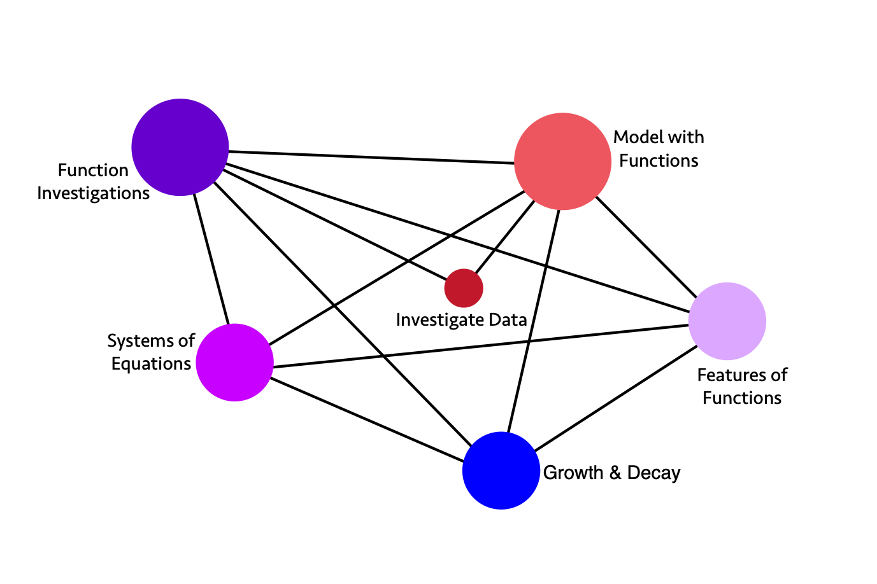
Long description: The graphic illustrates the connections and relationships of some high school algebra mathematics concepts. Direct connections include:
- Model with Functions directly connects to: Features of Functions, Growth & Decay, Investigate Data, Systems of Equations, Function Investigations
- Features of Functions directly connects to: Growth & Decay, Systems of Equations, Function Investigations, Model with Functions
- Growth & Decay directly connects to: Features of Functions, Model with Functions, Function Investigations, Systems of Equations
- Systems of Equations directly connects to: Growth & Decay, Features of Functions, Model with Functions, Function Investigations
- Function Investigations directly connects to: Model with Functions, Features of Functions, Growth & Decay, Investigate Data, Systems of Equations
- Investigate Data directly connects to: Model with Functions, Function Investigations
Figure 9.7a. High School Algebra Content Connections, Big Ideas, and Standards
Content Connection | Big Idea | Algebra Standards
Communicating Stories with Data  &  Discovering Shape and Space | Investigate Data | S-ID.1, S-ID.2, S-ID.3, S-ID.6: Represent data from two or more data sets with plots, dot plots, histograms, and box plots, comparing and analyzing the center and spread, using technology, and interpreting the results. Interpret and compare data distributions using center (median, mean) and spread (interquartile range, standard deviation) through the use of technology.  - Students have opportunities to explore and research a topic of interest and meaning to them, using the statistical methods, tools, and representations.  - Have students consider how different, competing interpretations can be made from different audiences, histories, and perspectives.  - Allow students to develop follow-up questions to investigate, spurred by the original data set.
Communicating Stories with Data  &  Discovering Shape and Space | Model with Functions | F-IF.1, F-IF.2, F-IF.4, F-IF.5, F-IF.6, F-IF.7, F-IF.8, F-IF.9, F-BF.1, F-BF.2, F-BF.4, F-LE.1, F-LE.2, S-ID.5, S-ID.6, S-ID.7, S-ID.8, S-ID.9: Investigate data sets by table and graph and using technology; fit and interpret functions** to model the data between two quantities. Interpret information from the functions, noticing key features* and symmetries. Develop understanding of the meaning of the function and how it represents the data that it is modeling; recognizing possible associations and trends in the data - including consideration of the correlation coefficients of linear models.  - Students can disaggregate data by different characteristics of interest (populations for example), and compare slopes to examine questions of fairness and bias among groups.  - Students have opportunities to consider how to communicate relevant concerns to stakeholders and/or community members.  - Students can identify both extreme values (true outliers) and data errors, and how the inclusion or exclusion of these observations may change the function that would most appropriately model the data.  *intercepts, slope, increasing or decreasing, positive or negative  ** functions include linear, quadratic and exponential
Exploring Changing Quantities | Systems of Equations | A-REI.1, A-REI.3, A-REI.4, A-REI.5, A-REI.6, A-REI.7, A-REI.10, A-REI.11, A-REI.12, NQ.1, A-SEE.1, F-LE.1, F-LE.2: Students investigate real situations that include data for which systems of 1 or 2 equations or inequalities are helpful, paying attention to units. Investigations include linear, quadratic, and absolute value. Students use technology tools strategically to find their solutions and approximate solutions, constructing viable arguments, interpreting the meaning of the results, and communicating them in multidimensional ways.
Exploring Changing Quantities | Function investigations | F-IF.1, F-IF.2, F-IF.4, F-IF.5, F-IF.6, F-IF.7, F-IF.8, F-IF.9, F-BF.1, F-BF.2, F-BF.4, S-ID.5, S-ID.6, S-ID.7, S-ID.8, S-ID.9, F-LE.1, F-LE.2: Students investigate data sets by table and graph and using technology; such as earthquake data in the region of the school; they fit and interpret functions to model the data between two quantities and consider the meaning of inverse relationships. Students interpret information from the functions, noticing key features* and symmetries. Students develop understanding of the meaning of the function and how it represents the data that it is modeling; they recognize possible associations and trends in the data - including consideration of the correlation coefficients of linear models.  *one to one correspondence, intercepts, slope, increasing or decreasing, positive or negative
Exploring Changing Quantities | Features of Functions | A-SSE.3, F-IF.3, F-IF.4, F-LE.1, F-LE.2, F-LE.6: Students investigate changing situations that are modeled by quadratic and exponential forms of expressions and create equivalent expressions to reveal features* that help understand the meaning of the problem and situation being investigated. (driver of investigation 1, making sense of the world)  Investigate patterns, such as the Fibonacci sequence and other mathematical patterns, that reveal recursive functions.  *Factored form to reveal zeros of a quadratic function, standard form to reveal the y-intercept, vertex form to reveal a maximum or minimum.
Taking Wholes Apart, Putting Parts Together | Growth & Decay | F-LE.1, F-LE.2, F-LE.3, F-LE.5, F-LE.6, F-BF.1, F-BF.2, F-BF.3, F-BF.4, F-IF.4, F-IF.5, F-IF.9, NQ.1, A-SEE.1: Investigate situations that involve linear, quadratic, and exponential models, and use these models to solve problems. Recognize linear functions grow by equal differences over equal intervals; exponential functions grow by equal factors over equal intervals, and functions grow or decay by a percentage rate per unit interval. Interpret the inverse of functions, and model the inverse in graphs, tables, and equations.
Critical Areas of Instructional Focus
Figure 9.8 High School Geometry Big Ideas
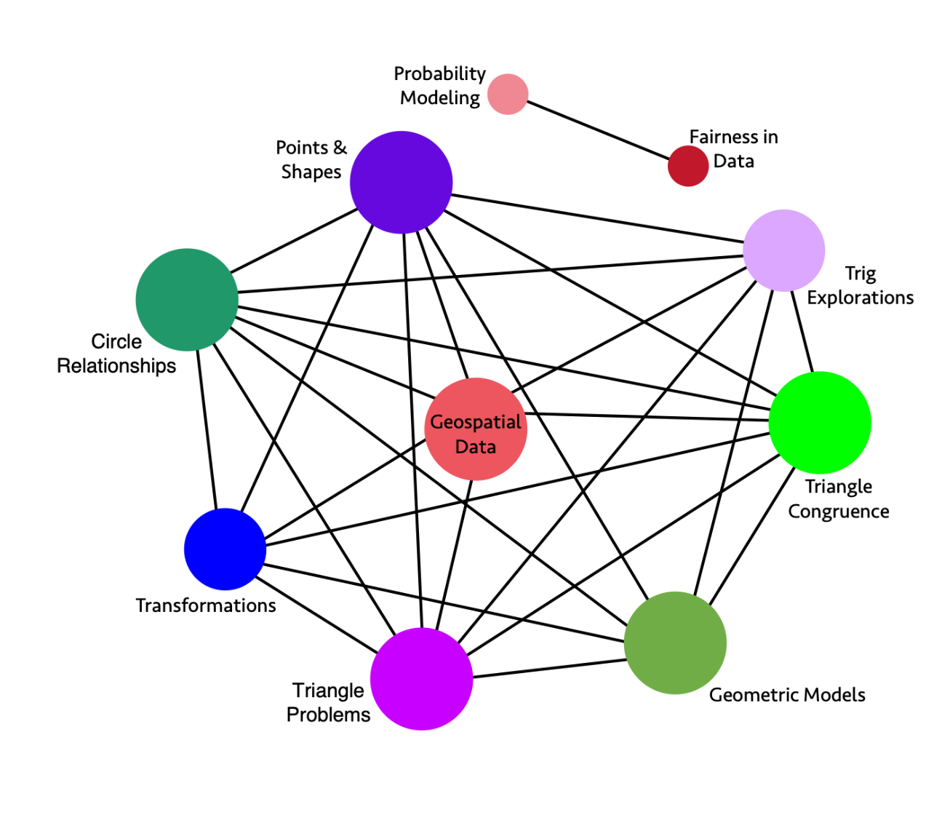
Long description: The graphic illustrates the connections and relationships of some high school geometry mathematics concepts. Direct connections include:
- Probability Modeling directly connects to: Fairness in Data
- Fairness in Data directly connects to: Probability Modeling
- Trig Explorations directly connects to: Triangle Congruence, Geometric Models, Triangle Problems, Geospatial Data, Circle Relationships, Points & Shapes
- Triangle Congruence directly connects to: Geometric Models, Triangle Problems, Transformations, Geospatial Data, Circle Relationships, Points & Shapes, Trig Explorations
- Geometric Models directly connects to: Triangle Problems, Transformations, Circle Relationships, Points & Shapes, Trig Explorations, Triangle Congruence
- Triangle Problems directly connects to: Geometric Models, Triangle Congruence, Transformations, Geospatial Data, Circle Relationships, Points & Shapes, Trig Explorations
- Transformations directly connects to: Geometric Models, Triangle Problems, Triangle Congruence, Geospatial Data, Circle Relationships, Points & Shapes
- Circle Relationships directly connects to: Geometric Models, Triangle Problems, Transformations, Geospatial Data, Triangle Congruence, Points & Shapes, Trig Explorations
- Points & Shapes directly connects to: Geometric Models, Triangle Problems, Transformations, Geospatial Data, Circle Relationships, Triangle Congruence, Trig Explorations
- Geospatial Data: Triangle Problems, Transformations, Triangle Congruence, Circle Relationships, Points & Shapes, Trig Explorations
Figure 9.8a. High School Geometry Content Connections, Big Ideas, and Standards
Content Connection | Big Idea | Geometry Standards
Communicating Stories with Data | Probability Modeling | S-CP.1, S-CP.2, S-CP.3, S-CP.4, S-CP.5, S-IC.1, S-IC.2, S-IC.3, S-MD.6, S-MD.7: Explore and compare independent and conditional probabilities, interpreting the output in terms of the model. Construct and interpret two-way frequency tables of data as a sample space to determine if the events are independent and use the data to approximate conditional probabilities. Examples of topics include product and medical testing, and player statistics in sports.
Communicating Stories with Data | Fairness in Data | S-MD.6, S-MD.7: Determine fairness and make decisions based on evaluation of outcomes. Allow students to explore fairness by researching topics of interest, analyzing data from two-way tables. Provide opportunities for students to make meaningful inference, and communicate their findings to community or other stakeholders.
Communicating Stories with Data | Geospatial Data | G-MG.1, G-MG.2, G-MG.3, F-LE.6, G-GPE.4, G-GPE.6, G-SRT.5, G-CO.1, G-CO.2, G-CO.12, G-C.2, G-C.5: Explore geospatial data that represent either locations (e.g., maps) or objects (e.g., patterns of people’s faces, road objects for driverless cars), and connect to geometric equations and properties of common shapes. Demonstrate how a computer can measure the distance between two points using geometry, and then account for constraints (e.g., distance and then roads for directions) and multiple points with triangulation. Model what shapes and geometric relationships are most appropriate for different situations.
Exploring Changing Quantities | Trig Explorations | G-SRT.1, G-SRT.2, G-SRT.3, G-SRT.5, G-SRT.9, G-SRT.10, G-SRT.11, GPE.7. G-C.2, G-C.4: Investigate properties of right triangle similarity and congruence and the relationships between sine, cosine, and tangent; exploring the relationship between sine and cosine of complementary angles, and apply that knowledge to problem solving situations. Students recognize the role similarity plays in establishing trigonometric functions, and they use trigonometric functions to investigate situations. Using dynamic geometric software students investigate similarity and trigonometric identities to derive the Laws of Sines and Cosines and use the laws to solve problems.
Exploring Changing Quantities | Triangle Problems | G-SRT.4, G-SRT.5, G-SRT.6, G-SRT.8, G-C.2, G-C.4, G-CO.12: Understand and use congruence and similarity when solving problems involving triangles, including trigonometric ratios. Use trigonometric ratios and the Pythagorean Theorem to solve right triangles in applied problems using dynamic geometric software.
Exploring Changing Quantities | Points & Shapes | G-GPE.1, G-GPE.2, G-GPE.4, G-GPE.5, G-GPE.6, G-GPE.7, G-CO.1, G-CO.12, G-C.2, G-C.4: Solve problems involving geometric shapes in the coordinate plane using dynamic geometric software to apply the distance formula, Pythagorean Theorem, slope, and similarity rules in solving problems.  - Investigate equations of circles and how coefficients in the equations correspond to the location and radius of the circles.  Find areas and perimeters of triangles and rectangles in the coordinate plane.
Taking Wholes Apart, Putting Parts Together  &  Discovering Shape and Space | Transformations | G-CO.1, G-CO.3, G-CO.4, G-CO.5, G-CO.12: Understand rotations, reflections, and translations of regular polygons, quadrilaterals, angels, circles, and line segments. Identify transformations, through investigation, that move a figure back onto itself, using that process to prove congruence.
Discovering Shape and Space  &  Exploring Changing Quantities  &  Taking Wholes Apart, Putting Parts Together | Triangle Congruence | G-CO.1, G-CO.2, G-CO.7, G-CO.8, G-CO.9, G-CO.10, G-CO.11, G-CO.12, G-CO.13, G-SRT.5: Investigate triangles and their congruence over rigid transformations verifying findings using triangle congruence theorems (ASA, SSS, SAS, AAS, and HL) and other geometric properties, including vertical angles, angles created by transversals across parallel lines, and bisectors.
Exploring Changing Quantities  &  Discovering Shape and Space | Circle Relationships | G-C.1, G-C.2, G-C.3, G-C.4, G-CO.1, G-CO.12, G-CO.13, G-GPE.1: Investigate similarity in circles and relationships between angle measures and segments, including inscribed angles, radii, chords, central angles, inscribed angles, circumscribed angles, and tangent lines using dynamic geometric software.
Discovering Shape and Space | Geometric Models | G-GMD.1, G-GMD.3, G-GMD.4, G-GMD.5, G-MG.1, G-MG.12, G-MG.13, SRT.5, G-CO.12, G-C.2, G-C.4: Apply geometric concepts in modeling situations to solve design problems using dynamic geometric software.  - Investigate 3-D shapes and their cross sections.  - Use volume, area, circumference, and perimeter formulas.  - Understand and apply Cavalieri’s principle.  - Investigate and apply scale factors for length, area, and volume.
Note: Digital tools and resources to support the implementation of the strategies and considerations identified in this section are included in the Appendices. Please also note that digital tools referenced in Appendix B include free and premium options, and their inclusion in the guidance are largely derived from interviews with California educators. LEAs exercise local control when selecting digital tools and resources. Resources and digital tools included in the guide should not be considered endorsements by the CDE.

Appendix D: Mathematics Rubric Samples
This tool gives an overview of the priority standards for grade 3. It connects the Drivers of Investigation to both the big ideas and the standards for mathematical practice (SMP). Periodically and throughout the school year, teachers can use a tool like this to assess and give feedback to students around their strengths and areas for growth. The teacher notes those indicators that the student has shown mastery, and which ones the student should focus on to further student learning. The final two columns are meant to be filled in by the teacher.
Considerations for the final two columns to be completed by the teacher (TBT):
Student Strength: What does the student understand in terms of this standard? What linguistic and cultural assets possessed by the students can I tap into to support all students, including those on the road to English proficiency, in their mastery of the content?
Student Area for Growth: What should the student focus on to strengthen their understanding of this standard?
Content Connections | Big ideas | Mathematical  Practice Standards | Indicators: The student... | Student Strength | Student area for Growth
Communicating Stories with Data | Represent Multivariate Data | SMP1: Make sense of problems and persevere in solving them.  SMP4: Model with mathematics  SMP6: Attend to precision | -Interprets appropriate meaning from graphs  -Strategically organizes multivariable data  -Creates graphs that clearly communicate information from data | TBT | TBT
Communicating Stories with Data | Fractions of Shape and Time | SMP4: Model with mathematics  SMP5: Use appropriate tools strategically.  SMP6: Attend to precision | -Creates data visualizations that clearly capture and communicate about data collected over time | TBT | TBT
Exploring Changing Quantities | Addition and Subtraction problems | SMP3: Construct viable arguments and critique the reasoning of others.  SMP5: Use appropriate tools strategically.  SMP7: Look for and make use of structure. | -Computes sums and differences within 1000  -Justifies solutions using appropriate tools or models  -Constructs arguments with clear reasoning to support solutions | TBT | TBT
Exploring Changing Quantities | Number Flexibility to 100 | SMP3: Construct viable arguments and critique the reasoning of others.  SMP4: Model with mathematics.  SMP5: Use appropriate tools strategically. | -Computes products and quotients within 100  -Justifies solutions using appropriate tools or models  -Constructs arguments with clear reasoning to support solutions | TBT | TBT
Taking Wholes Apart, Putting Parts Together | Square Tiles | SMP2: Reason abstractly and quantitatively.  SMP5: Use appropriate tools strategically. | -Measures area using square tiles as tools  -Connects the area of individual square tiles to area of entire shape’s area using fractions. | TBT | TBT
Taking Wholes Apart, Putting Parts Together | Fractions of shape and time | SMP2: Reason abstractly and quantitatively.  SMP4: Model with mathematics  SMP7: Look for and make use of structure | -Collects and organizes multivariable data in relationship to time  -Creates connections that highlight the relationship between measures of time including minutes, quarter, and half hours. | TBT | TBT
Taking Wholes Apart, Putting Parts Together | Fractions as relationships | SMP2: Reason abstractly and quantitatively.  SMP7: Look for and make use of structure | -Interprets the relationship between the numerator and denominator of fractions-- especially in context  -Recognizes and connects equivalent fractions to one another. | TBT | TBT
Taking Wholes Apart, Putting Parts Together | Unit Fraction Models | SMP3: Construct viable arguments and critique the reasoning of others.  SMP4: Model with mathematics | -Uses visual models to compare unit fractions  -Justifies arguments about unit fractions using visual models | TBT | TBT
Discovering Shape and Space | Analyze Quadrilaterals | SMP2: Reason abstractly and quantitatively.  SMP4: Model with mathematics | -Compares quadrilaterals based on various features  -Investigates how area and perimeter change when side lengths change.  -Solves real world problems involving area and perimeter of quadrilaterals through modeling. | TBT | TBT
Discovering Shape and Space | Fractions as Relationships | SMP2: Reason abstractly and quantitatively.  SMP4: Model with mathematics | -Creates visual representations that model fractions  -Justifies how a model represents a fractional quantity by relating the numerator, denominator and visual. | TBT | TBT
Discovering Shape and Space | Unit Fraction Models | SMP3: Construct viable arguments and critique the reasoning of others.  SMP4: Model with mathematics | -Uses visual models to compare unit fractions by attending to differences in scale  -Justifies arguments about unit fractions using visual models | TBT | TBT

Example Rubric based around YouCubed’s Halving task.
- This investigation gives opportunity for students to: Make sense of the world, using content from Taking Wholes Apart, Putting Parts Together, and Discovering Shape and Space and related standards of mathematical practice.
- The rubric is meant to encourage reflection and metacognition in students by providing space for them to show evidence of understanding and also pinpoint areas where they can still grow. Teachers use this rubric as a tool for formative assessment and feedback.
- Columns to be completed by teacher (TBT); Columns to be completed by student (TBS)
Teacher feedback for area of growth: To keep growing, focus on... | Student reflection for area to grow: A question I have or something I still need to work on is... | Big Idea | Student reflection for material learned: I can show that I understand by... | Teacher feedback: A strength you have shown is…
TBT | TBS | Fractions as relationships:  I understand that a fraction is a relationship between numerators and denominators – and I connect this understanding to the visuals in this task. (NF.1, NF.3 a,b, MP2 MP7) | TBS | TBT
TBT | TBS | Unit Fraction Models: I can compare unit fraction using different visual models.  (NF.2, MP4, MP5) | TBS | TBT
TBT | TBS | I can justify my comparisons to convince myself and others.  (NF.3d, MP1, MP3) | TBS | TBT
TBT | TBS | Analyze Quadrilaterals: I can describe, analyze, and compare quadrilaterals (4-sided shapes) and the ways the area changes when it is cut in different ways. (MD.8, G.1, G.2. MP2, MP4) | TBS | TBT
TBT | TBS | Square Tiles: I can think about fractions with shape and space, expressing the base unit as a unit fraction of the whole. (NF.1, G.2) | TBS | TBT

California Department of Education, June 2021

https://tech.ed.gov/files/2017/01/NETP17.pdf
https://bit.ly/ISTEDistrictGuidance
https://digcitcommit.org/
https://www.youtube.com/watch?v=QTuLn5kiyyg
https://teachinctrl.org/math/
https://tech.ed.gov/files/2017/01/NETP17.pdf
http://www.ldonline.org/article/6291/
https://www.understood.org/en/school-learning/assistive-technology/ assistive-technologies-basics/word-prediction-technology-what-it-is-and-how-it-works
https://www.wolframalpha.com/
https://tech.ed.gov/files/2017/01/NETP17.pdf
https://lvp.digitalpromiseglobal.org/content-area/math-3-6/ strategies/student-generated-problems-math-3-6/summary
https://lvp.digitalpromiseglobal.org/content-area/math-3-6/ strategies/guided-inquiry-math-3-6/summary
https://lvp.digitalpromiseglobal.org/content-area/math-7-9/ factors/spatial-skills-math-7-9/summary
https://www.teachthought.com/pedagogy/ strategies-for-using-digital-choice-boards-in-the-classroom/
https://www.pblworks.org/pbl-remote-learning
https://scratch.mit.edu/
https://www.youtube.com/watch?v=0GCJC_pcBts
https://mathvisuals.wordpress.com/
https://www.youcubed.org/resource/k-8-curriculum/
www.youcubed.org/resources/jo-teaching-visual-dot-card-number-talk/
https://www.sfusdmath.org/math-talks-resources.html
https://www.insidemathematics.org/classroom-videos/number-talks
https://www.youcubed.org/
https://www.youcubed.org/resource/number-sense/
https://www.youcubed.org/resource/data-talks/
https://www.nytimes.com/column/whats-going-on-in-this-graph
https://slowrevealgraphs.com/
https://www.cde.ca.gov/sp/cd/re/documents/preschoollf.pdf
https://www.tapfun.com/blog/number-paths-a-fabulous-tool-for-kindergarten-and-first-grade-math#:~:text=A%20number%20path%20is%20a,confidence%20and%20accurately%20solve%20problems
https://www.youcubed.org/resource/visual-mathematics/
https://www.tapfun.com/blog/number-paths-a-fabulous-tool-for-kindergarten-and-first-grade-math#:~:text=A%20number%20path%20is%20a, confidence%20and%20accurately%20solve%20problems
https://nrich.maths.org/
https://www.mathlearningcenter.org/apps
https://toytheater.com/category/teacher-tools/virtual-manipulatives/
https://www.youcubed.org/evidence/fluency-without-fear/
https://www.youcubed.org/wim/number-visuals-3-5/
https://nrich.maths.org/
https://www.youcubed.org/algebra/ - week-1
https://codap.concord.org/
https://www.youcubed.org/wp-content/uploads/2019/08/WIM-Halving-Grades-3-5.pdf

