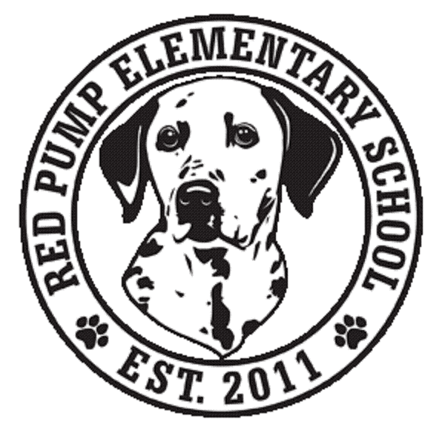
December 2023
Dear Red Pump Families,
This month, we are partnering with Mountain Christian Church and collecting new or gently used coats (children and adult sizes), hats, gloves, scarves, sweaters, and socks for their campaign- Love in Every Thread, We've Got You Covered! Helping the community to stay warm, one coat at a time.
These items can be dropped off in the large boxes in the lobby until January 31, 2024.
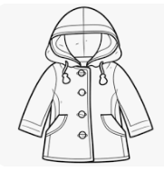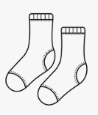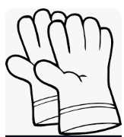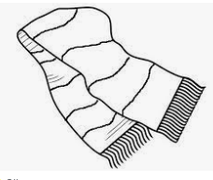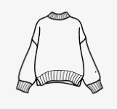
We are also continuing to collect pull tabs from soda cans for Ronald McDonald House. This is a year-long service project. Holiday gatherings are a perfect time to collect these tabs. A box for these tabs is also located in the lobby!
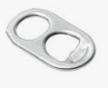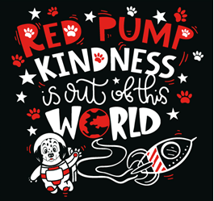
Thank you for your support!
Questions? Please contact Jenifer.Salvi-Burke@hcps.org

