Dear Parents/Guardians:

We have great news to share! Aberdeen High School and Harford County Public Schools have partnered with FEV Tutor to provide free academic support and/or tutoring in all mathematics, reading, science, and social studies courses. This resource is available to all students in grades ­­­3-12. FEV Tutor provides drop-in homework help, as well as scheduled sessions, 24/7- all day, every day. The resource will be available beginning today, Tuesday, January 17, 2023. Please see below for the breakdown of each of the options.

Click [HERE](https://nam11.safelinks.protection.outlook.com/?url=https%3A%2F%2Fyoutu.be%2FXqhCrkRJaLw&data=05%7C01%7CRebecca.Pensero%40hcps.org%7C6160e9a61d3241ea3b8b08daf43deb94%7Cc1f6ac536b774db594724f104eeac96a%7C0%7C0%7C638090844045204463%7CUnknown%7CTWFpbGZsb3d8eyJWIjoiMC4wLjAwMDAiLCJQIjoiV2luMzIiLCJBTiI6Ik1haWwiLCJXVCI6Mn0%3D%7C3000%7C%7C%7C&sdata=SHSFSE7SgixIdaas06QjU16%2BEOZH0%2B3HNq9uFT%2BmE4g%3D&reserved=0) to watch an overview of FEV Tutor.

**Option 1: Drop-In Homework Help-** this option is best used when students are having difficulty with an assignment.

* Step 1: Log into HCPS student device
* Step 2: Access FEV Tutor through Clever.

*To access Clever students must go into Canvas, select the “help” icon displayed as a question mark, and sign into their HCPS account. Search “FEV Tutor” on the Clever Platform and select the FEV Tutor icon.

* Step 3: Select “Request an On-Demand Session!”
* Step 4: Select subject area
* Step 5: Submit

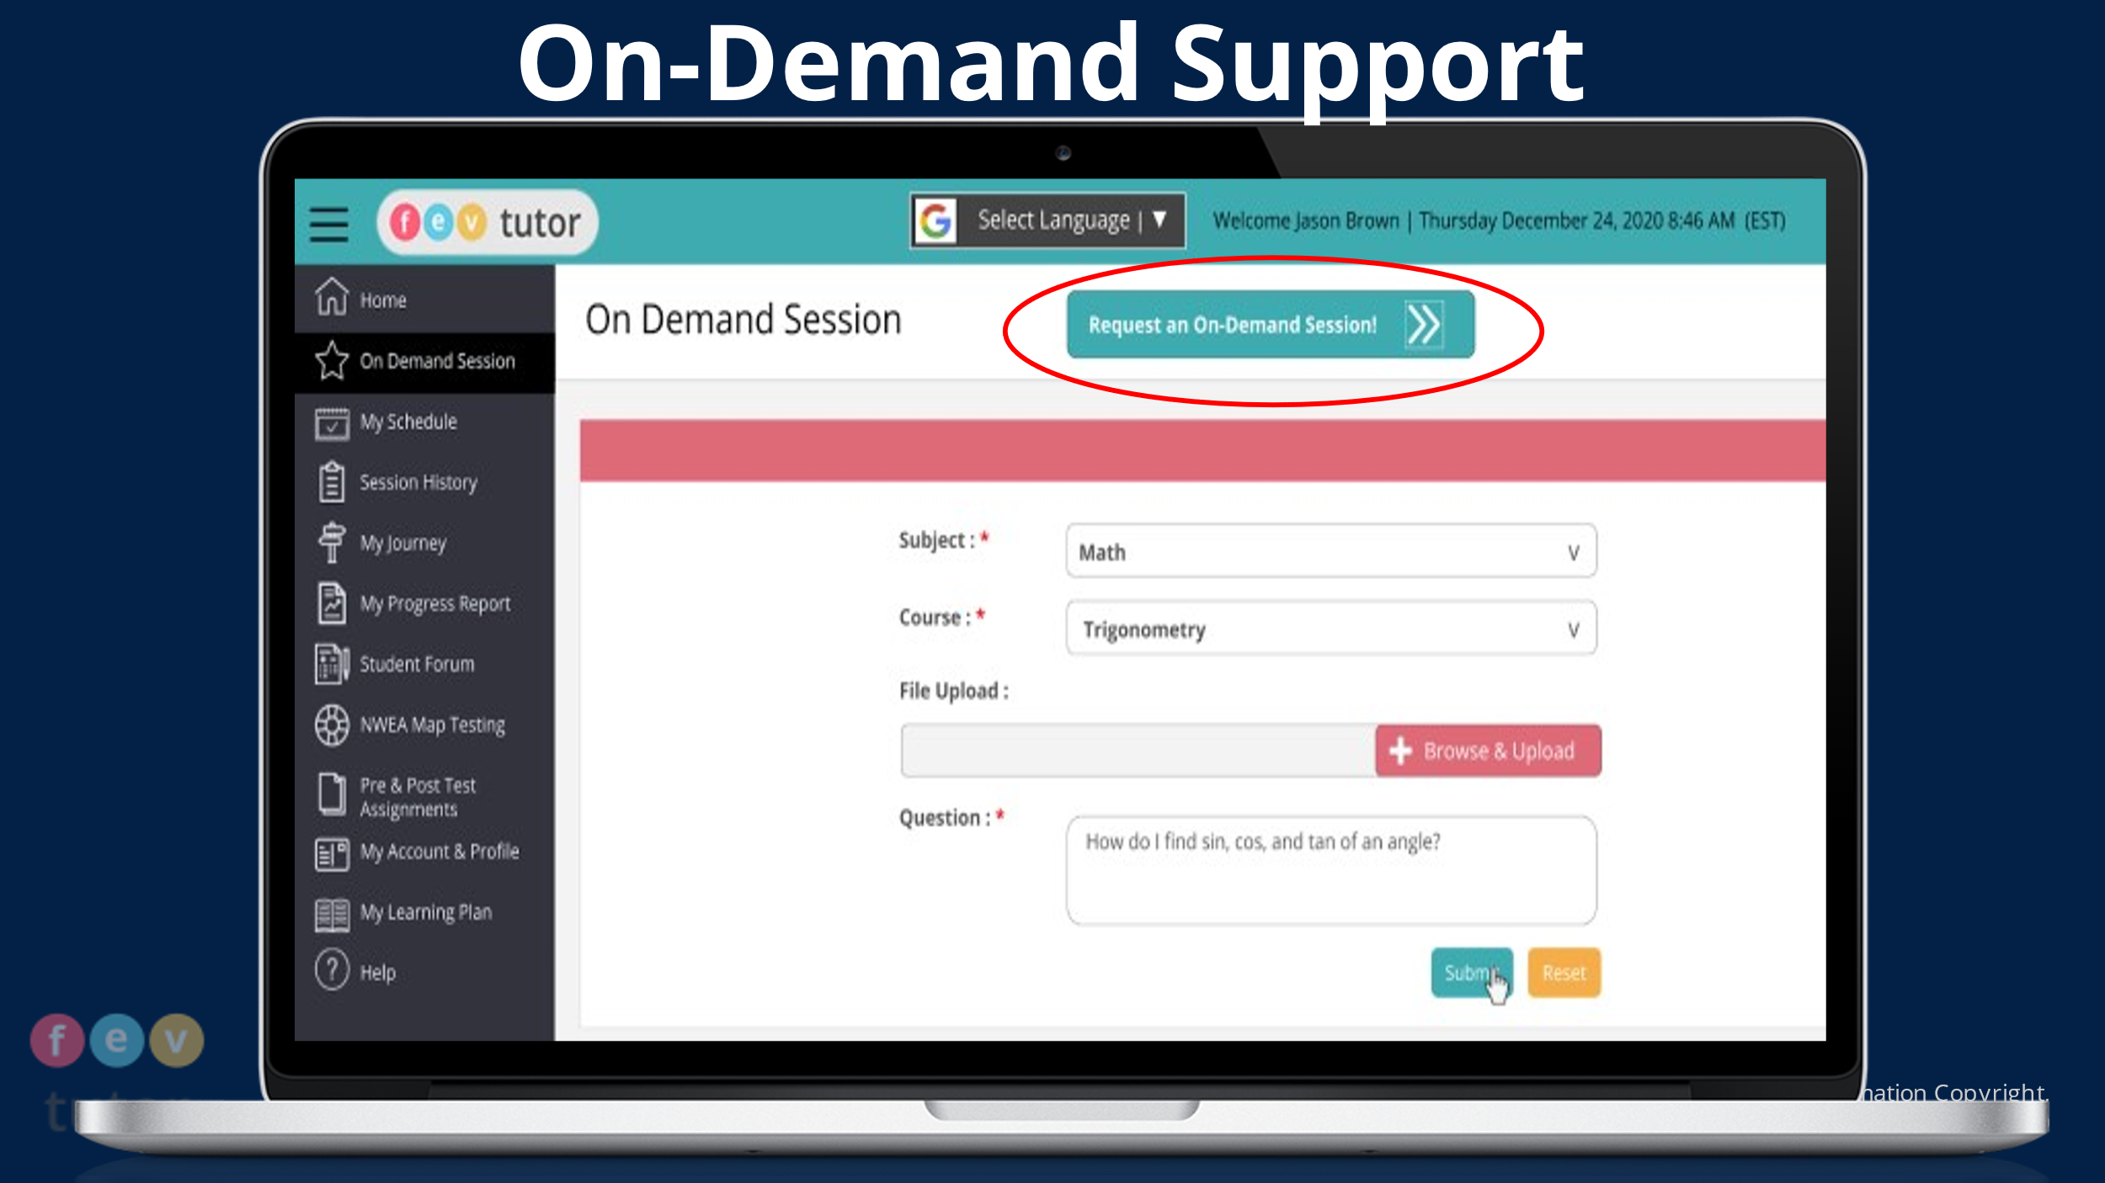

**Option 2: Scheduled Weekly Sessions-**This option is best for consistent support, in a single subject area.

* Step 1: Log into HCPS student device
* Step 2: Access FEV Tutor through Clever.

*To access Clever students must go into Canvas, select the “help” icon displayed as a question mark, and sign into their HCPS account. Search “FEV Tutor” on the Clever Platform and select the FEV Tutor icon.

* Step 3: Schedule a tutoring session. Click [HERE](https://nam11.safelinks.protection.outlook.com/?url=https%3A%2F%2Fwww.youtube.com%2Fwatch%3Fv%3DemTi2PBYmDY&data=05%7C01%7CRebecca.Pensero%40hcps.org%7C0e889b7f1f094b26b4a508da9c08f9fc%7Cc1f6ac536b774db594724f104eeac96a%7C0%7C0%7C637993859787404522%7CUnknown%7CTWFpbGZsb3d8eyJWIjoiMC4wLjAwMDAiLCJQIjoiV2luMzIiLCJBTiI6Ik1haWwiLCJXVCI6Mn0%3D%7C3000%7C%7C%7C&sdata=YY%2FN9yb%2F40Z5mfebj%2FvtSyryu7ZFXUfvFqrtEakYUFs%3D&reserved=0) to learn how.
* Step 4: Select red flashing button “Your session has started, Join Now!” at your scheduled time.

**Getting Started Resources:**

[**Intro Video**](https://nam11.safelinks.protection.outlook.com/?url=https%3A%2F%2Fwww.youtube.com%2Fwatch%3Fv%3Di1B8oYeqClg&data=05%7C01%7CRebecca.Pensero%40hcps.org%7Cc6e98269eb4040557a6608daef20a416%7Cc1f6ac536b774db594724f104eeac96a%7C0%7C0%7C638085220731125239%7CUnknown%7CTWFpbGZsb3d8eyJWIjoiMC4wLjAwMDAiLCJQIjoiV2luMzIiLCJBTiI6Ik1haWwiLCJXVCI6Mn0%3D%7C3000%7C%7C%7C&sdata=bBNuhh8O3uV9CcZ7t1tC%2FxyLqrRYeBxQ8bzP9YMXGVo%3D&reserved=0)

[**Frequently Asked Questions**](https://fevtutor.helpsite.com/)

[**Learning Style and Communication Options**](https://nam11.safelinks.protection.outlook.com/?url=https%3A%2F%2Fwww.youtube.com%2Fwatch%3Fv%3D8xqc5l-Ykyc&data=05%7C01%7CRebecca.Pensero%40hcps.org%7C0e889b7f1f094b26b4a508da9c08f9fc%7Cc1f6ac536b774db594724f104eeac96a%7C0%7C0%7C637993859787404522%7CUnknown%7CTWFpbGZsb3d8eyJWIjoiMC4wLjAwMDAiLCJQIjoiV2luMzIiLCJBTiI6Ik1haWwiLCJXVCI6Mn0%3D%7C3000%7C%7C%7C&sdata=sgEBIsVtuAe03K4X7%2FK%2F5kB%2BWl0kvtODdOncVrC%2BYYQ%3D&reserved=0)

[**How to Use Whiteboard Tools and Share Content with Tutors**](https://nam11.safelinks.protection.outlook.com/?url=https%3A%2F%2Fwww.youtube.com%2Fwatch%3Fv%3DBPZQG3Vymks&data=05%7C01%7CRebecca.Pensero%40hcps.org%7C0e889b7f1f094b26b4a508da9c08f9fc%7Cc1f6ac536b774db594724f104eeac96a%7C0%7C0%7C637993859787404522%7CUnknown%7CTWFpbGZsb3d8eyJWIjoiMC4wLjAwMDAiLCJQIjoiV2luMzIiLCJBTiI6Ik1haWwiLCJXVCI6Mn0%3D%7C3000%7C%7C%7C&sdata=8bk6Ge5phAkCHOoOdoLQqoDX8A0O32GDmuCAOVJskUA%3D&reserved=0)

If you have any questions about this free virtual tutoring program, please contact FEV Tutor directly via email at: md@fevtutor.com or call 855-763-2607. FEV's Support Team is happy to answer any questions and work with you to create a personalized tutoring experience that best suits you as a learner.

You may also contact Rebecca Pensero, Coordinator of Supplemental Instruction and Tutoring, via email at [Rebecca.Pensero@hcps.org](mailto:Rebecca.Pensero@hcps.org).

Yours in Education,