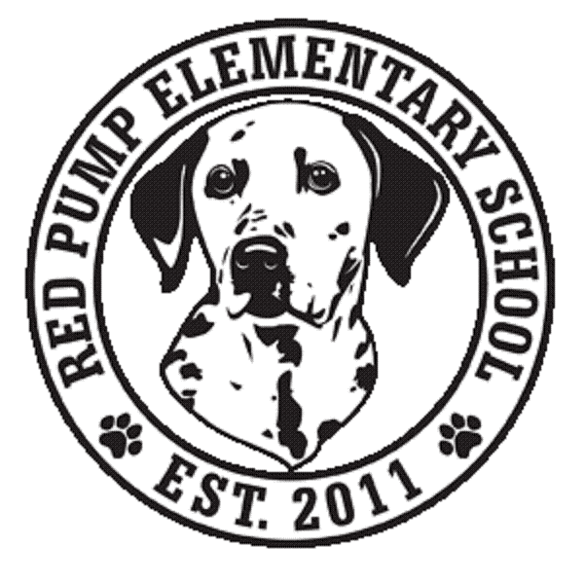
November 2023
Dear Red Pump Families,
This month, we are partnering with We Cancerve and a recent Red Pump alumni to collect brand new pillows to donate to Anna’s House. Anna’s House is in Bel Air, and they provide transitional living spaces for those experiencing homelessness.
Brand new pillows can be dropped off in the large boxes in the lobby until December 15th.

We are also continuing to collect pull tabs from soda cans for Ronald McDonald House. This is a year-long service project. Holiday gatherings are a perfect time to collect these tabs. A box for these tabs is also located in the lobby!
Thank you for your support!

