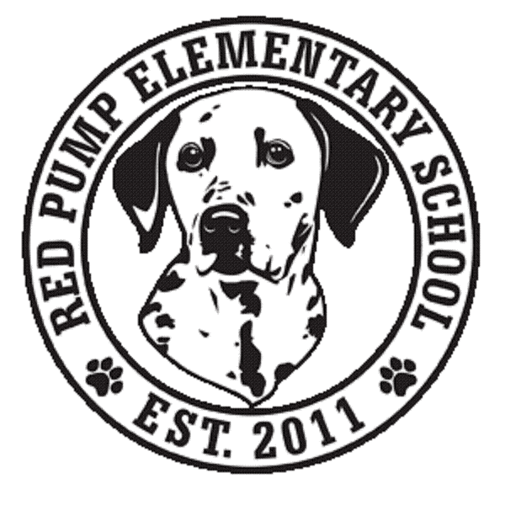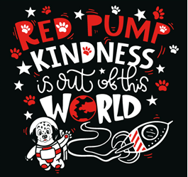
March 2024
Dear Red Pump Families,
This month, we are partnering with The Hope Center of Maryland. The Hope Center is a non-profit organization that provides food to various food pantries, Senior Housing centers, and various organizations in Harford County. They have recently partnered with some of the Title I schools in our county. As you probably are aware, there is a tremendous need for weekend food options for children. Many of the schools do provide some food, but often it is never enough. The Beyond Blessings program provides a large variety of non-perishable food items for the children with the greatest need within the schools. The Hope Center is currently providing 125 bags total (6 meals per bag) every weekend to certain schools in Harford County.
If your family would like to help the Beyond Blessings program, please see the list of items below. These items can be dropped off in the boxes in the lobby until April 5, 2024.
Items being collected include fruit cups, pudding cups, individual cheese and peanut butter cracker packs, Pop Tarts, Nature Valley granola bars, any fruit gummy snacks, microwavable mac and cheese, and capri suns.

We also continue to collect pull tabs from soda cans for Ronald McDonald House. This is a year-long service project.
A box for these tabs is also located in the lobby! 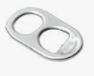
Thank you for your support!
Questions? Please contact Jenifer.Salvi-Burke@hcps.org

